BQ40Z50-R1 3S1P电池出现触发VIMR PF问题
BQ40Z50-R1 3S1P battery has triggered the VIMR PF issue
- 背景：background:
客户在整机老化后出现VIMR PF保护，充放电MOS关闭，PF置起，电池无输出电压，通讯读取cell 1电压为：4161mV,cell 2 电压为：4159mV,cell 3电压为：4160mV。
After the full machine aging, the customer encountered VIMR PF protection, the charge and discharge MOS was shut down, PF was set up, and the battery had no output voltage. The communication reading of cell 1 voltage was 4161mV, cell 2 voltage was 4159mV, and cell 3 voltage was 4160mV。
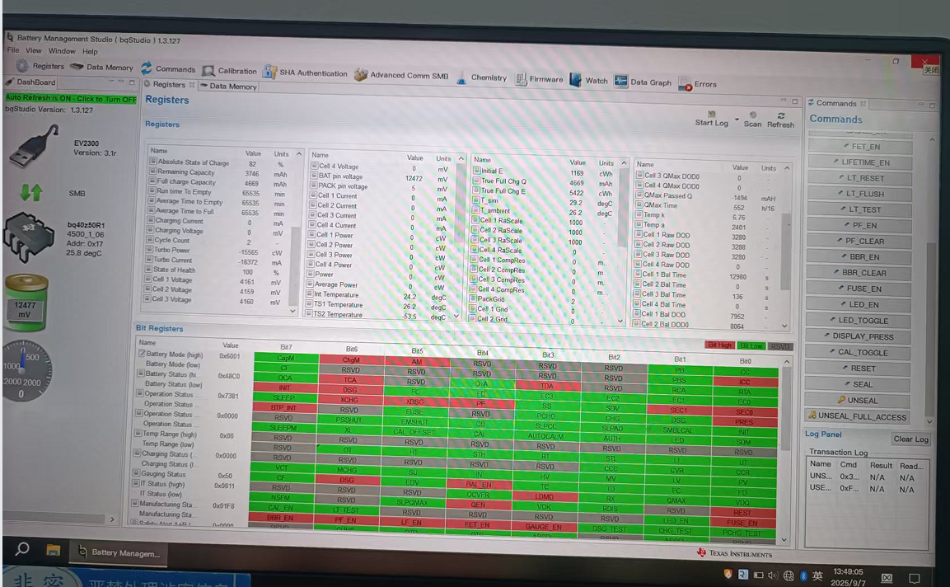

- PF Status B:08, VIMR 置1：显示压差最大为623mV
PF Status B:08, VIMR set to 1: Displays the maximum pressure difference as 623 mV.
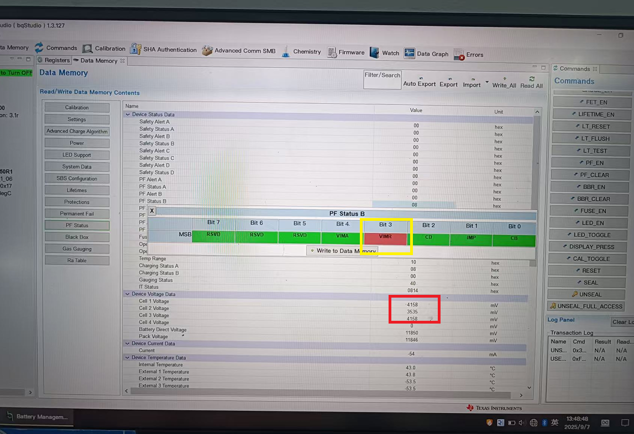

- Lifetimes:最高温度69度，最大放电电流8709mA:
Lifetimes: Maximum temperature 69 degrees, Maximum discharge current 8709 mA：
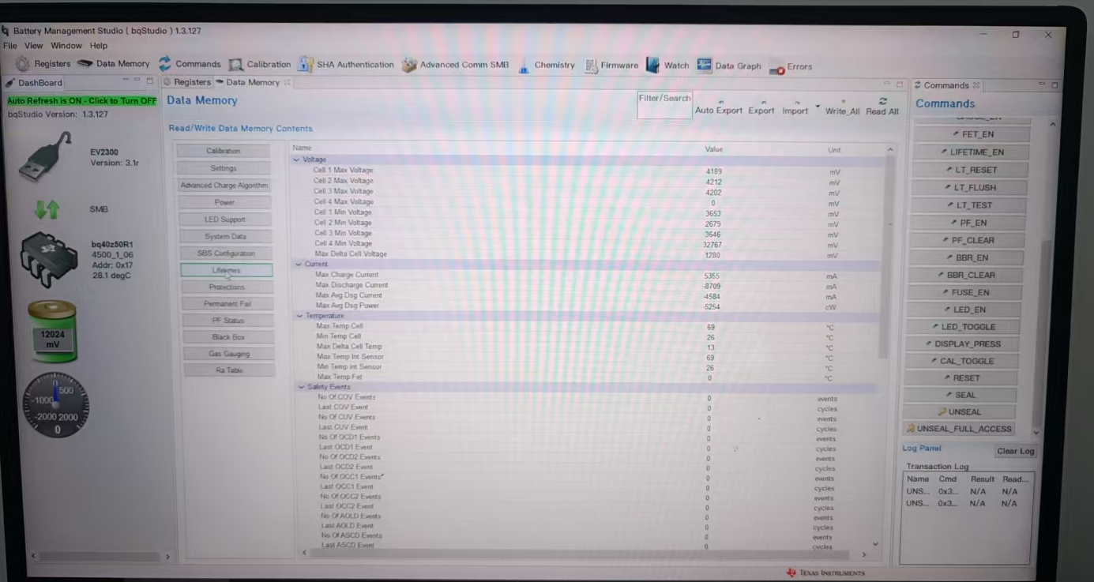

4、Permanent Fail: VIMR 500mV 20s:
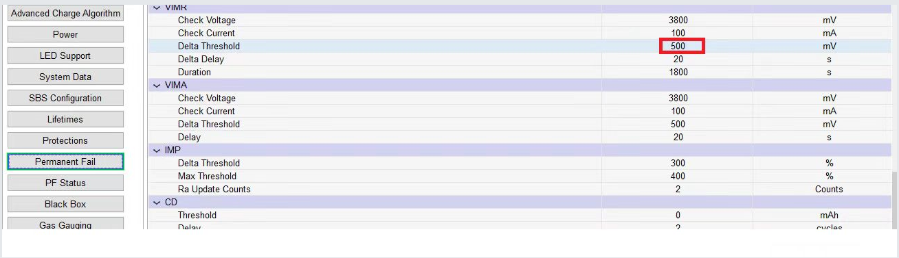

5、电路图：circuit diagram：
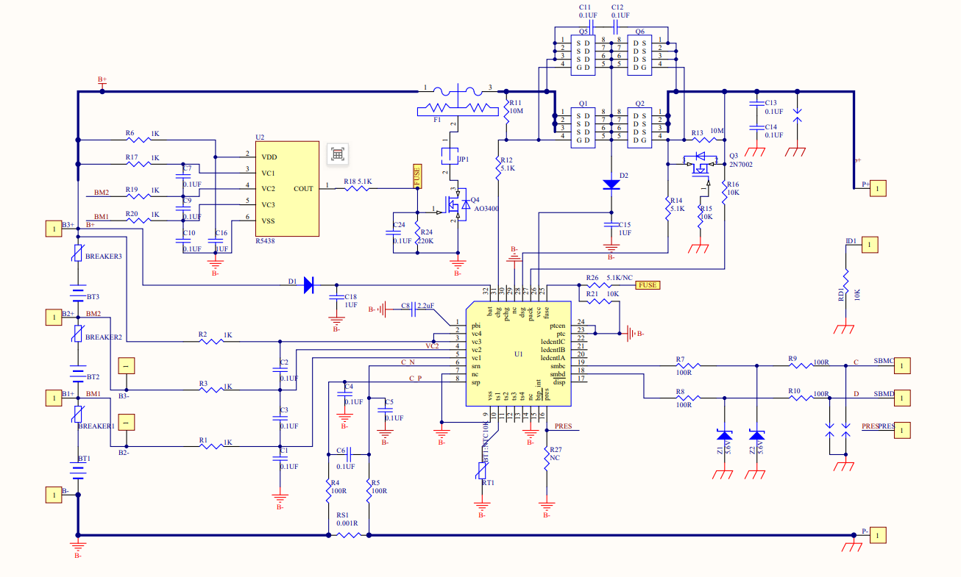

- BREAKER 规格:NR77AB0 触发温度：77±5℃
BREAKER specification: NR77AB0 Trigger temperature: 77 ± 5℃
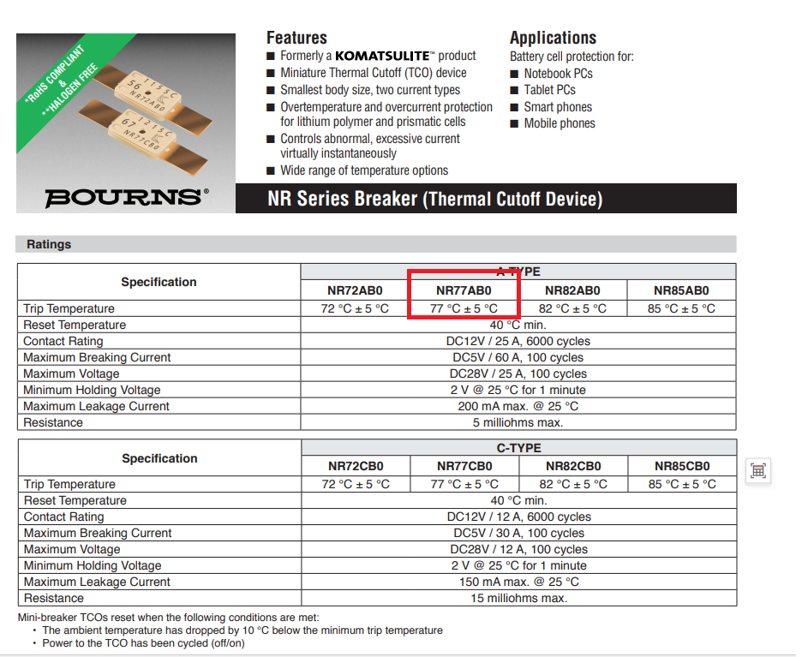

- 实际测量电芯电压：电芯之间压差 2mV
Actual measurement of cell voltage: Voltage difference between cells is 2 mV:
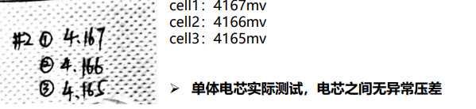

- 疑问：Question:
为什么会触发VIMR？记录有显示超过500mV的压差，但实际通讯读取每节电芯电压，显示压差只有2mV。
Why was VIMR triggered? The record shows a pressure difference of over 500mV, but when the actual communication reads the voltage of each cell, it shows that the pressure difference is only 2mV。

