Customer was use BQ76930 management IC to control 9-serial battery

Customer schematic



Found the VGS voltage shown as following

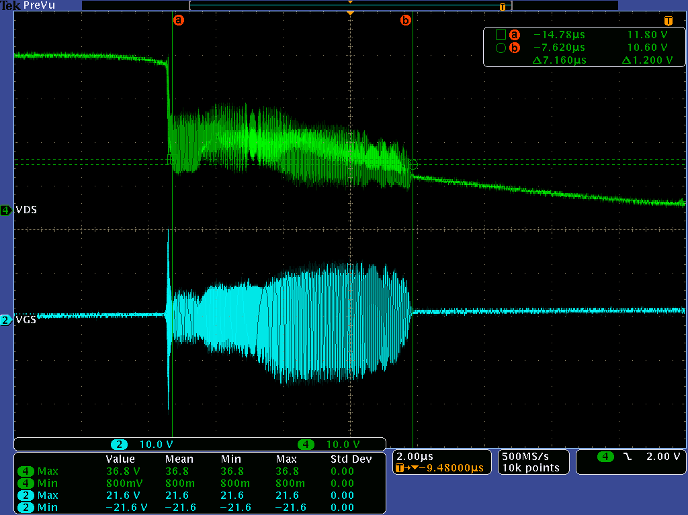

Than we add a serial Bead for each CSD18542

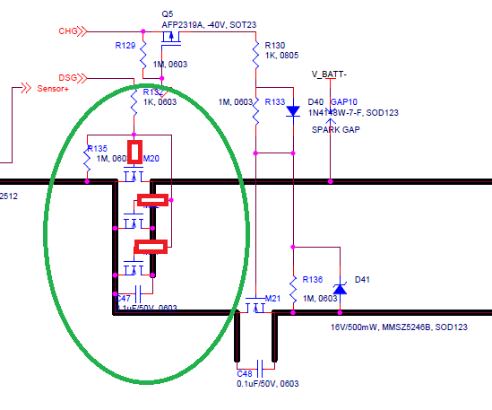

It turns out VGS become

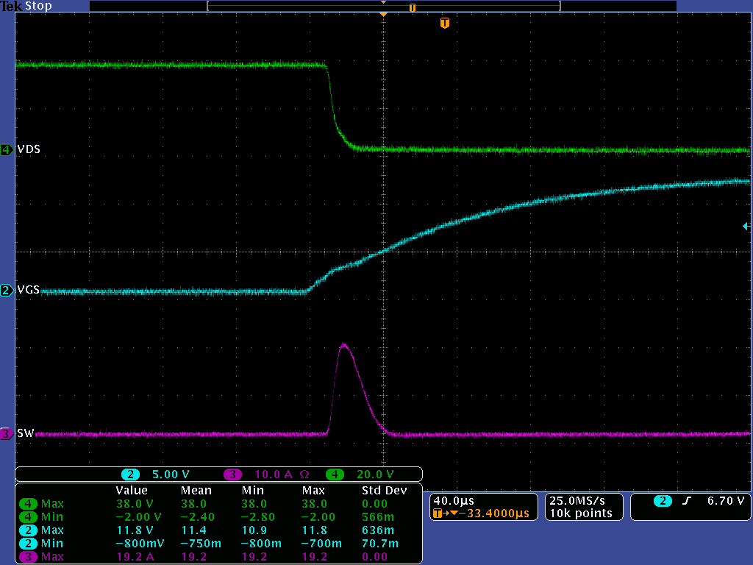

From reference design, we found the 220 ohm resistance from gate of each MOSFET

