- Is the FET_EN bit set?
Andrew: the FET_EN is not set as default

- Can you send a oscilloscope capture of the SRP and SRN with both the differential voltage across the pins as well as the voltage of SRP relative to VSS and SRN relative to VSS.
Andrew:SCD there is a pulse at SRN &SRP if no capacitor coupled to SRN/SRP and the SCD bit could not be set:
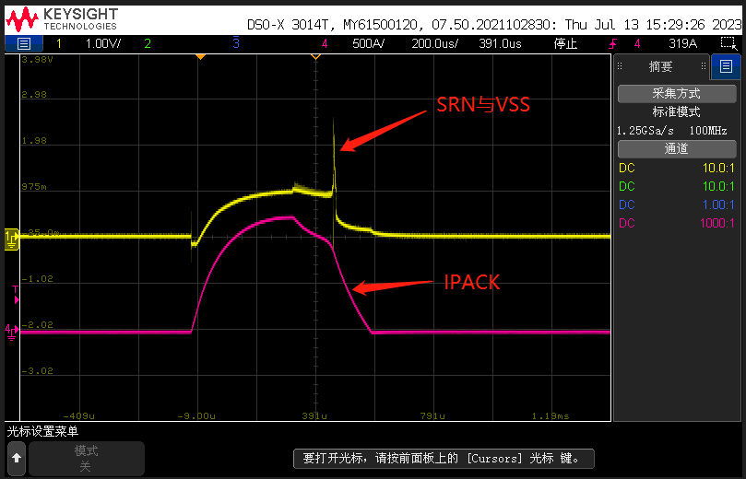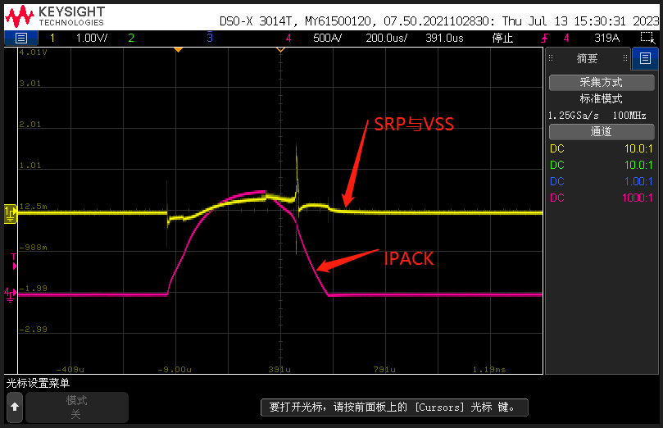
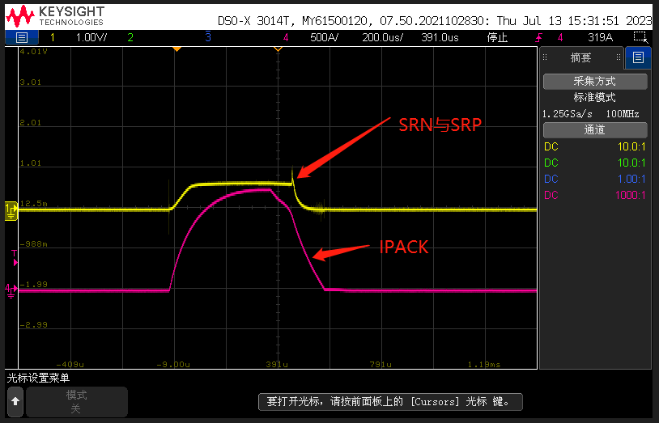
- I noticed you don't have filter caps to VSS on SRP and SRN. It is generally recommended to have a capacitor (~.1uF) between each pin and VSS. I'd suggest adding those and seeing if that helps with performance. I've attached an example below:

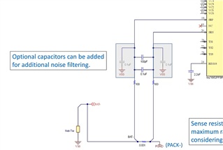
Andrew: if add 0.1uF capacitor to SRN/SRP, the pulse will be removed and the SCD alert bit may be triggered correctly :
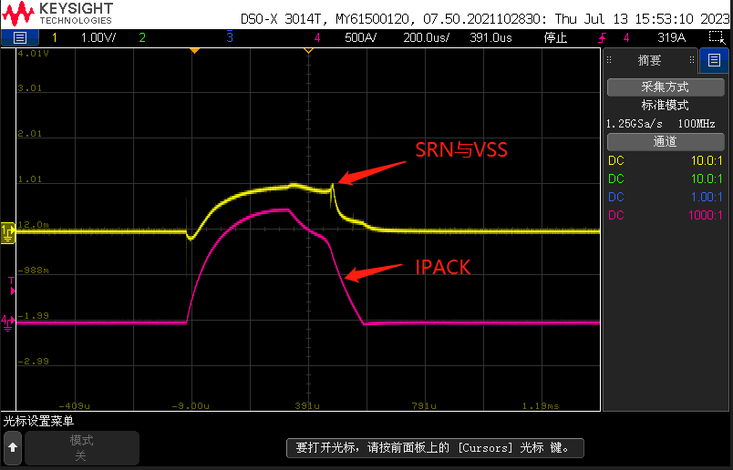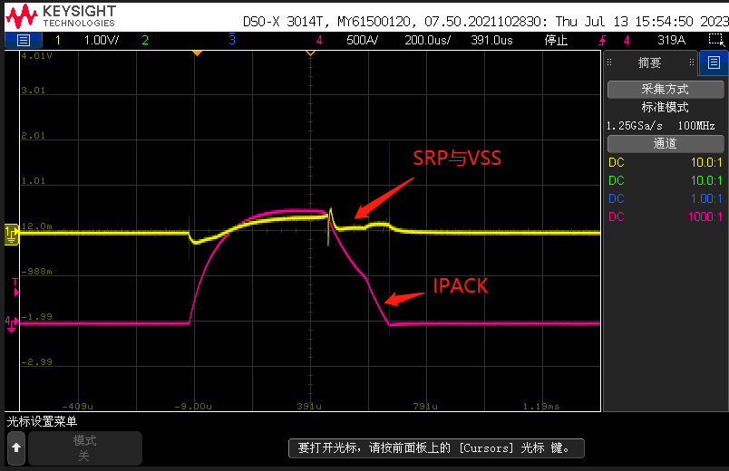
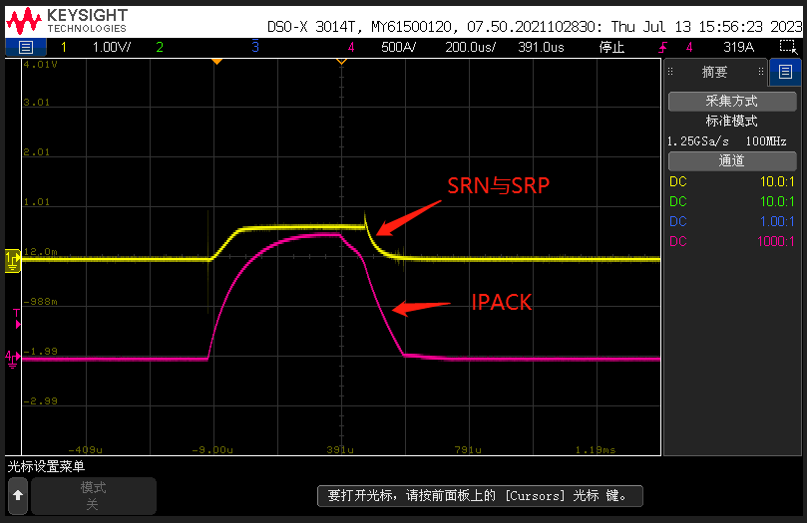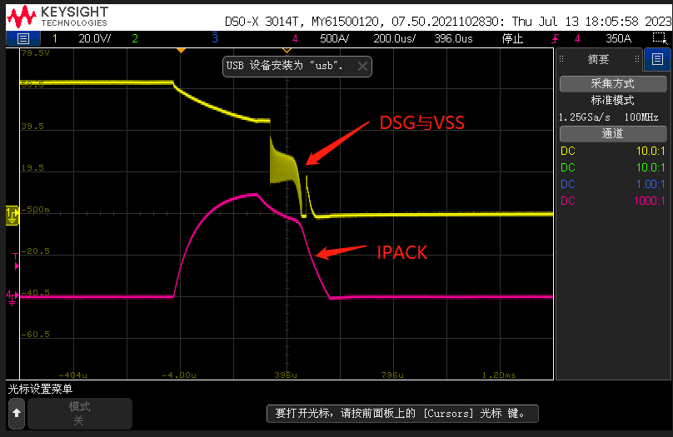
- You mentioned you use an MCU. Does it immediately try to write to the device once the device is powered up? If it doesn't, you could try reading the POR bit in the 0x12 Battery Status() register to see if a full reset has occurred since the last exit from CONFIG_UPDATE. I've attached a brief description of what POR does from the datasheet.
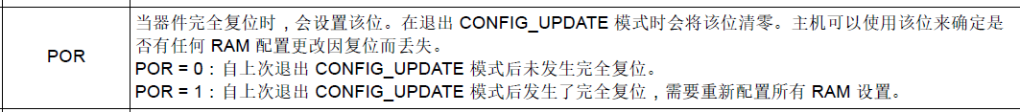
Andrew: the POR is not set.

4. How negative is Vgs (and the DSG pin) going? The pin is rated for -.3V below VSS so that might cause some issues.
Andrew: VDGS may be pulled down to -3V.

