BQ75695202 SCD bit not triggered successfully
when short circuit happened

The customer use BQ7695202 for a 16s11p battery, the charge and discharge ports are separated. The DSG control circuit is as below:
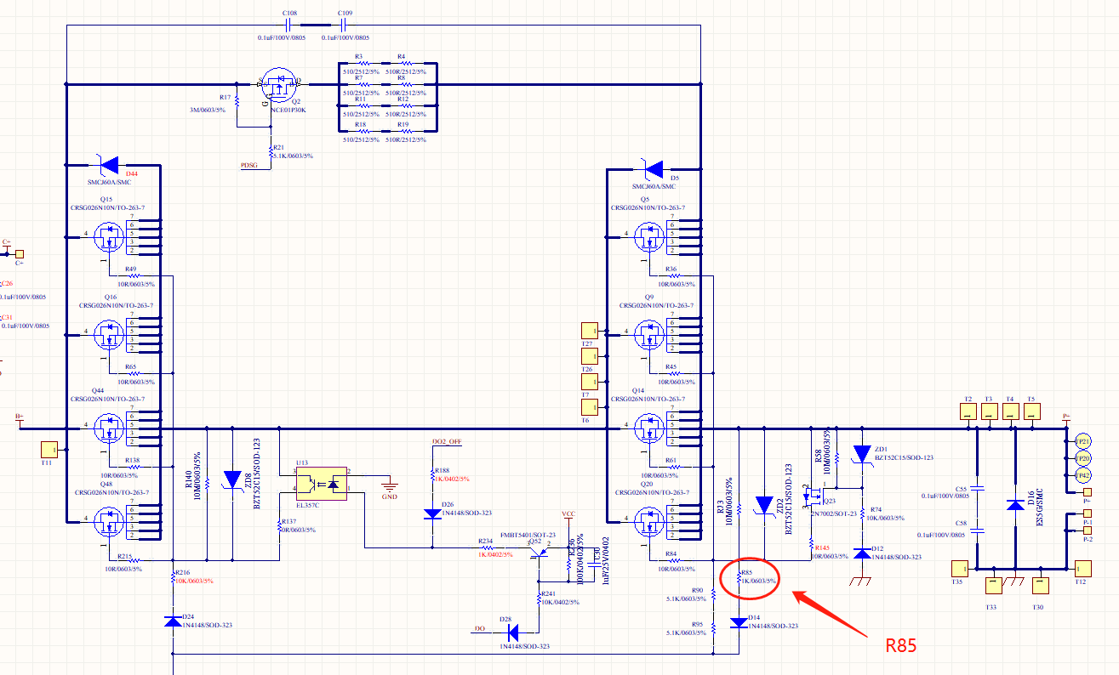
When the customer conducted short circuit test, they found that the protection alert bit SCD will not be triggered mostly (seldomly, it may be triggered):
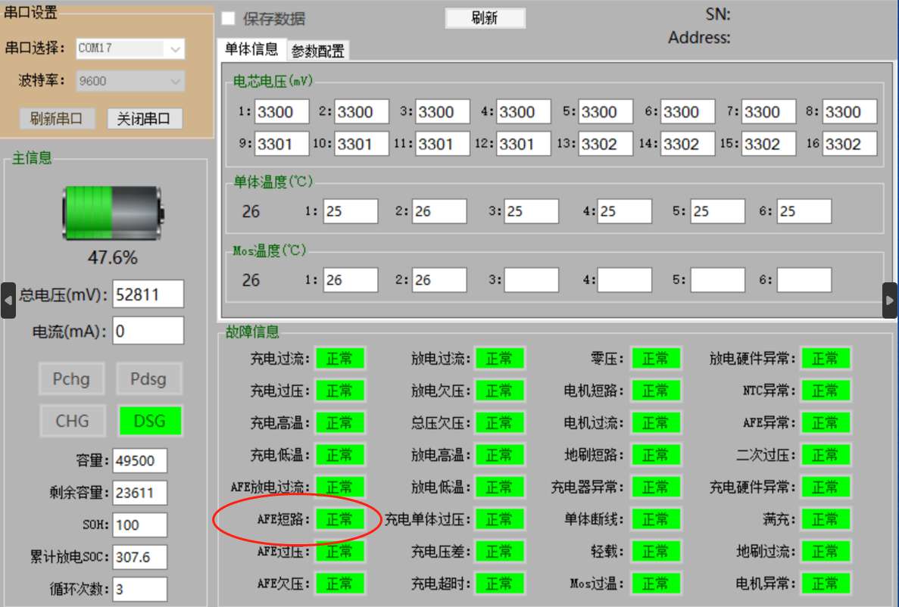
SCD bit is not triggered when short circuit happened

The customer changed R85 to 2K ohm and the SCD bit maybe triggered frequently, but still not stable.
We checked the VDSG, the waveform is as below, there is negative voltage when the SCD not triggered successfully as shown in the blue circle:
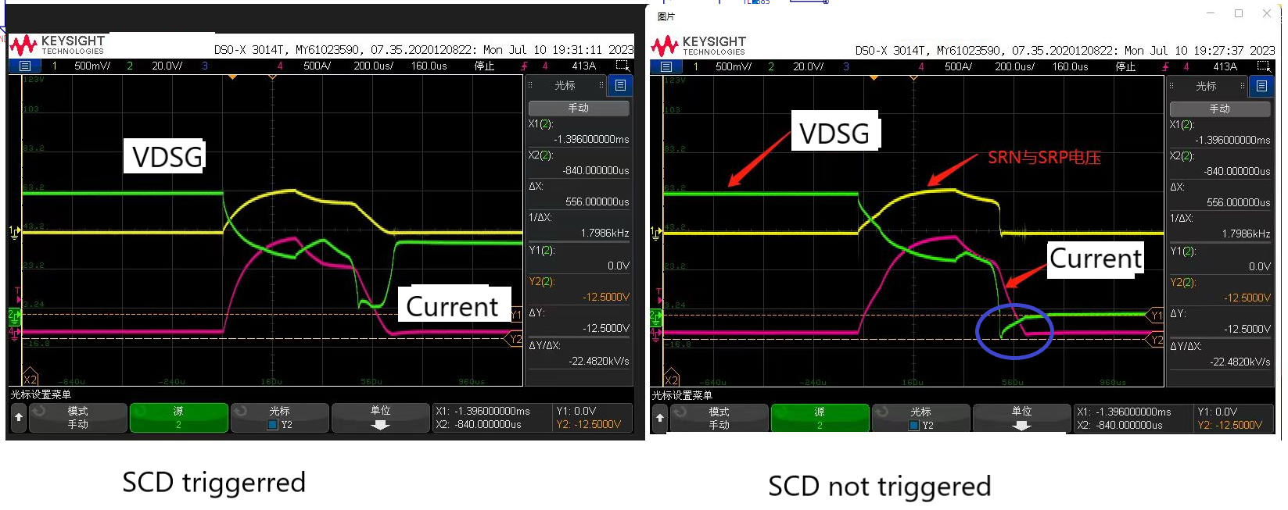

The VGS of the discharge MOS waveform shows the VGS dropped sharply in the case that the SCD not triggered successfully:
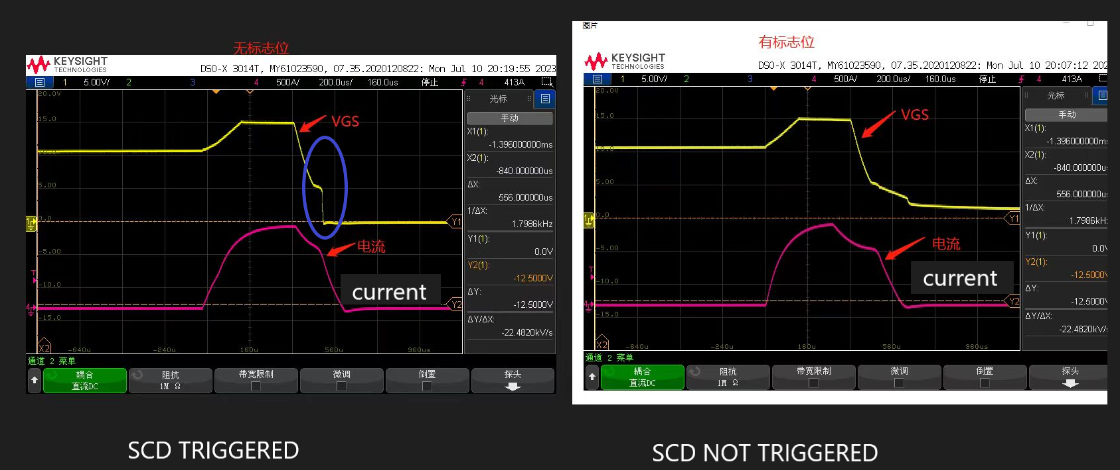

We also checked the other signals such as VBAT/I2C/REGG1/REG18/RST_SHUT as below:
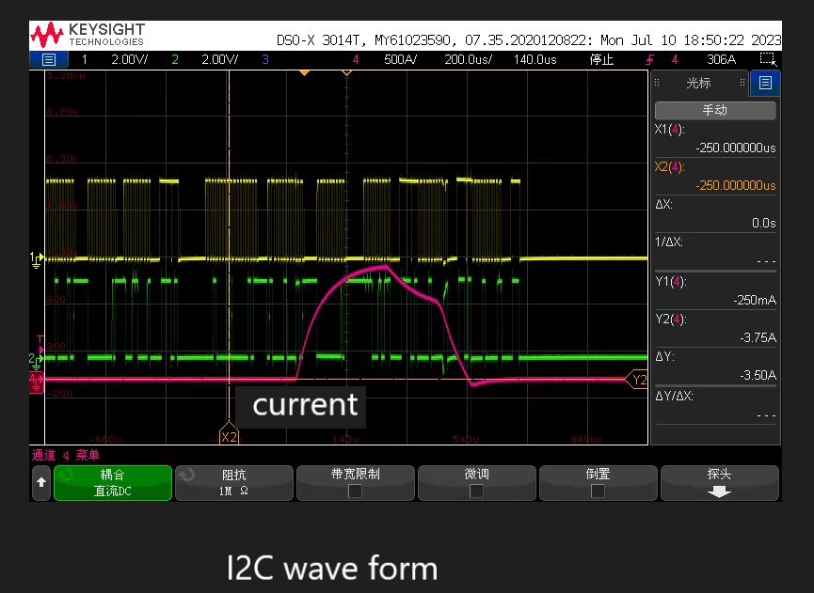

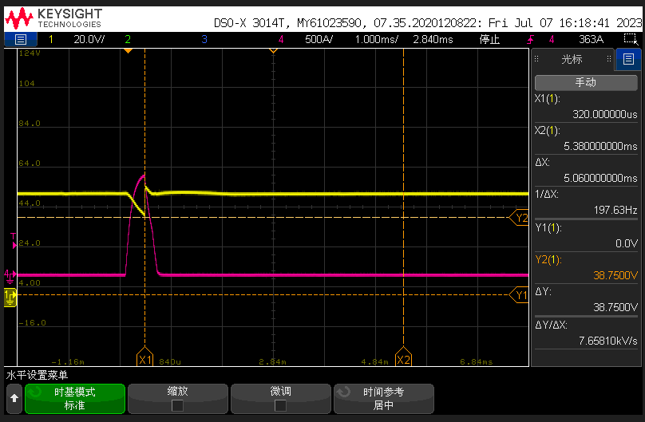
VBAT
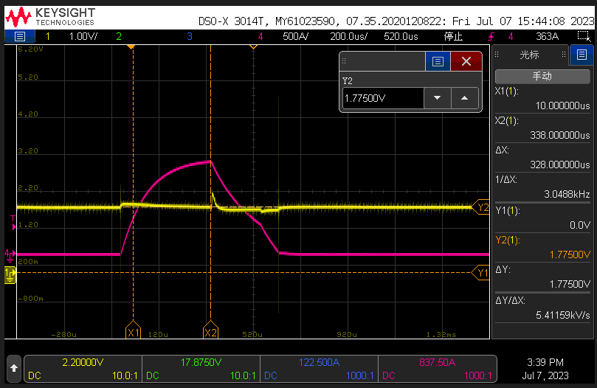
VREG18

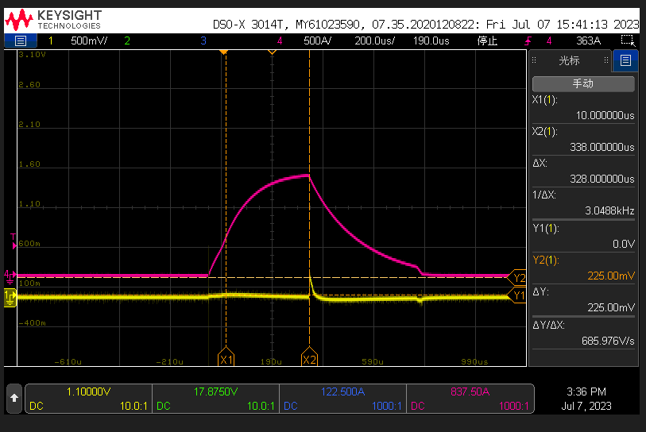
RST_SHUT
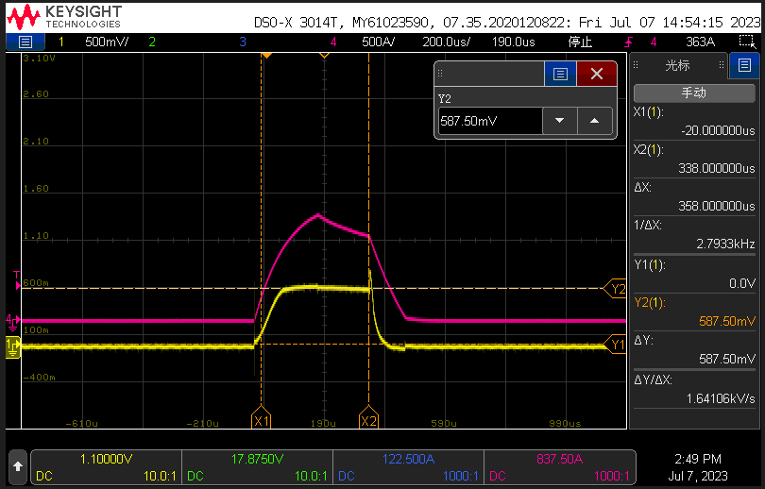
VRSN/ VRSP
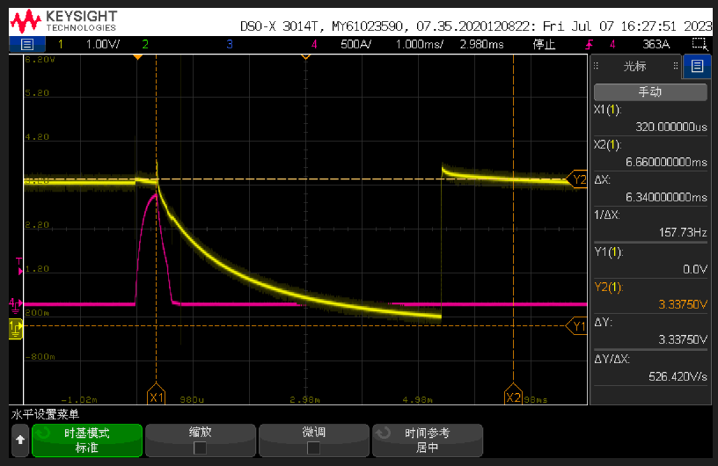
REG1
We found that REG1 will drop slowly after the short circuit conducted but the SCD was not triggered (REG1 is not being employed, there is a 1uF capacitor coupled and the settings of the REG1 are just default value), it seems a shutdown is triggered.

