**BQ769x2 - Collecting Raw ADC Measurements for Temperature**

**(Also includes how to use ADCIN Function on multi-purpose pins)**

1. Set up Config registers for temp sensor pins. For example:
   * Set TS1 Config to 0x07. This sets up an 18k pullup, selects the 18k temperature model, and reports temperature in 0.1K when reading from 0x70.
   * Set CFETOFF Config to 0xB3. This sets CFETOFF pin as a general purpose ADC input for measuring voltage. For this example, apply 1.1V to the pin.
   * Set TS3 Config to 0x2B. This sets the 18k pullup and selects the custom temperature model. It also sets the pin to not be used for temperature protections. 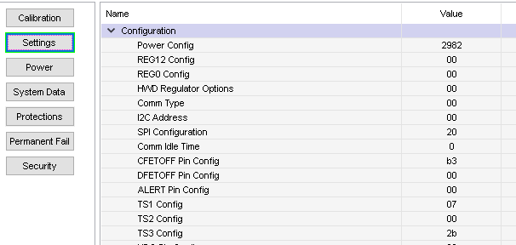
2. Set up the Custom Temperature Model to report raw counts instead of applying a polynomial:
   * a1, a2, a3, a4 = 0
   * a5 = 16384
   * b1, b2, b4 = 0
   * b3 = 32767
   * Rc0, Adc0 = 11703

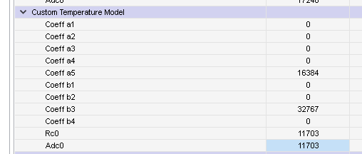

1. Use the Command Sequence Window of BQStudio to read using the Direct commands and DASTATUS6() and DASTATUS7() Subcommands.
   * 0x6A reads the reported CFETOFF Temperature. Since this pin is configured to read ADC voltage, the units are reported in mV. The reading of 0x044E shown in the first line of the log in the image below is 1102 mV (decimal).
   * 0x70 reads the reported TS1 Temperature. This pin is configured to measure temperature and is reported in 0.1K units. 0x0B94 = 2964. (2964/10 – 273.15) = 23.25 degrees C
   * 0x74 reads the reported TS3 Temperature. This pin is configured to measure the raw counts – because the temperature coefficients are set to not use a polynomial. However it is slightly different from the raw counts reported in the DASTATUS registers in that it accounts for the internal pullup variation and pin series resistance. This is the best reading for a user who wants to calculate temperature using the host MCU. In the example below, the reading is 0x2EDA (11994 decimal). The approximate voltage can be calculated as (1.8V * count)/2^15 = 0.6588V.
   * 0x0076 and 0x0077 read the raw ADC counts for each of the pins. In the image below, CFETOFF is reading 0x45CDC8 (4574664 decimal). This corresponds to a voltage of (counts * ADC_Gain)/(2^24) = 1101.86 mV. (The ADC Gain register in the Calibration section is set to 4041 for this device).
   * The value for TS3 read with 0x0077 is 0x1D739C (1930140 decimal). (counts * 1.8V * 1.667) / (2^23) = 0.69V. This corresponds to ~11.2k thermistor resistance, but this measurement does not reflect the variation of the internal pullup resistor or pad resistance.

