Yellow：Vbe
Green：Vec
Power on voltage waveform
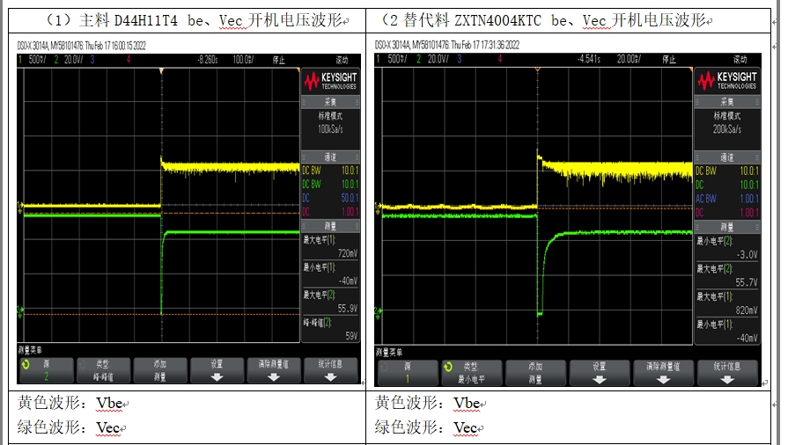
Yellow：Vbe
Left：Vbe max voltage is 0.72V<1.5V, which follows the requirement of DATASHEET
Right：Vbe has drift， sometimes will drop down to -1.5V, Vbe max voltage is 0.82V<0.95V,and the Transistor is not stable.
And this is what they need to solve.
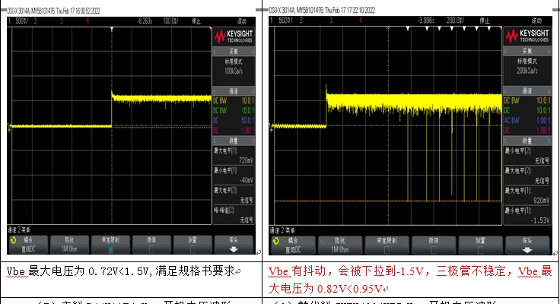
Power down waveform
Both devices are normal
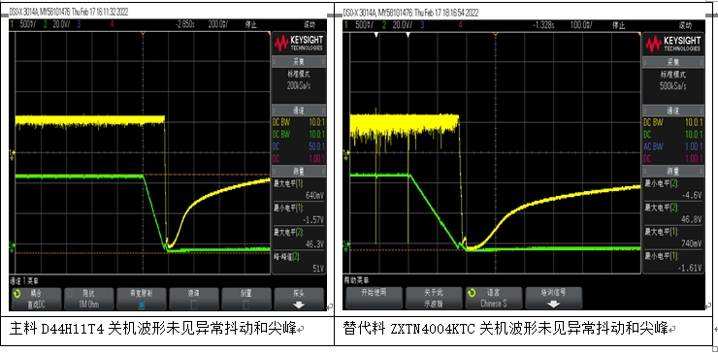
Ripple on Ve- GND, which is also ‘VP’ of LP455. Both follows the datasheet.
Left:14mV
Right:24mV
