**BQ78350 Logic Analyzer Captures of different Commands**

**Reset: 0x0041**

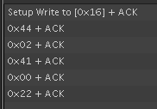

[0x16 0x44 0x02 0x41 0x00 0x22]

[DevAddr MacCmd ByteCount ResetCommand PEC]

**SpecInfo: 0x1A**

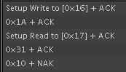

With PEC

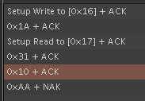

**FET_EN: 0x0022**

