Board Failures

Failure One  
  
Board was running at 1.5A. I put meter probe on 28VDC input and the board failed

Failure Two

Board was running at ~800mA. Board failed. I turned up the amperage to see what would happen and the magic smoke came from the IC.  
  
Failure Three

Ran test at 180mA for ten minutes. No issues at all.  
  
Started test at 500mA. No issues initially. 5 minutes into test, power output failed. So far into the test, the test data showed no issues at all. At the time, I was a few feet away from desk. Current into the board rose to 2.8A which was the power supply current limit. Board outputted no voltage or current and thus, no current to load. Regulator temp rose to 35C and board temp 36C before pulling power. Right at point of failure, exactly one I2C sample was lost.

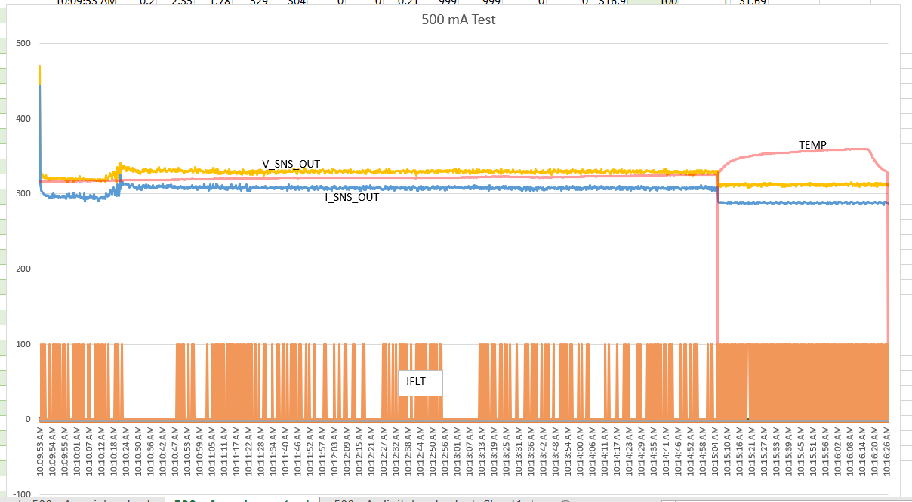

Looking that the data, the failure happened at 5 minutes into the test. At that point, there is a single loss of a temperature data point, a loss of current and voltage, and a rising temperature. The !FLT pin was sampled at the anode of the FLT error LED which was got a great place for it as the Arduino picked up tons of noise.  
  
  
During all three failures, there was a failure of the regulator IC with an internal short

Failure 4:

Was running board 5 for power efficiency test. Was running with 34V in at 1.85 amps and 12V out at 5.1 amps out. Looking at the SW node, there was some ringing on the positive and negative slopes of the square wave is some voltages on the low side going negative. Curtis thinks that was due to ground loops in measurement though. During the test, I toggled the connection to the load a few times to see if there were any issues. There were none. At least 10 minutes into the run, I saw that the thermocouple came loose from the board. Without thinking of the power supply being on, I took the probe and reinserted it under a piece of tape that was above the regulator. I then pressed down to secure the part. When I looked up, the output voltage was zero and the power supply had dipped to ~3v out and 7.8A out. The regulator has shorted internally. Both SW to ground and Vin to ground are shorted. In previous test, the board was tested with diode in series on the output. My memory might fail me but there is a chance that this board was run on the ESC without a diode. One of the wires that was in use filed to 1k ohm.

Possible Failure Causes

* High input voltage
  + What is the max input voltage per DS?
    - 36VDC continuous, 42 VDC transient
  + What happens if the max input voltage is exceeded?
    - Not listed
* Shorting switch node to ground
  + HS FET will fail