Just USB-C Cable Attached – showing CC lines add Rd fixed resistor
TI TPS25751EVM
Vbus=0V , CC-yellow = open Vbus=5V, CC- Yellow = 3V State -Attached.SRC
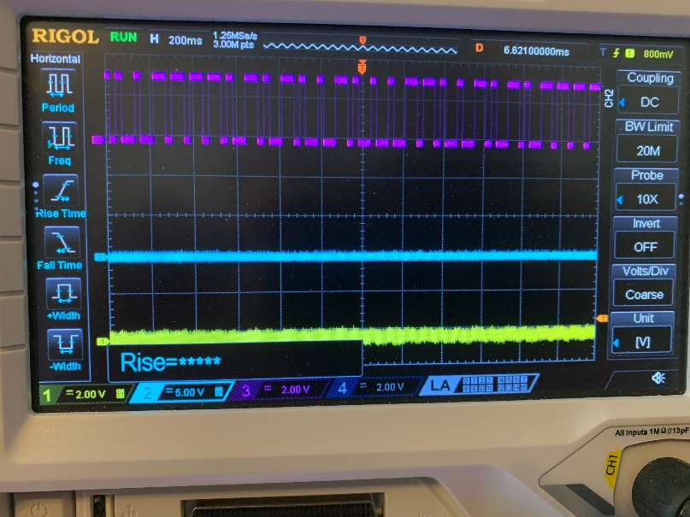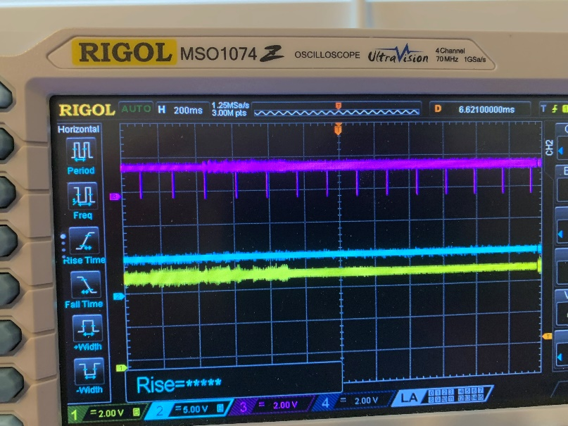
Custom design
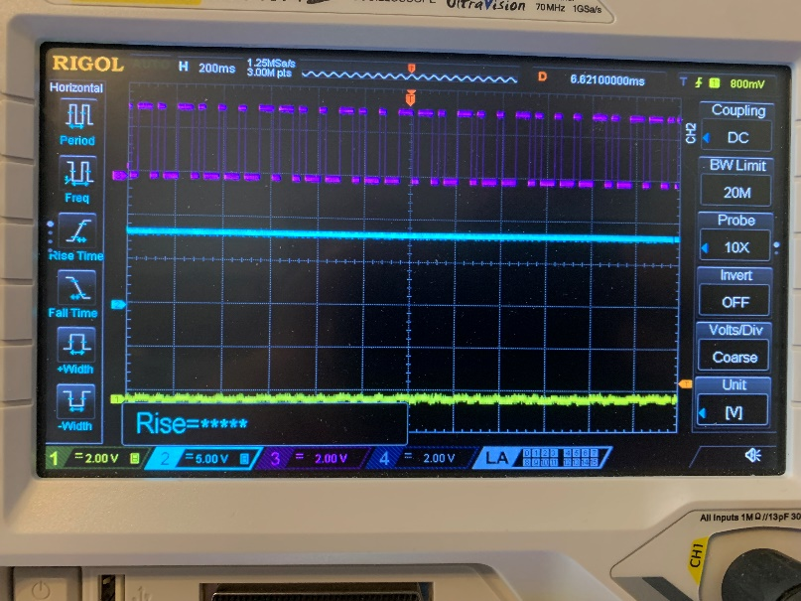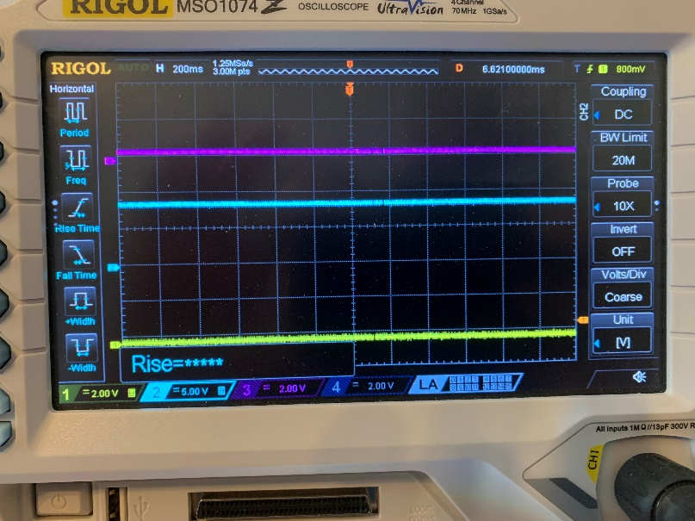
Vbus=9V , CC-yellow = open Vbus=9V, CC- Yellow = open STATE Attach.Wait.Src

