BQ34Z100-R2

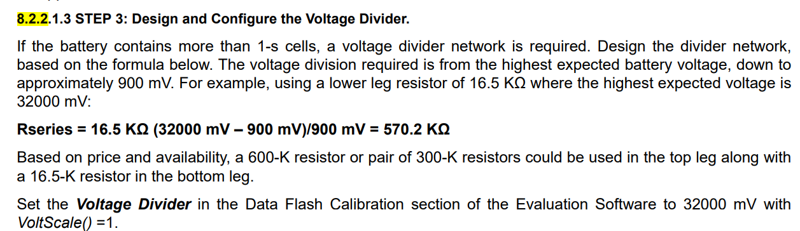

Source: Datasheet Page 15

1. For 900mV is a fixed value/constant for this equation?
2. Or should I use the lowest voltage for 1 cell battery (for my design)?

For example: 2.7V

1. Or should I used lowest voltage for 4 cell battery(Total Pack Voltage for my design)

For example: $2.7V×4=10.8V$