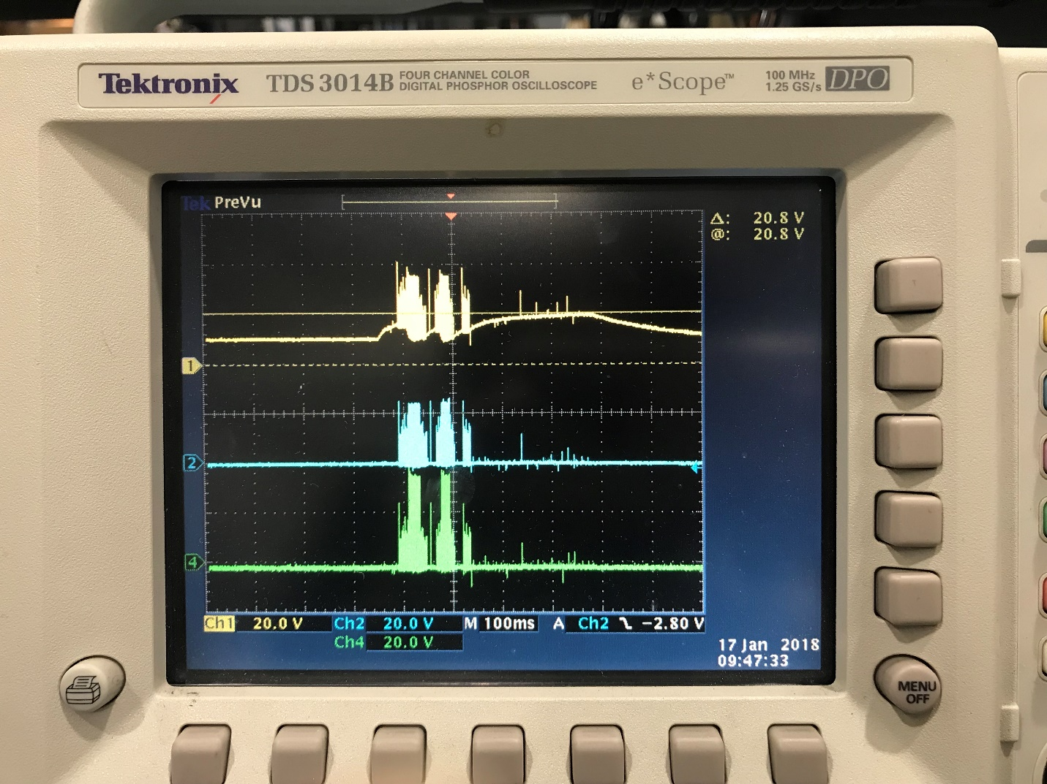

HB-VSS: yellow, HS-VSS: blue, HO-VSS: green