Comment 1:

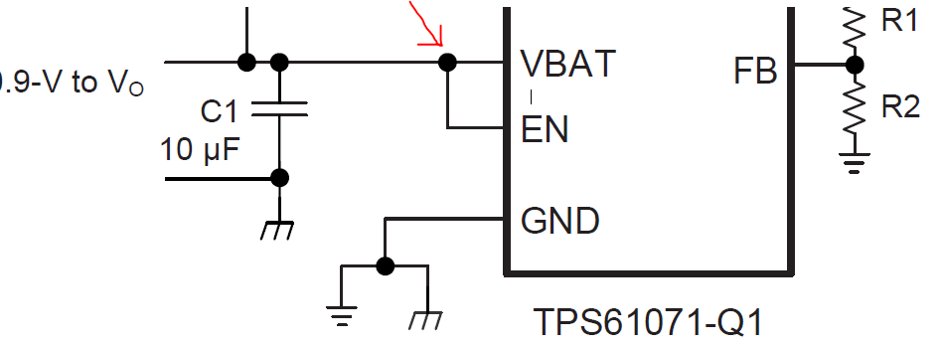

Comment 2:

$I_{L}=\frac{{27}_{mA}{*3.5}_{V}}{{1.9}_{V}*0.9}=55.26mA$, $L=\frac{{1.9}_{V}{*(3.5}_{V}-{1.9}_{V})}{40\%*{55.26}_{mA}*1200{*10}^{3}*{3.5}_{V}}=\frac{{2.66}_{V}}{0.4*55.26*1200*{3.5}_{V}}=33uH$

$C_{OUT}=\frac{{27}_{mA}{*(3.3}_{v}-{1.9}_{v})}{{10}_{mv}*1.2MHz*{3.3}_{v}}=\frac{27{*10}^{-3}*\left(3.3-1.9\right)}{10{*10}^{-3}*1.2{*10}^{6}*3.3}=1.05uF$

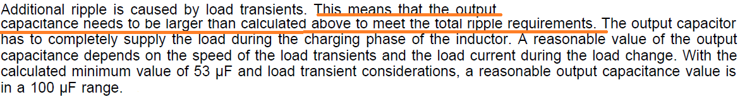

**chosen: 2.2uF**