Continuing my quest to get my NVDC Charger and Gauge Evaluation setup working by following the bq24770EVM-540 User’s Guide, I was able to write “810E” into the Charge Option 0 register. But I could not get any charge current to flow.
I had to digress from the instructions in the guide at section 3.2 step 2. Because I don’t have a Kepco BOP36-12M bipolar operational power supply (or the $5000 to buy one), I hooked up my battery/gauge setup in place of “Load #2.” My battery/gauge setup consists of nine Panasonic NCR18650PF batteries in a 3S-3P configuration, and my gauge is the bq40z50EVM-561. Here is a diagram and a photo of my setup.
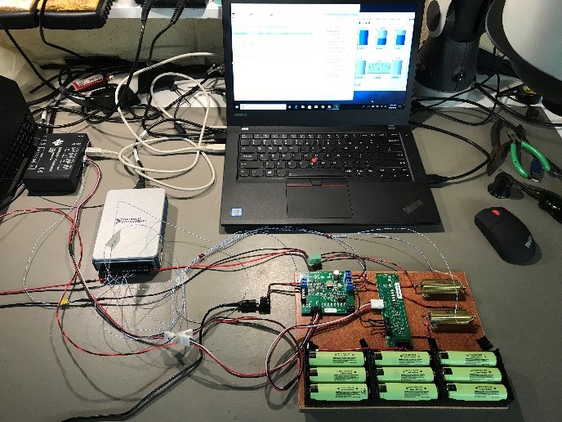

And here is a screenshot of my bqStudio and LabVIEW monitoring program, after writing “3008 mA” to the Charge Current DAC. No charging current is present and the register reads back properly: “0BC0”.
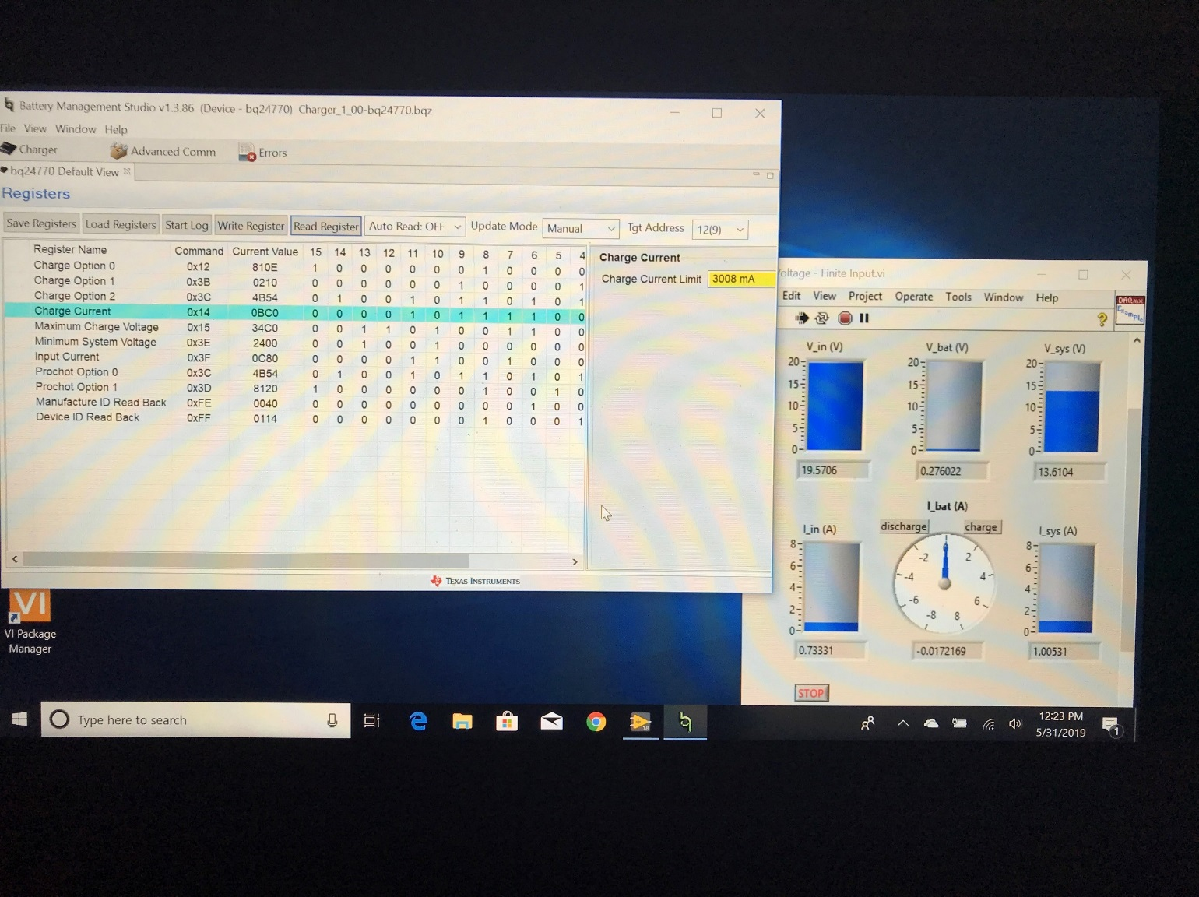

Another thing I noticed: V_BAT at J3 measures 0.28V on the bq24770EVM-540 but the actual battery voltage from 1N to 3P of the bq40z50EVM-561 measures 10.54V.

I Installed bqStudio v1.3.86_Build3 and yes, it works for both of my EVMs. However, if the bq40z50EVM-561 is plugged into the SMBus, along with the bq24770EVM-540, the bqStudio automatically loads the gauge (bq40z50-r2) and related screens. To interact with the bq24770EVM-540 charger, I have to unplug the bq40z50EVM-561 from the SMBus and restart the bqStudio. The bqStudio then offers the selection of gauges, chargers, etc. From there I can select the bq24770.

I see now how to enable the “Write Registers” button from the bqStudio bq24770 dashboard, by selecting “Manual” instead of “Immediate” from the Update Mode pull-down menu. I also see how to write to the registers directly from the dashboard.

I can’t get the batteries to charge by trying to mimic the User’s Guide instructions with my setup. Also, I can’t get the batteries to discharge by disconnecting PS1 from Vin of the bq24770EVM-540. I do have the SYS PRES signal jumpered to PACK- on the bq40z50EVM-561.

