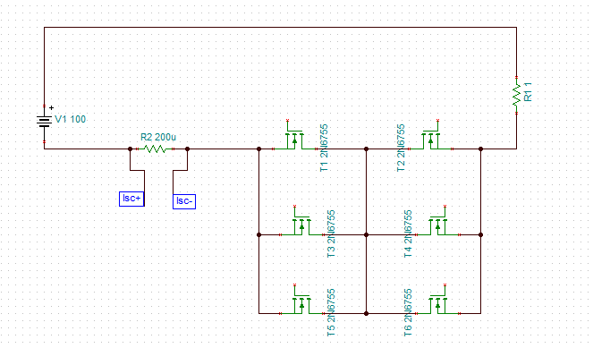

Current Sensor requirement:

1. Upto 400A bidirectional current sensing
2. Nominal current is ±100A continuous charge and or discharge
3. In case of short circuit (~400A), MOSFET should be turn off immediately ( < few uSeconds)

