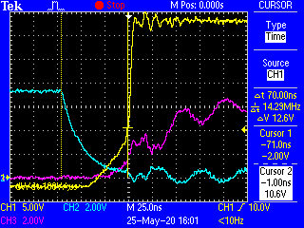

5Ohm Gate drive, all resistors on buck stage. 1A load.

Yellow = Vds, Lower Buck FET

Blue = Vgs, Lower Buck FET

Pink = Vgs, Upper Buck FET

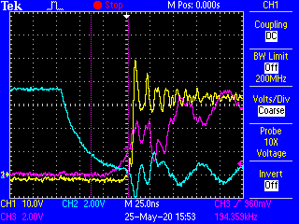

5Ohm Gate drive, all resistors on buck stage. 17A load.

Yellow = Vds, Lower Buck FET

Blue = Vgs, Lower Buck FET

Pink = Vgs, Upper Buck FET