**Design of voltage regulator circuit, based on TI/LM2743 voltage controller**

Tuvia Liran; Rev. 1.; 14-May-2020

## Purpose and scope

For cost reduction of Ramon Space’s systems for space applications, we are considering using automotive grade devices, and hardening them for space by system design techniques.

## Reference documents

1. LM2743 datasheet - <http://www.ti.com/lit/ds/symlink/lm2743.pdf?HQS=TI-null-null-mousermode-df-pf-null-wwe&ts=1589436802878>
2. FDS6898 datasheet - <https://www.mouser.com/datasheet/2/149/FDS6898A-1008367.pdf>
3. Zener diode datasheet - <https://www.mouser.co.il/datasheet/2/308/BZX84C2V4LT1-D-1802533.pdf>

## Technical requirements

* VIN: 4.5÷9V
* VOUT: 1.0÷1.8V
* Current load: <4A
* Temperature: -40÷125C
* Features:
  + Power-good flag and shutdown
  + Output overvoltage and undervoltage detection
  + Low-side adjustable current sensing
  + Adjustable soft start

## Reference schematics [1]

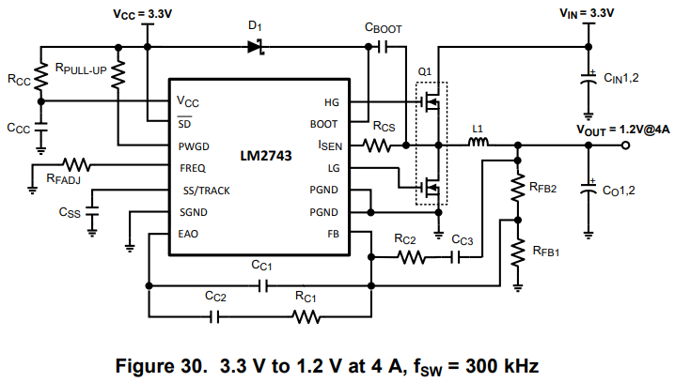

## Proposed schematics

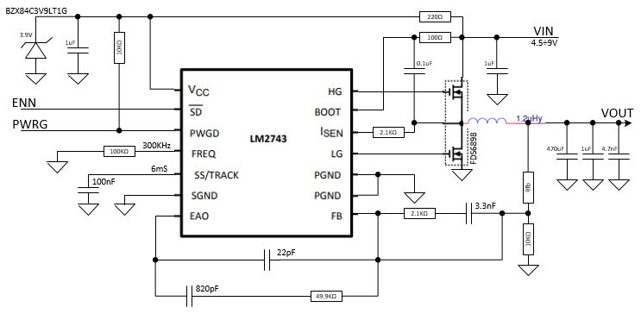

## Tuning of output voltage