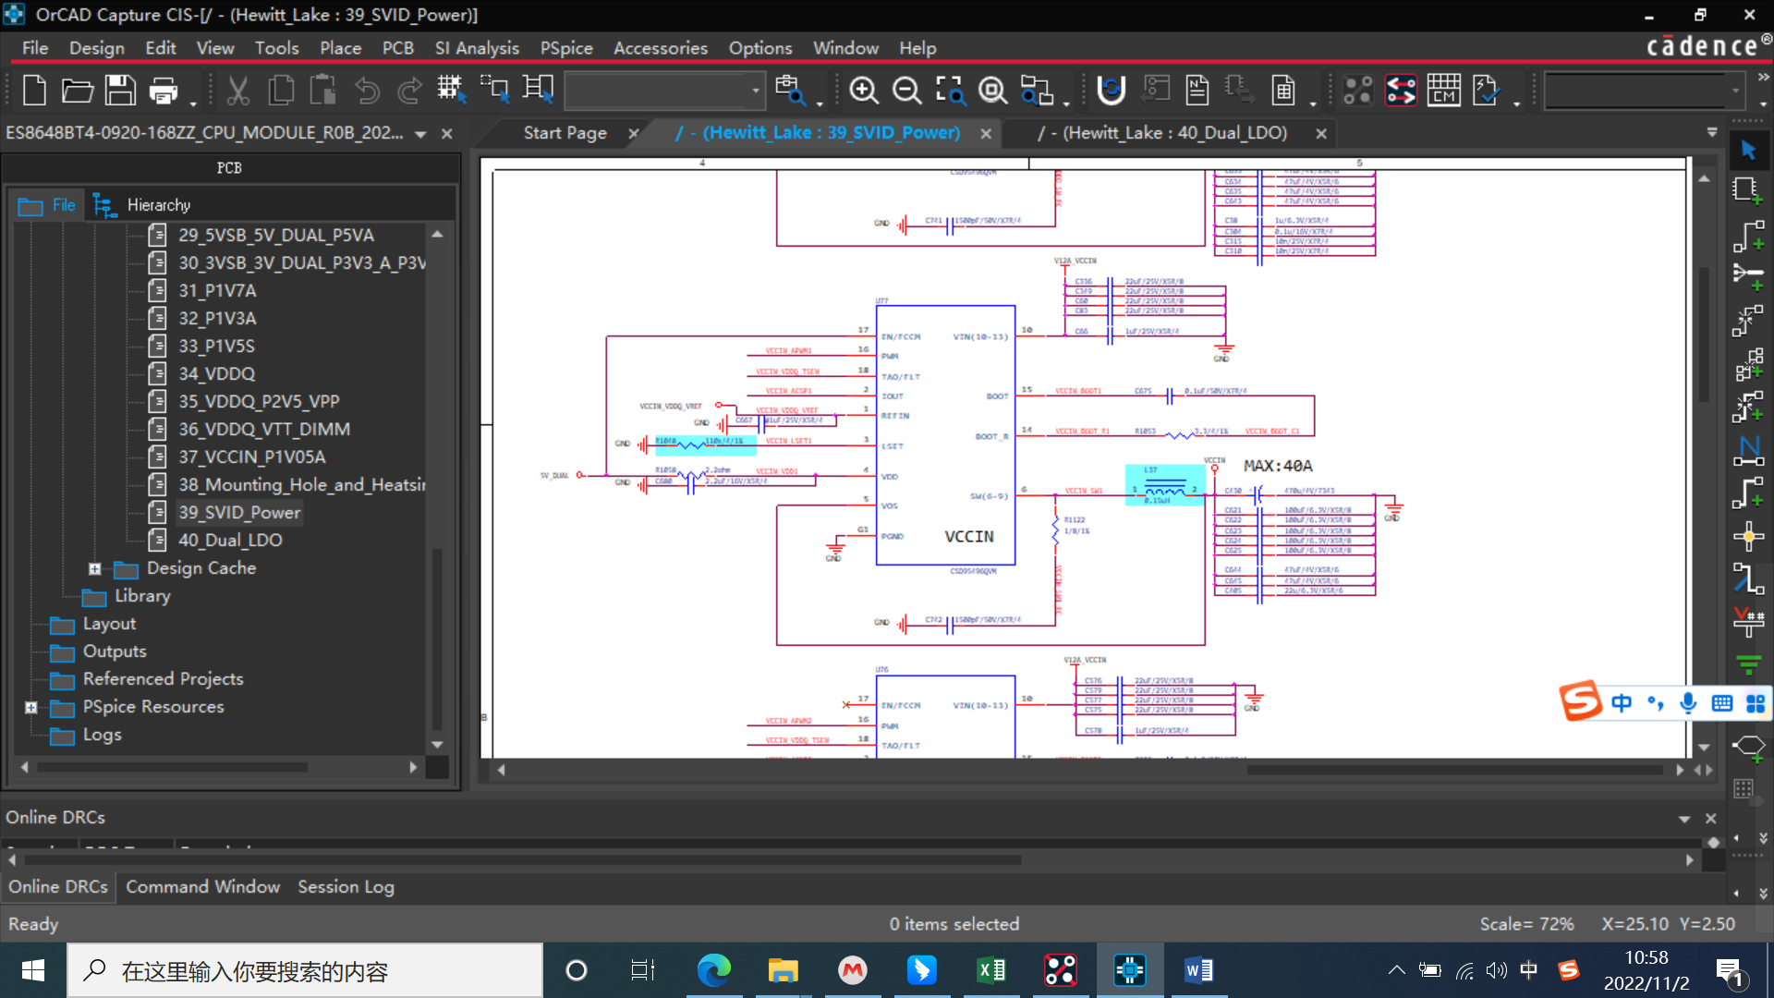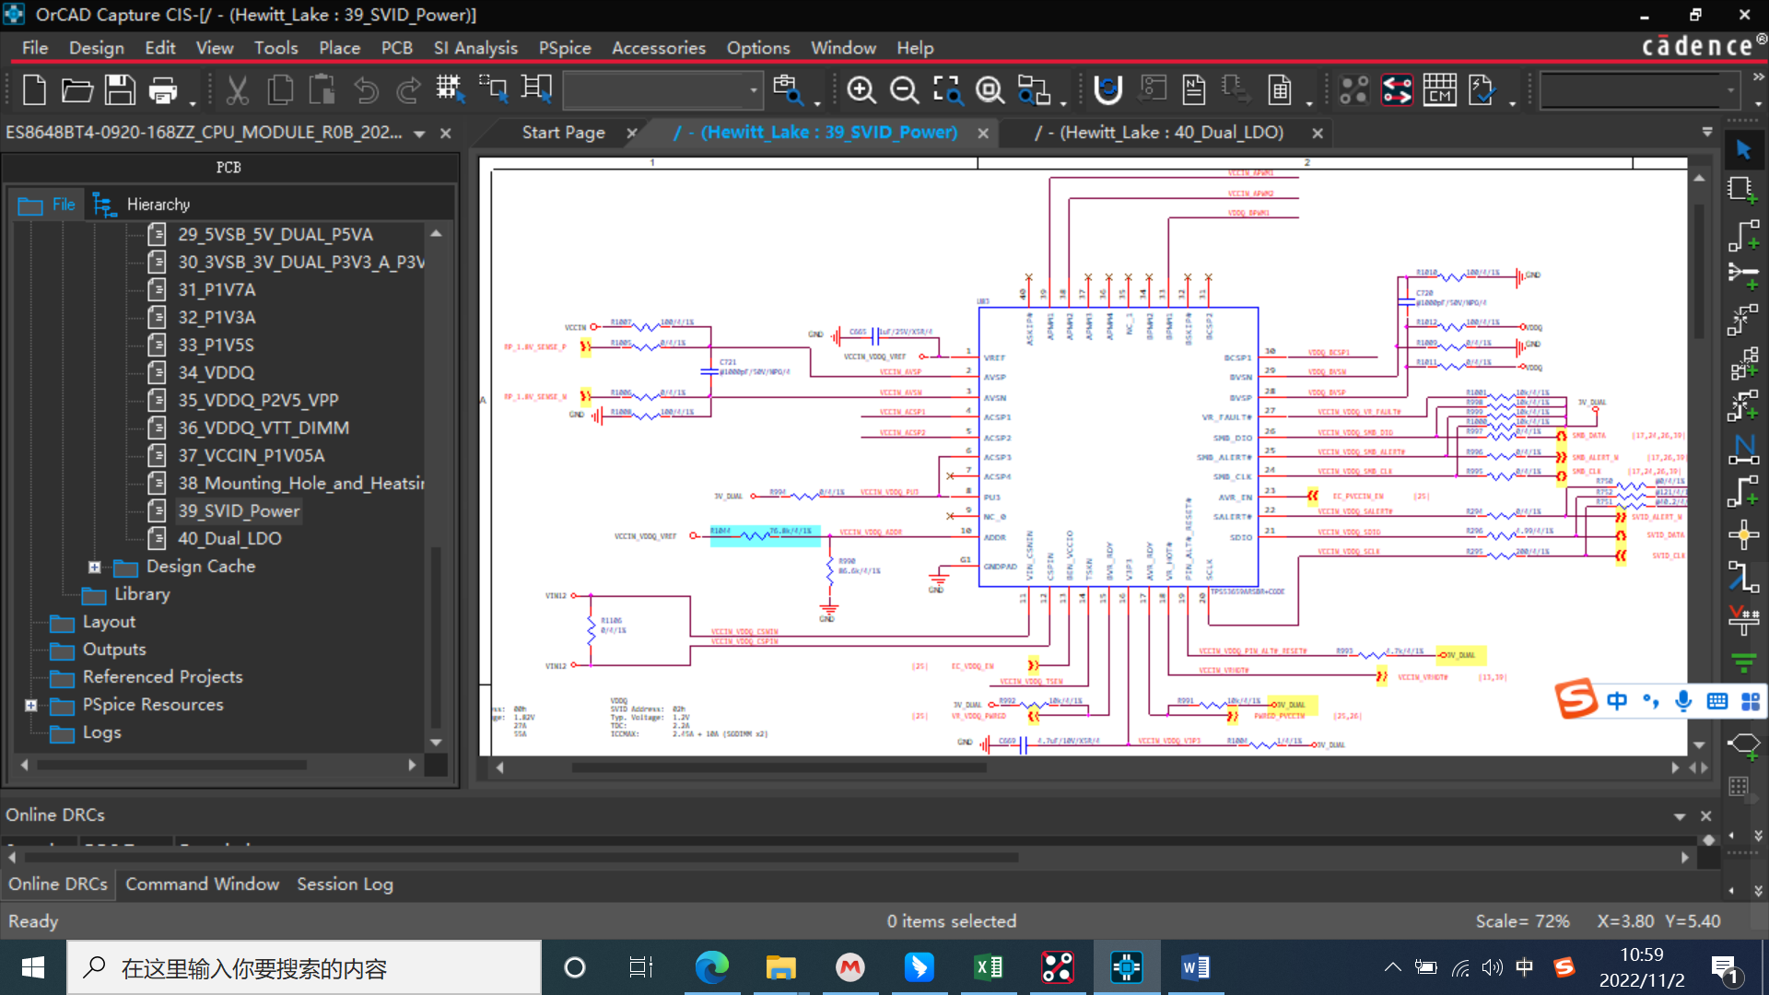

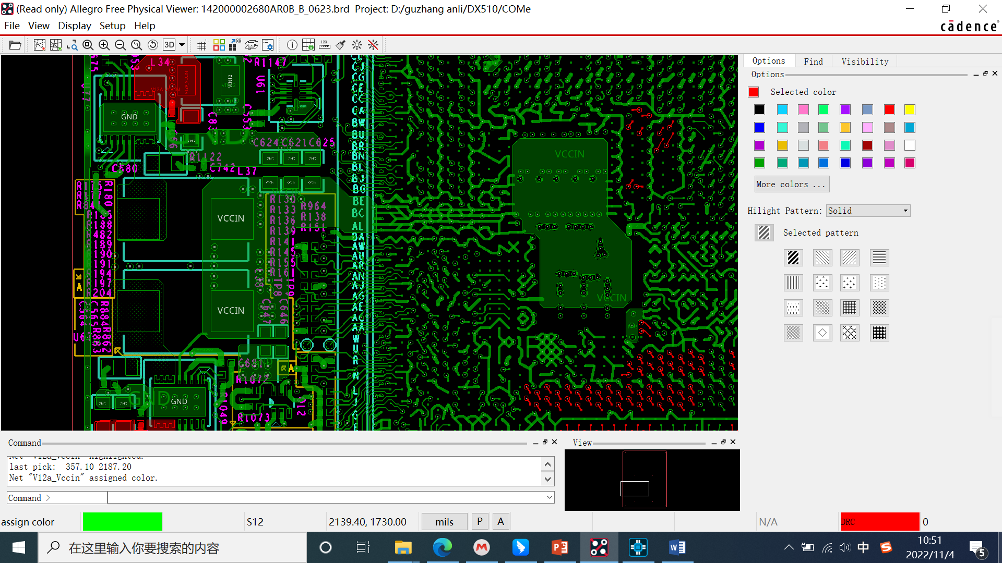

试验验证过程：

1、Drmos电流应力测试

25℃，CPU电流最大31.6A，开机冲击电流16A。

55℃，Drmos 71℃，CPU正常工作加压时电流最大32A，开机冲击电流18.6A。

Test verification process:

1. Drmos current stress test

25°C, the maximum CPU current is 31.6A, and the power-on inrush current is 16A.

55°C, Drmos 71°C, the maximum current of the CPU is 32A when the CPU is working normally and the current is 18.6A.

|  |  |
| --- | --- |
|  |  |
| CPU开机冲击电流 | CPU瞬时电流 |

VCCIN(1.8V)输出短路（直接在DX510设备上用短线短接），电源输出掉电锁死，设备重新上电，输出恢复正常。短路电路约44A。

The output of VCCIN (1.8V) is short-circuited (short-circuited directly on the DX510 device), the power output is locked when power off, the device is powered on again, and the output returns to normal. The short circuit is about 44A.

|  |  |
| --- | --- |
|  |  |
| VCCIN(1.8V)输出短路 | VCCIN(1.8V)输出短路 |

VCCIN(1.8V)输出带电子负载，过流（约35A）会保护，锁死，设备重新上电，输出恢复正常。

VCCIN (1.8V) output with electronic load, over-current (about 35A) will be protected, locked, the device will be powered on again, and the output will return to normal.

2、Vds电压应力测试 (Vds voltage stress test)

|  |  |
| --- | --- |
|  |  |
| VCCIN HS OCP(1Phase) | VCCIN HS OCP(1Phase) |
|  |  |
| VCCIN HS SHORT(1Phase) | VCCIN HS SHORT(1Phase) |
|  |  |
| VCCIN HS NORMAL(1Phase) |  |
|  |  |
| VCCIN HS NORMAL+20A(1Phase) | VCCIN HS NORMAL+20A(1Phase) |
|  |  |
| VCCIN HS CPU PRESSURE(1Phase) |  |
|  |  |
| VCCIN HS CPU PRESSURE+5~10A(1Phase) | VCCIN HS CPU PRESSURE+5~10A(1Phase) |
|  |  |
| VCCIN HS CPU PRESSURE+10A(1Phase) |  |
|  |  |
| VCCIN LS SHORT(1Phase) |  |
|  |  |
| 将预留的2相启用，分别测试两相Vds  Enable the reserved 2 phases and test the Vds of the two phases respectively |  |
|  |  |
| VCCIN HS NORMAL(phase1/2Phase) | VCCIN HS NORMAL(phase2/2Phase) |
|  |  |
| VCCIN HS NORMAL+30A(phase1/2Phase) | VCCIN HS NORMAL+30A(phase2/2Phase) |
|  |  |
| VCCIN HS SHORT(phase1/2Phase) | VCCIN HS SHORT(phase2/2Phase) |
|  |  |
| VCCIN HS SHORT(phase1/2Phase) | VCCIN HS SHORT(phase2/2Phase) |
|  |  |
| VCCIN LS NORMAL(phase1/2Phase) | VCCIN LS NORMAL(phase2/2Phase) |
|  |  |
| VCCIN LS NORMAL+30A(phase1/2Phase) | VCCIN LS NORMAL+30A(phase2/2Phase) |
|  |  |
| VCCIN LS SHORT(phase1/2Phase) | VCCIN LS SHORT(phase2/2Phase) |
|  |  |
| VCCIN LS SHORT(phase1/2Phase) | VCCIN LS SHORT(phase2/2Phase) |
|  |  |
| 对比未损坏的其他路电源：  Compare with other undamaged power: |  |
|  |  |
| 1V05 LS | 1V05 HS |
|  |  |
| SUS LS | SUS HS |
|  |  |
| VDDQ LS | VDDQ HS |

|  |  |
| --- | --- |
| 以下去除Drmos输入端1个0402电容（1uF）  Remove one 0402 capacitor (1uF) from the Drmos input | 以下去除Drmos输入端1个0402电容（1uF）+1个0805电容（22uF）  .Remove 1 0402 capacitor (1uF) + 1 0805 capacitor (22uF) at the input of Drmos |
|  |  |
| VCCIN HS NORMAL(1Phase) | VCCIN HS NORMAL(1Phase) |
|  |  |
| VCCIN HS SHORT(1Phase) | VCCIN HS NORMAL+30A(1Phase) |
|  |  |
| VCCIN HS NORMAL+30A(1Phase) | VCCIN HS SHORT(1Phase) |
|  |  |
| VCCIN HS NORMAL+30A(1Phase) | VCCIN HS SHORT(1Phase) |
|  |  |
| VCCIN LS NORMAL(1Phase) | VCCIN LS NORMAL(1Phase) |
|  |  |
| VCCIN LS NORMAL+30A(1Phase) | VCCIN LS NORMAL+30A(1Phase) |
|  |  |
| VCCIN LS SHORT(1Phase) | VCCIN LS SHORT(1Phase) |
|  |  |
| VCCIN LS SHORT(1Phase) | VCCIN LS SHORT(1Phase) |

结论：

1、CPU加压测试时，Drmos实测最大电流为32A，满足电流降额要求。VCCIN异常情况下（过流和短路），电源能够正常保护，锁死，重新上电能够自恢复，没有器件损坏。单纯过流情况下，Drmos不会损坏。

2、各种情况下（包括正常、异常情况），HS及LS Vds电压应力（平台和尖峰）不超过19V（2相）和17V（1相），去掉Drmos输入端口0402电容，电压应力没有明显变化，去掉Drmos输入端口0402电容+0805电容，电压应力不超过20V（19.26V）。增加负载会引起Vds变大，当Vds超过20V时，有损坏的风险。

3、两相输出时，HS Vds普遍减小，但LS Vds有所变大，具体原因需进一步分析。

1. During the CPU pressure test, the maximum current measured by Drmos is 32A, which meets the current derating requirements. In the case of abnormal VCCIN (overcurrent and short circuit), the power supply can be normally protected, locked, and self-recovery after re-powering, without any damage to the device. Drmos will not be damaged in the case of pure overcurrent.

2. Under various conditions (including normal and abnormal conditions), HS and LS Vds voltage stress (platform and peak) does not exceed 19V (2-phase) and 17V (1-phase), remove the Drmos input port 0402 capacitor, the voltage stress is not obvious Change, remove the Drmos input port 0402 capacitor + 0805 capacitor, the voltage stress does not exceed 20V (19.26V). Increasing the load will cause the Vds to increase, and when the Vds exceeds 20V, there is a risk of damage.

3. When two-phase output is used, the HS Vds generally decreases, but the LS Vds becomes larger, and the specific reasons need to be further analyzed.