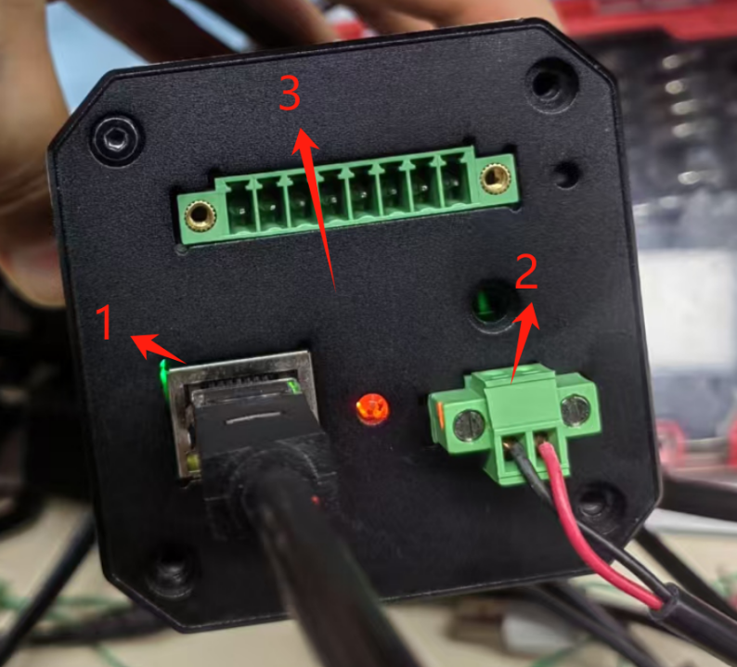

ESD electrostatic contact 4KV, air 6KV

Test point 1: RJ45 housing, very sensitive, contact discharge can easily disconnect the Ethernet communication. Software has a reconnection mechanism. However, it cannot be recovered. The differential communication channel of the PHY chip also experienced damage, which does not match the ground impedance with the good board

Test point 2: The power input of the POE chip 12V auxiliary power supply, contact or air, will turn off the 5 V at the back of the POE chip power transformer. The power supply of the POE chip 12V must be powered back off, and the 5 V can be restored to the output

Test point 3: Metal housing, digitally connected to the rear of the transformer to foam, contact and discharge can easily break the Ethernet communication cable