Please see the Green and Blue mark in the below two pictures.

1. **EVM_PMP4648**

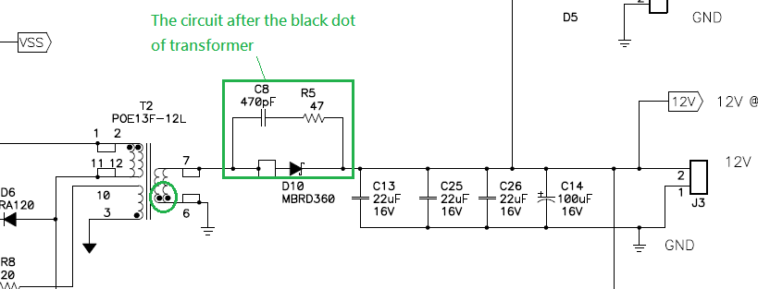

1. **EVM_PMP8803**

