ADC POWER SUPPLY

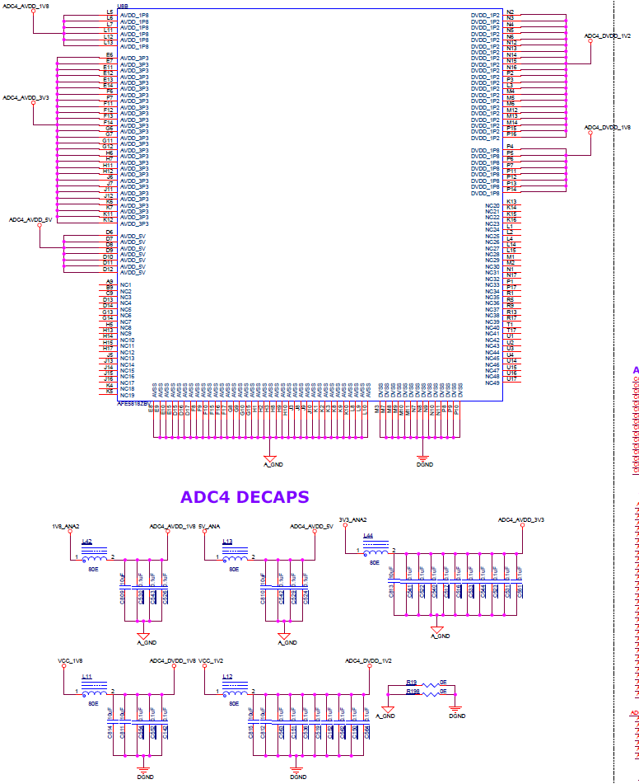

Analog and Digital supplies generated for ADCs which are having ground ref of A_GND and digital with D_GND(so the 1.2D PG is given as enable for opto-isolator which will enable the ADC’s regulators)

Power supply sequence for ADC(AFE5818)

