Fox oscilator by itself
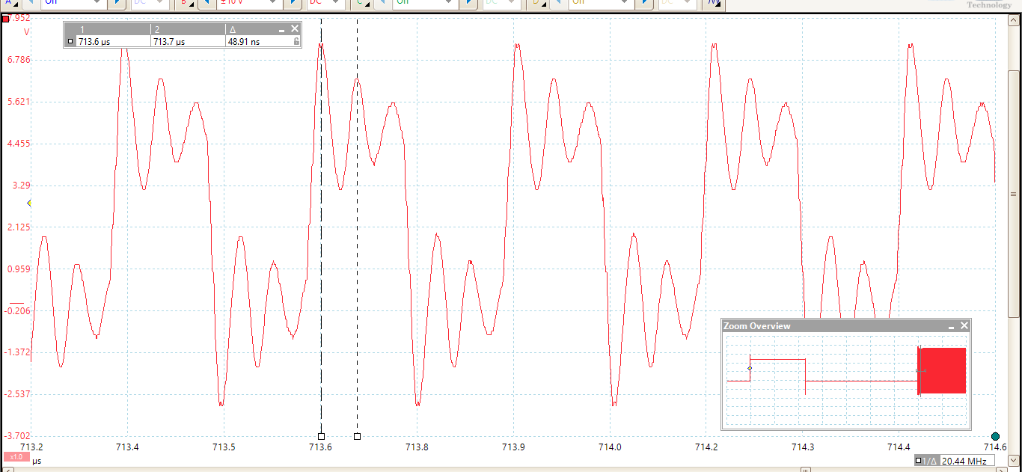
In circuit
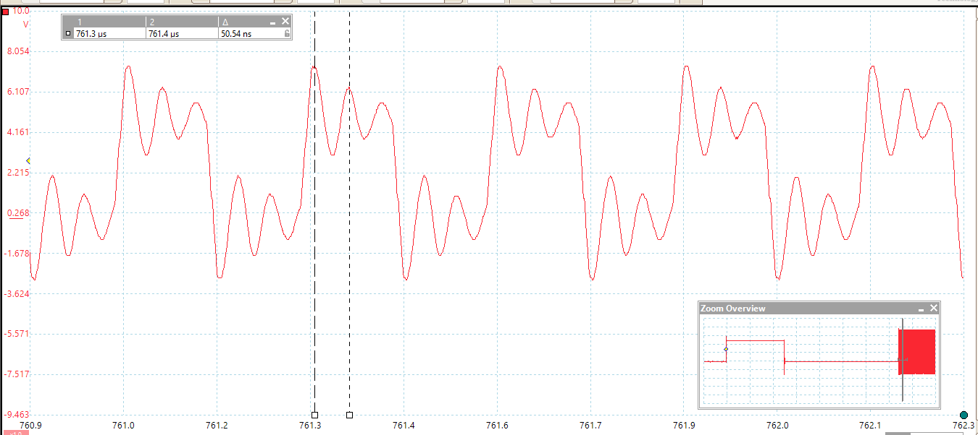

Output of driver, after the OUTH and OUTL resistors, shown in blue.
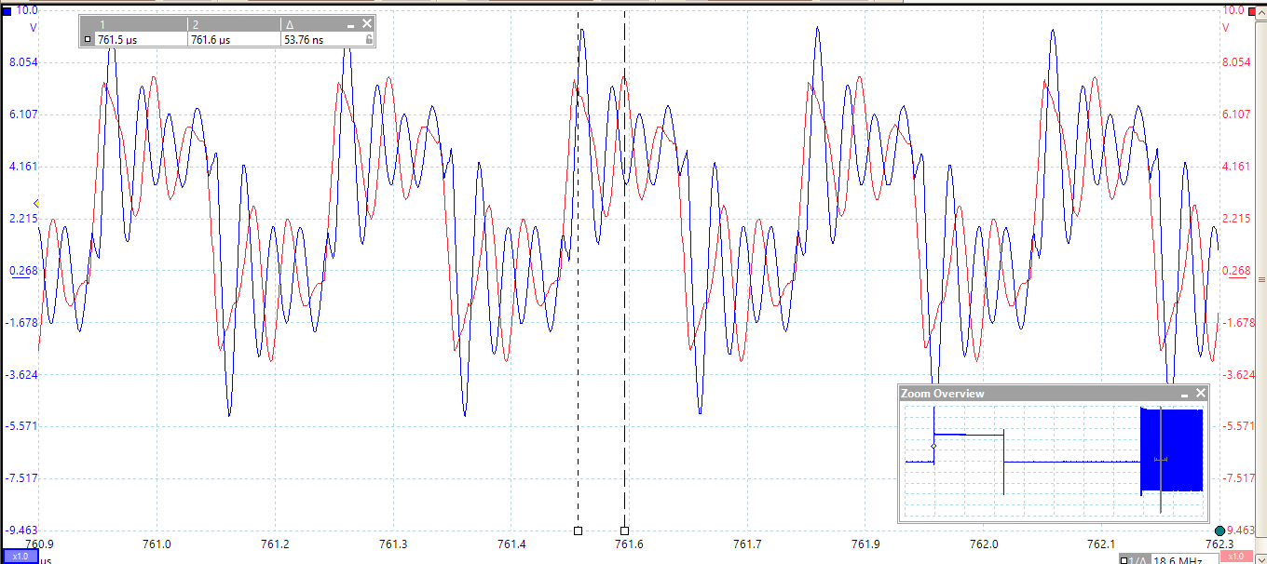

With the FET drain (green) the desired signal is 0V when on and 9V when off. FET appears to be on most of the time.
