1. Issue Observed:  
   Backlight flickering and unexpected system restarts during operation.

## Schematics:

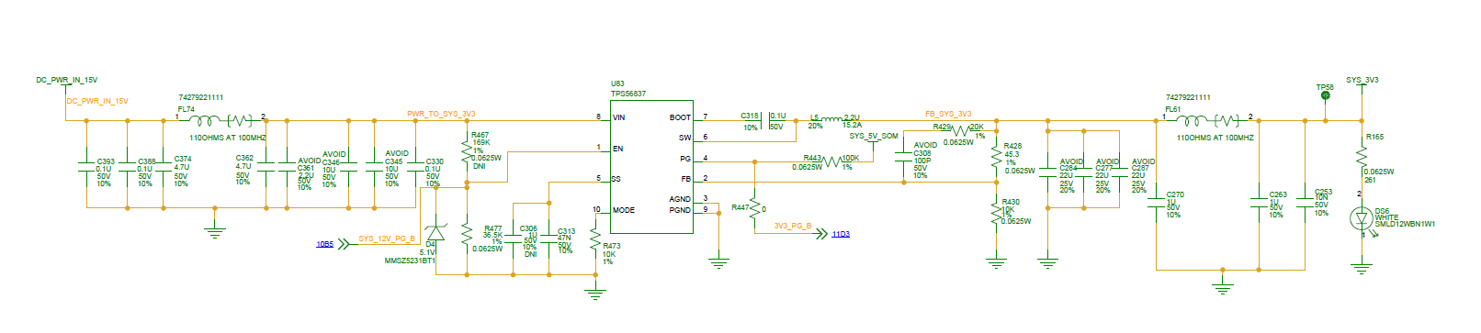 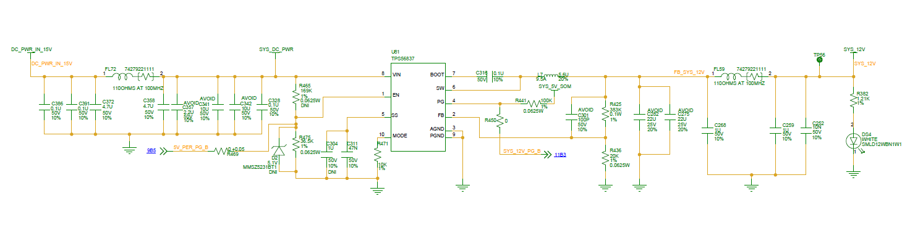

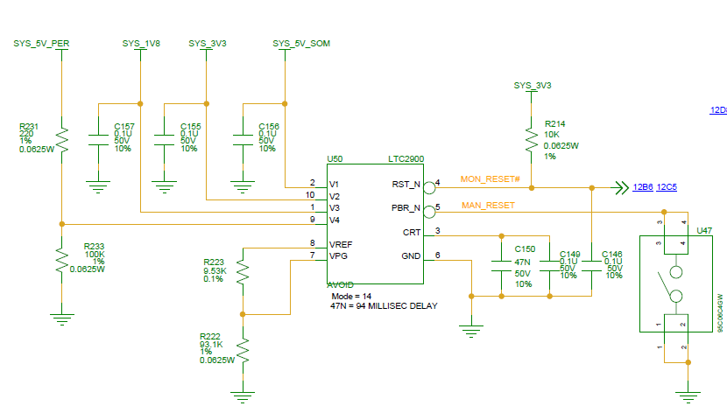

1. Analysis Findings:  
   Detailed troubleshooting of the LVDS Display section identified that the restart sequence is triggered by a voltage drop of approximately **2.5V** on the **SYS_12V** power rail. This voltage dip causes the **SYS_12V_PG_B** signal (Power Good indicator for the 12V regulator) to transition to **LOW**, which initiates the following sequence:
2. **3.3V regulator shutdown** due to loss of 12V Power Good signal.
3. **Power Supervisor IC** asserts a reset signal because of the 3.3V rail going down.
4. Complete **System restart** occurs.

## Observations:

1. When LCD1_BLKT_EN is asserted, there is a drop of approximately 2.5V on the 12V power rail after 24ms . The above waveform is based when Vin = 15V, the drop observed as 2.5V

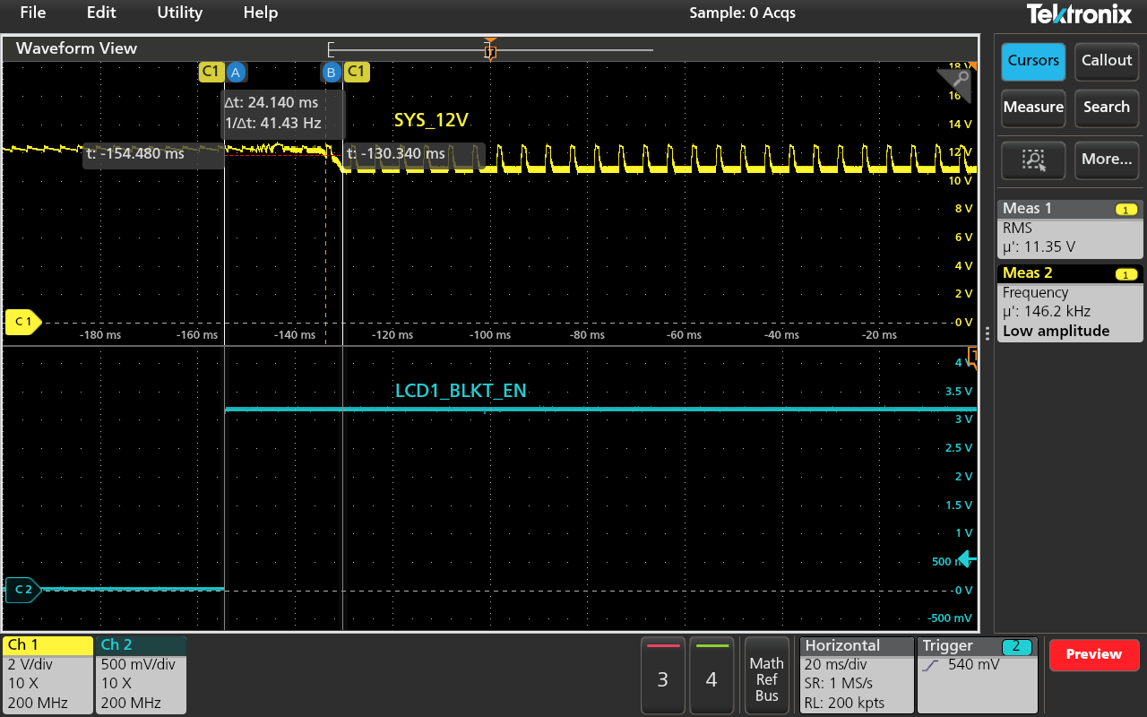

1. The drop on the 12V power rail is triggering Power bad of 12V regulator.

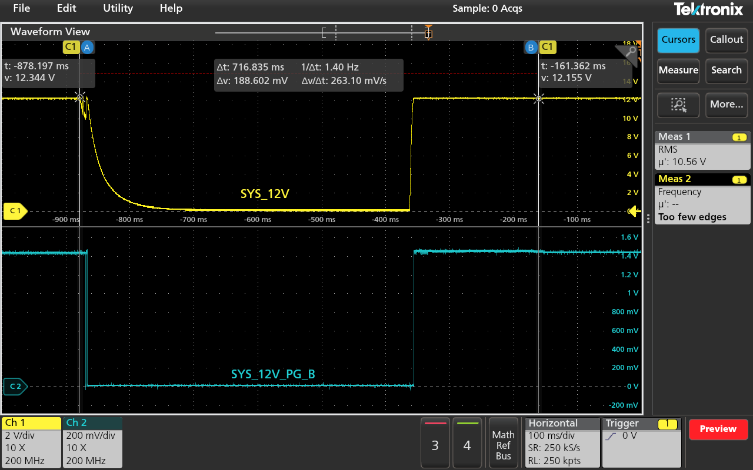

1. The Power Bad signal is generating the reset and deasserting the Carrier Power On signal and thus the entire board gets restarted

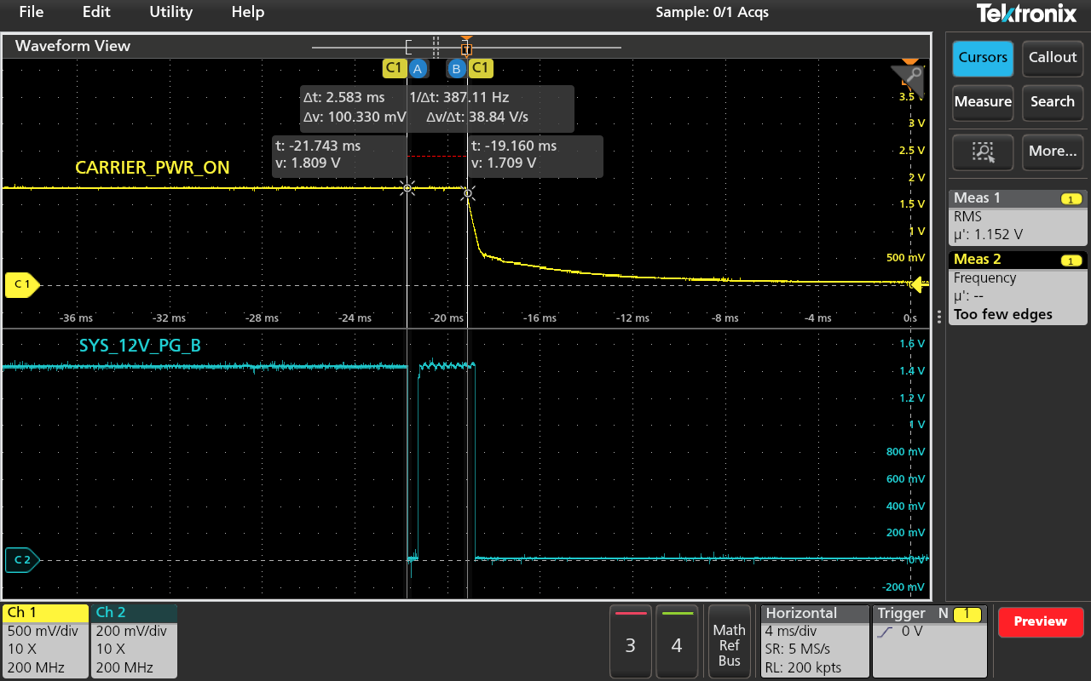

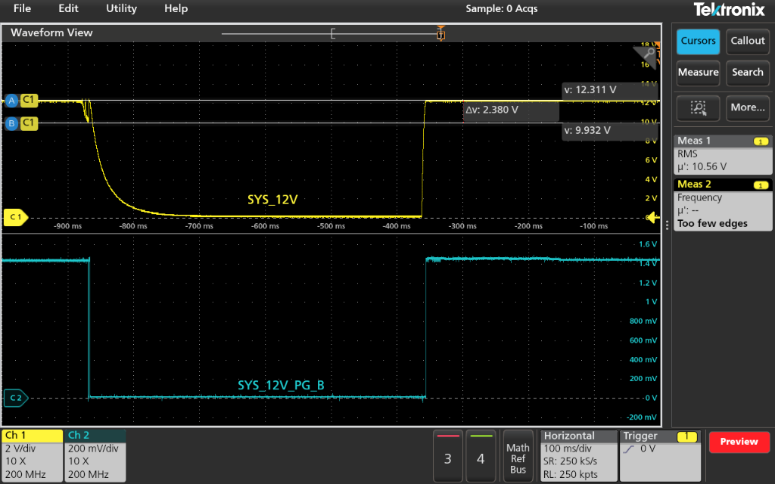

1. When the same experiment was repeated with 15.5V/2A, the entire setup was functioning properly. And the 12V voltage rail drops reduced to1.8V from 2.5V. Refer Point A

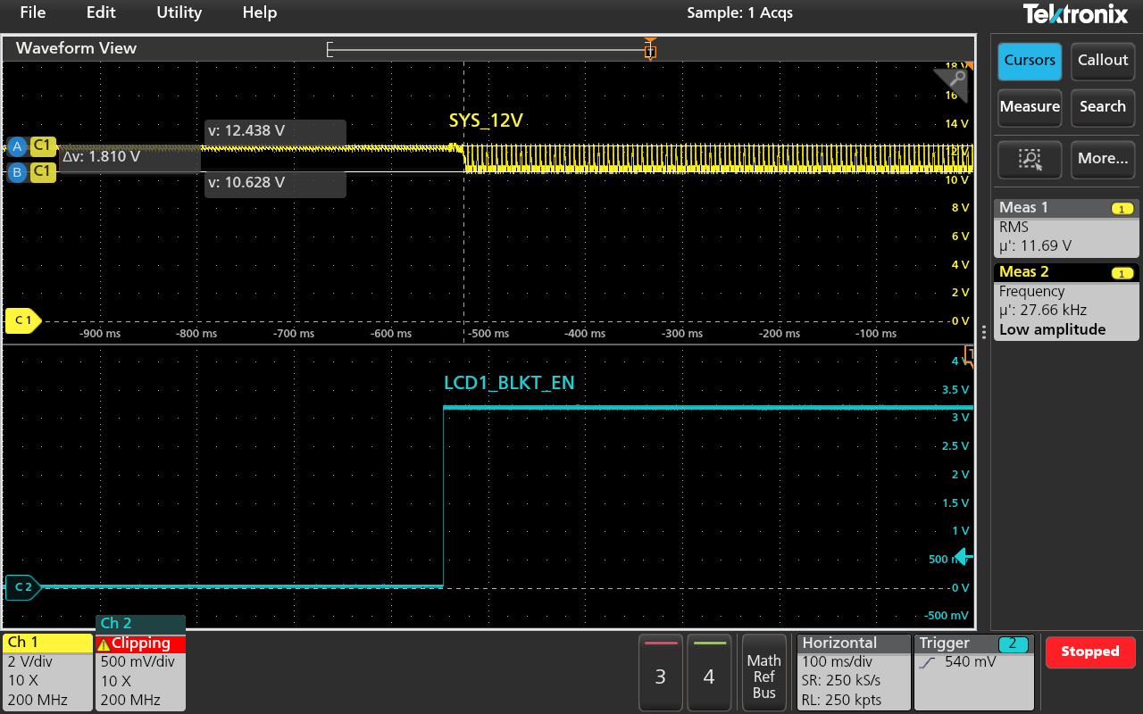

## Resolution from TI