Further testing on 5v rail power on

15th June 2019

The waveforms in this note record the IC2 VIN input voltages and 5 volts rail voltages during a number of power up conditions.

The 3.3 volt regulator was disconnected and measurements were taken with a 10K load (less than 1 mA) and 20 ohm load (250 mA).

Normal power on with 24 volts applied thru Power input and then power transfers when the unit was already powered from the 12 V battery and 24 v was applied through power input.

No excessive voltages was noted.

Power Input 24 volt blue (x10 probe)

VIN 23 volt red (x10 probe)

10k 5 volt load

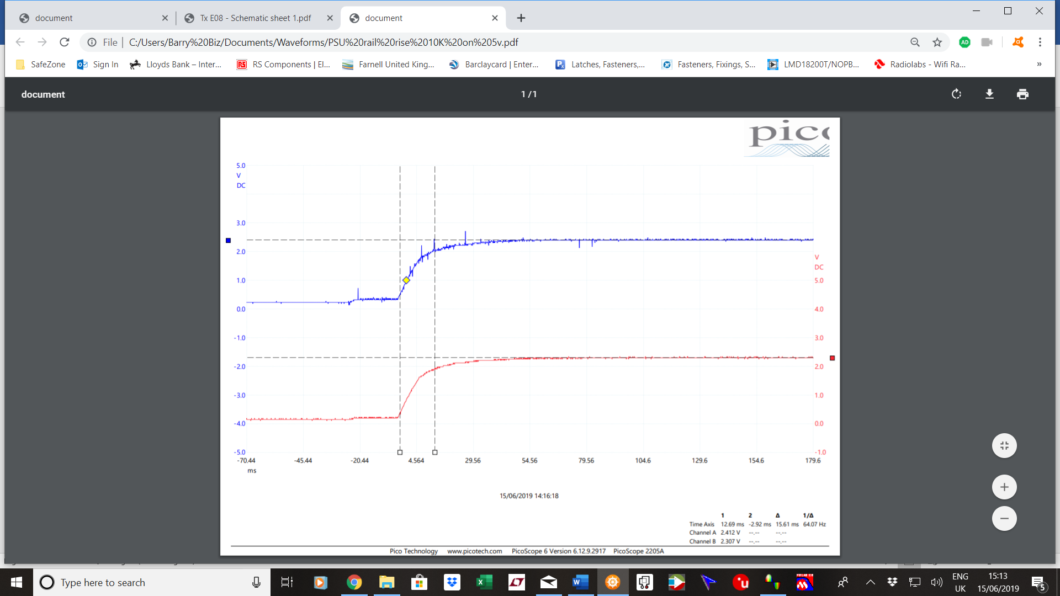

Power Input 24 volt blue (x10 probe)

VIN 23 volt red

20 ohm 5 volt load

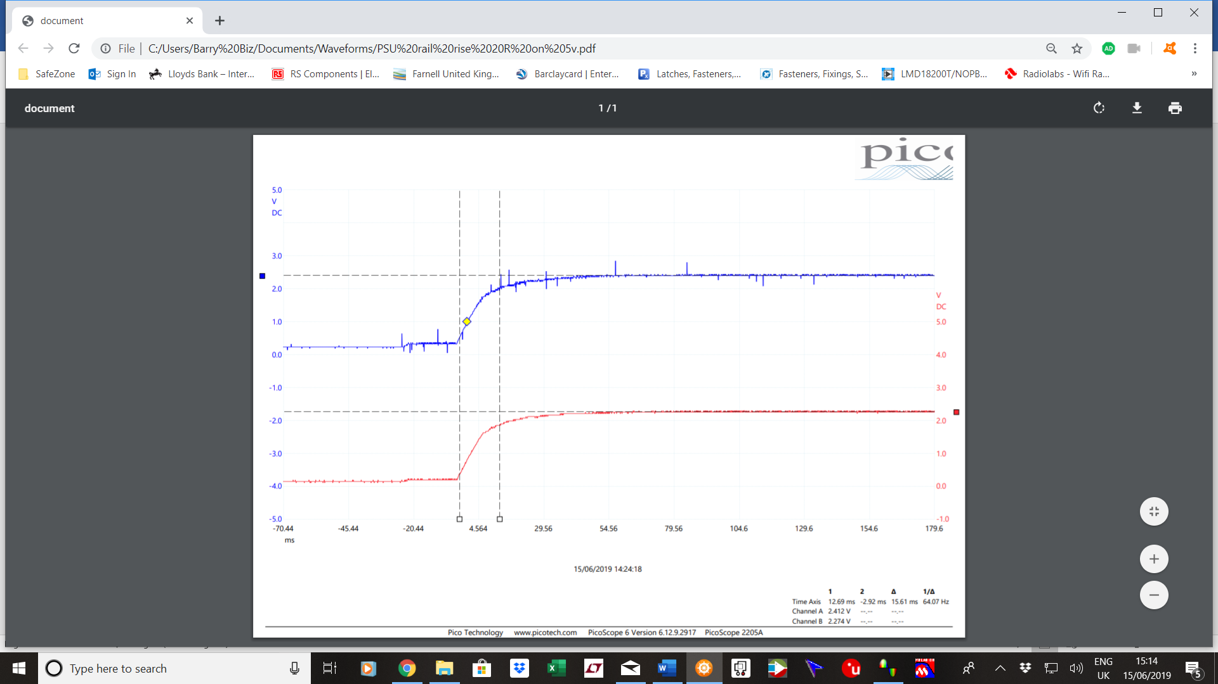

Power Input 24 volt blue (x10 probe)

5 volt red

20 ohm 5 volt load

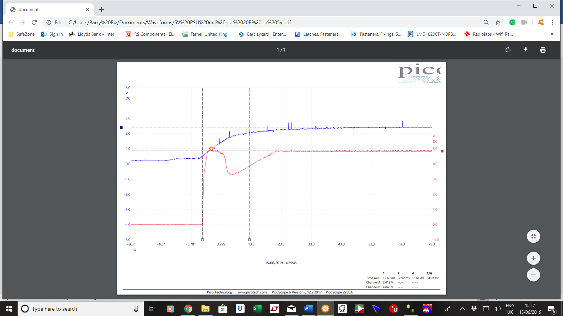

Batt 12 volt to Power Input 24 volt blue (x10 probe)

10 v to 23 volt VIN red (x10 probe)

20 ohm 5 volt load

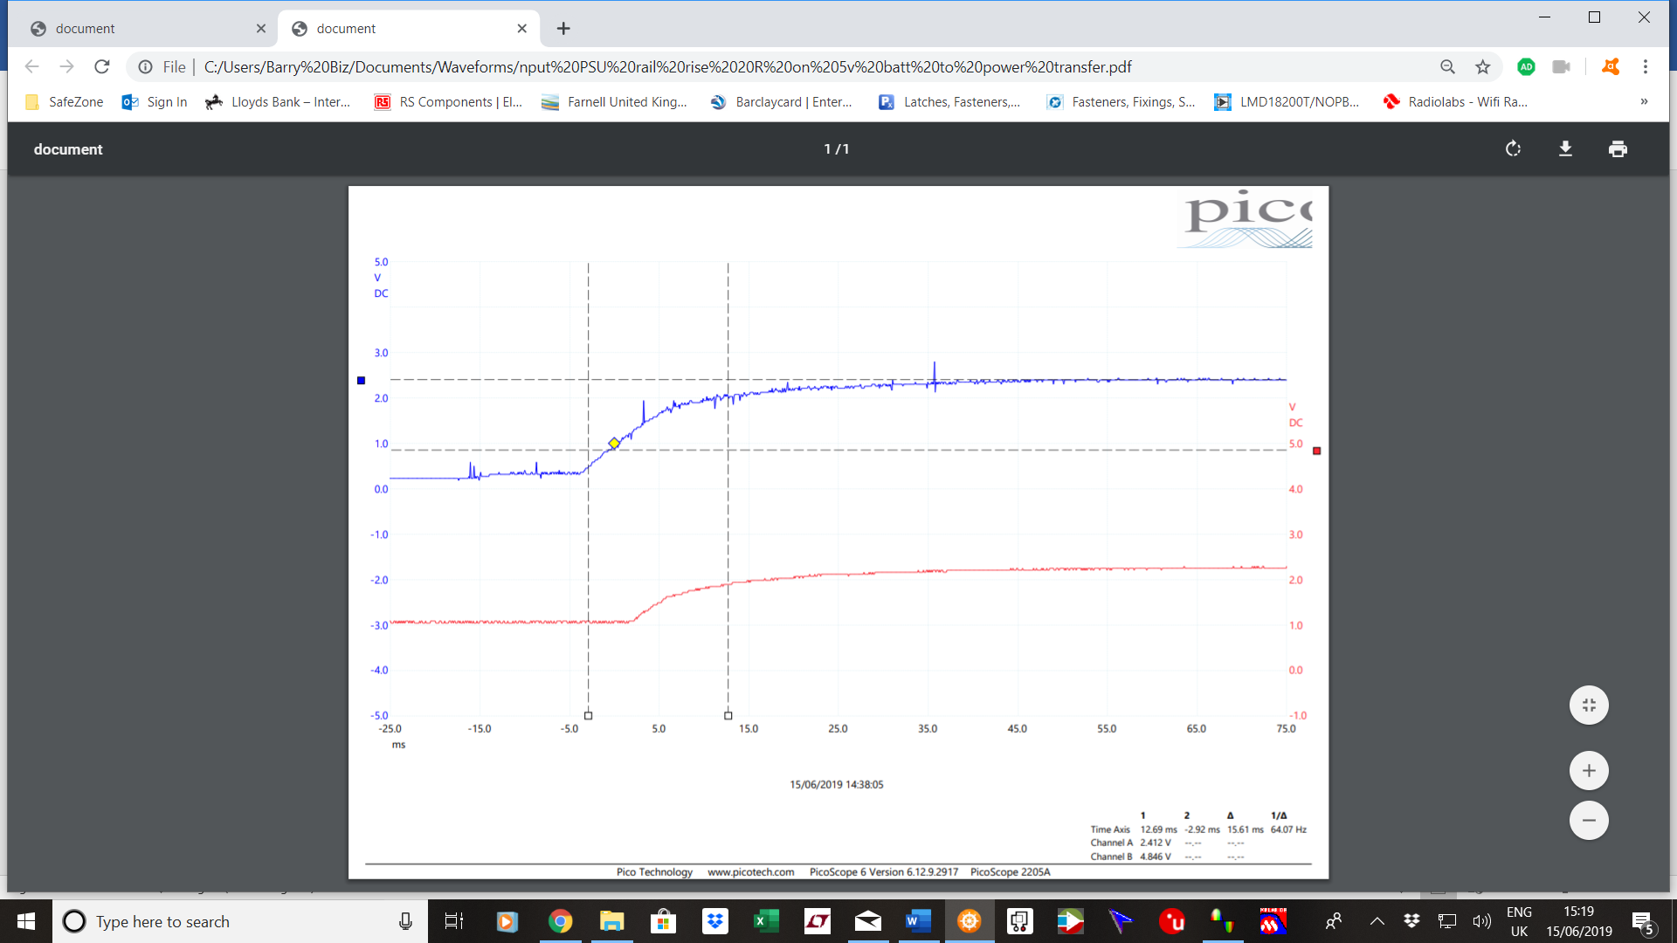

Batt 12 volt to Power Input 24 volt blue (x10 probe)

5 volt rail red

20 ohm 5 volt load

