Import csv file

Below is my import csv file process, please double check my step.

1. The main window of fusion, then click to configure device.

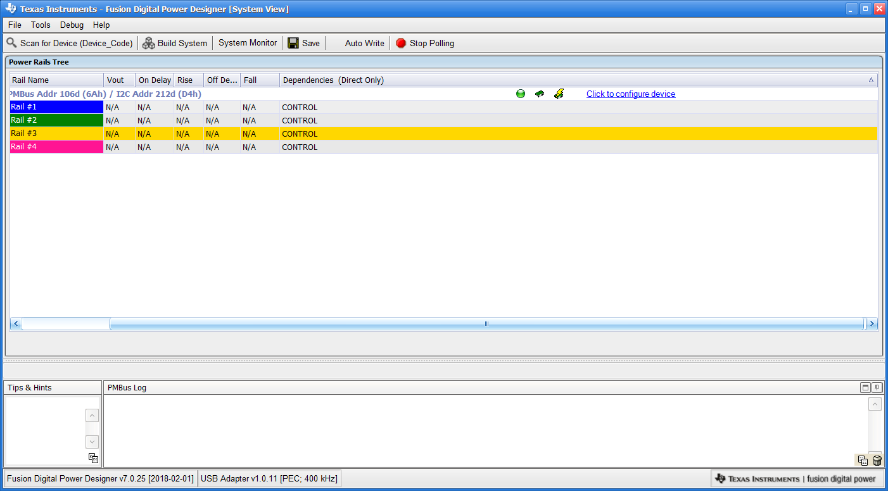

2. Show all parameters, then enable writes to all commands.

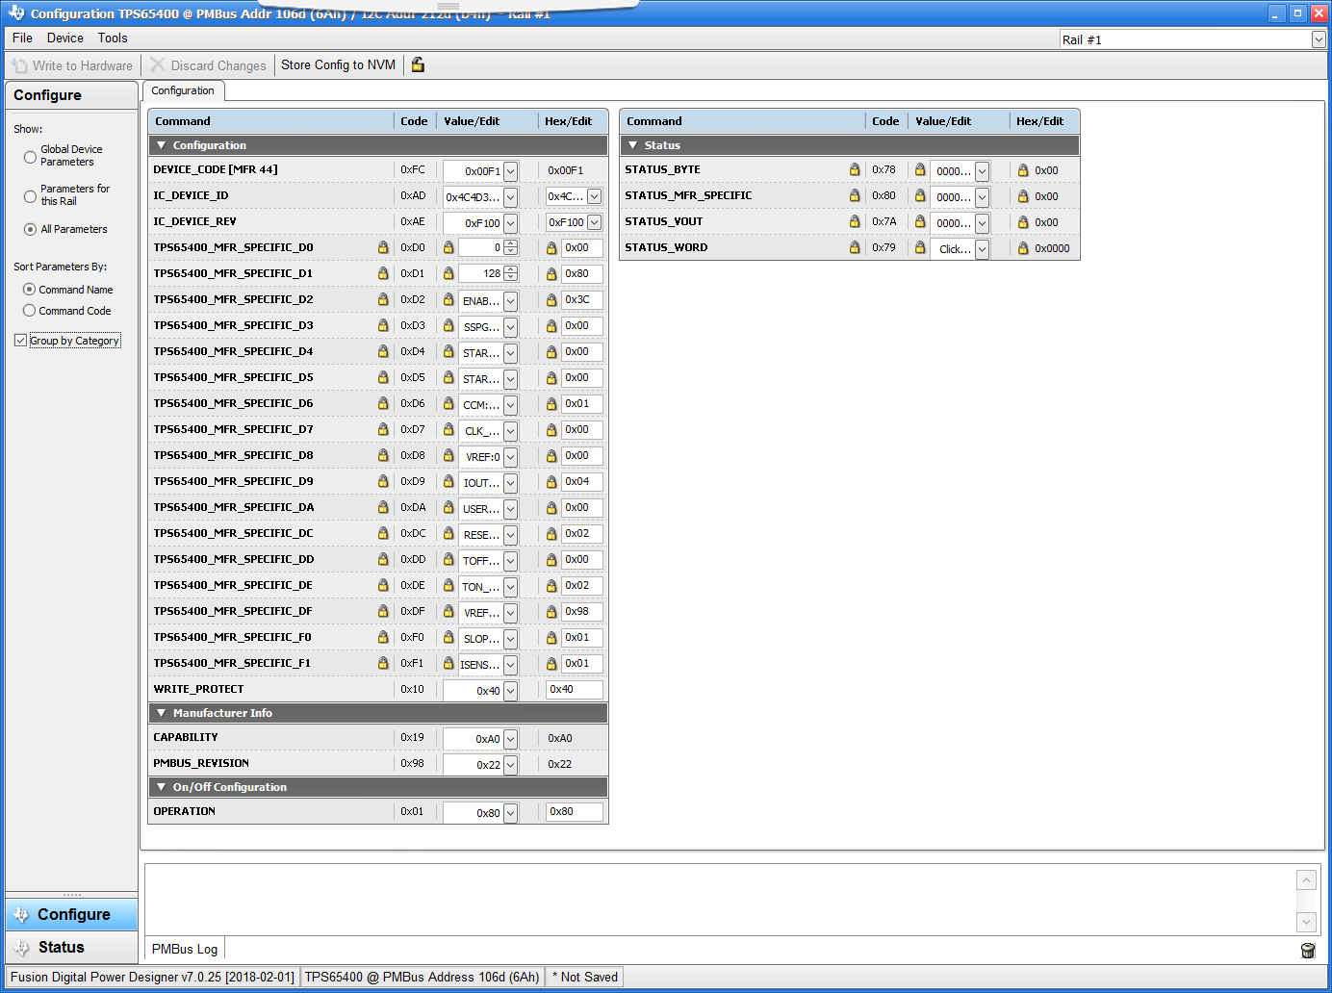

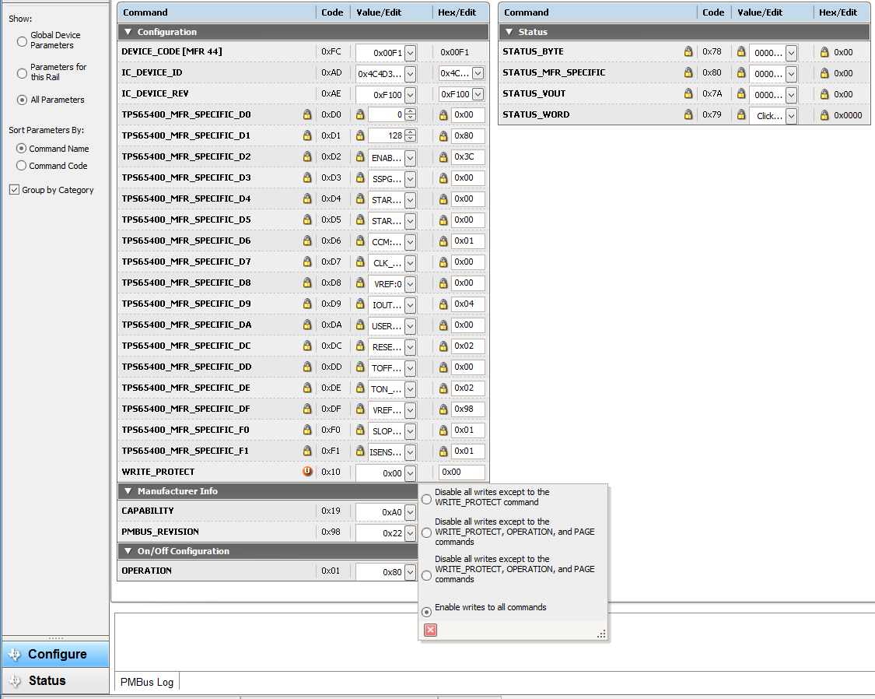

3. Click Write to Hardware, then click Store Config to NVM. 🡪 Success to store to NVM.

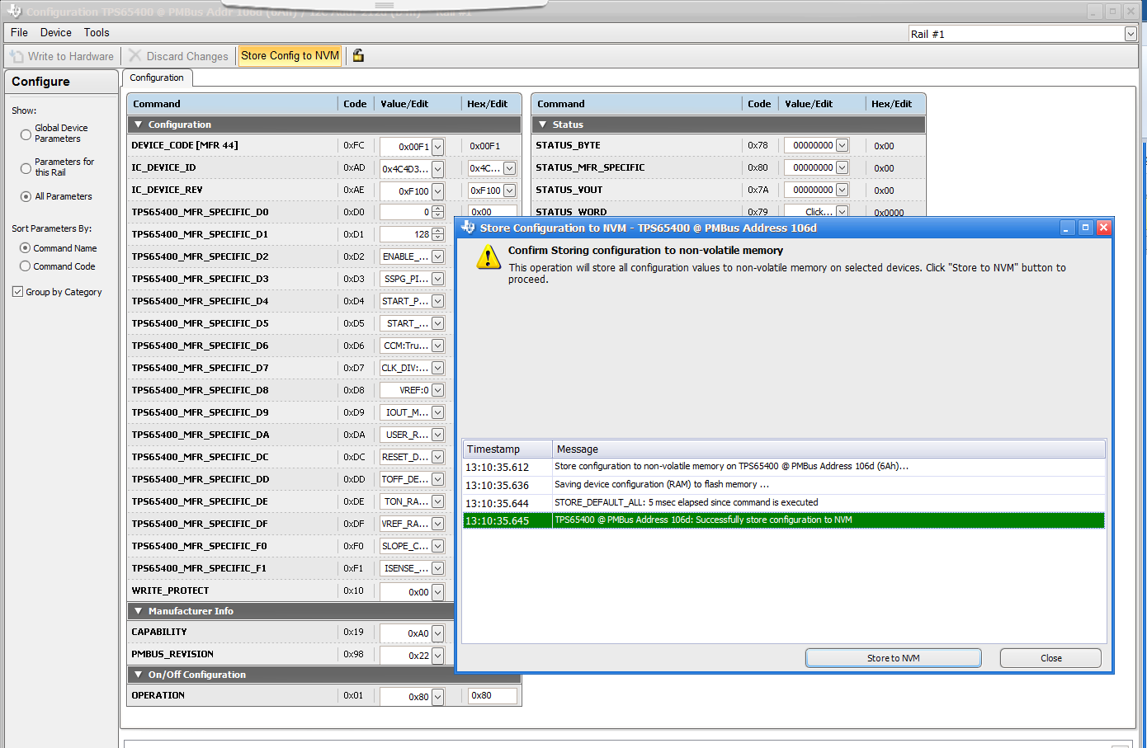

4. Select Export …

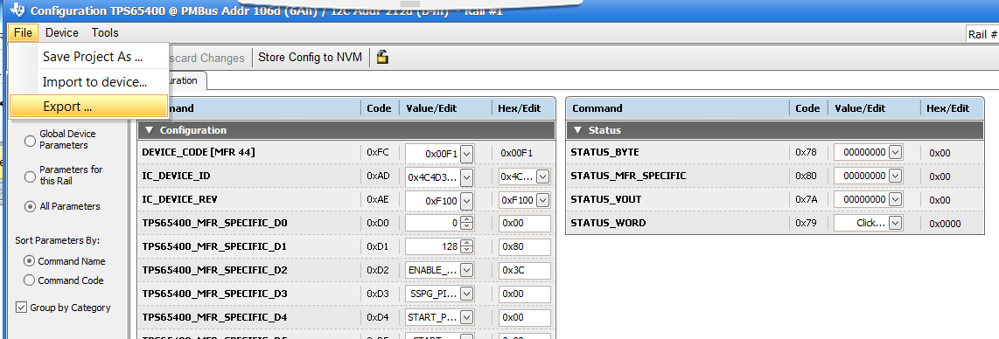

5. Select the PMBus Programmer Script. 🡪 for 3rd party programmer.

After that, Click Export all checked Formats.

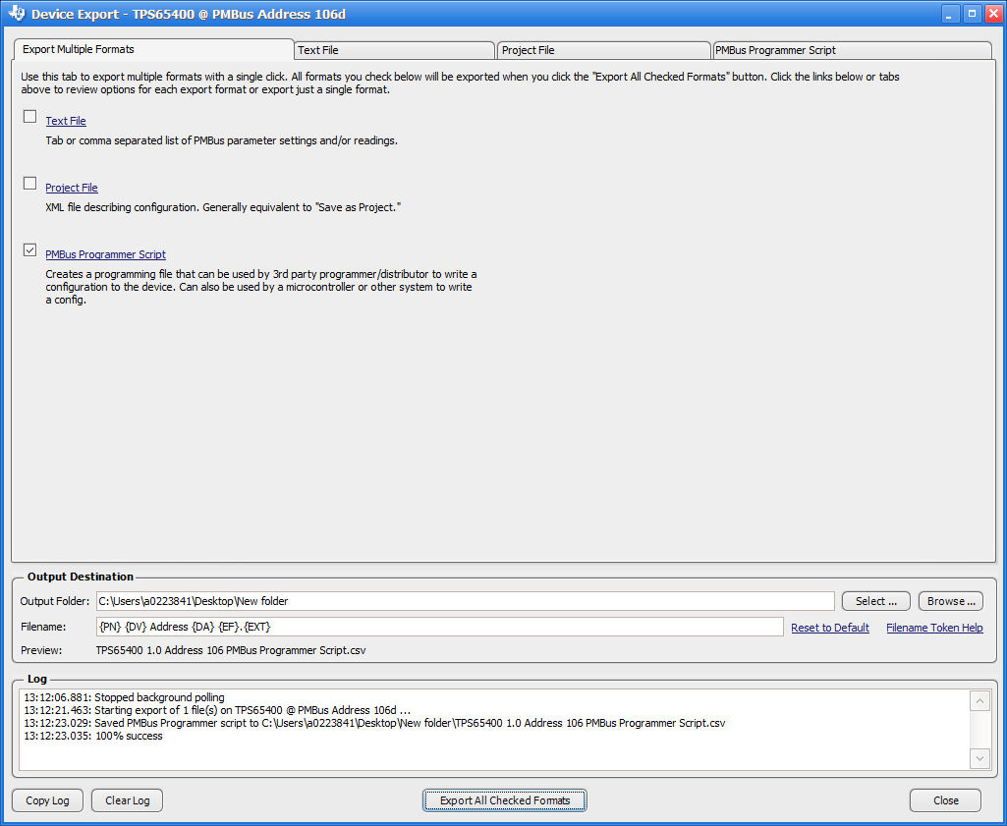

6. Select Import to device…

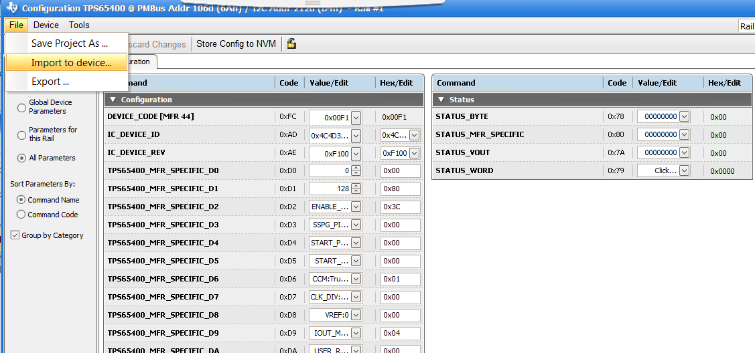

7. Select PMBus, SMBus, or I2C Script.

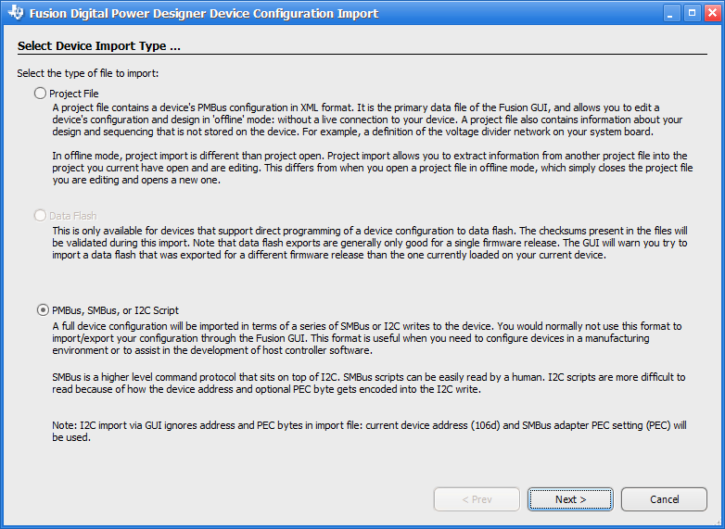

8. Select the file which you just exported.

