The following are various screens I see when attempting to read the flash from the EVM board and save it as a binary file: Below is example screen #1

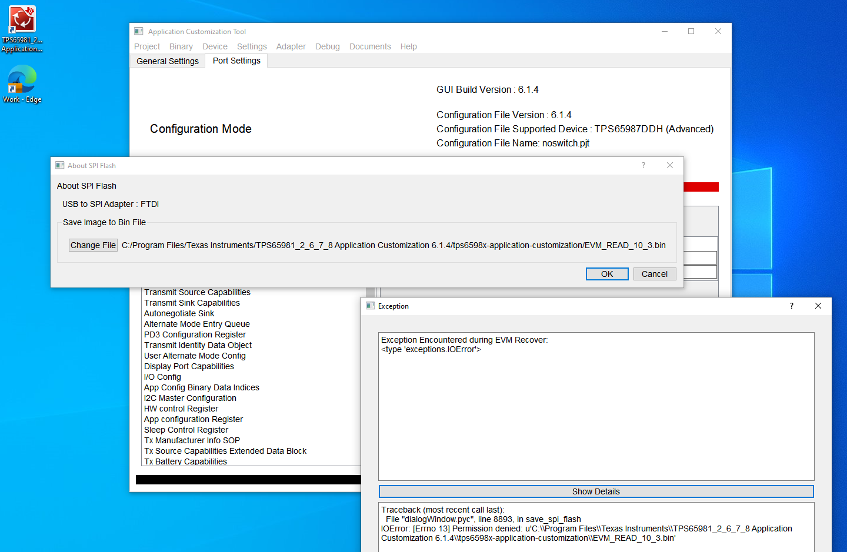

Below is example screen #2

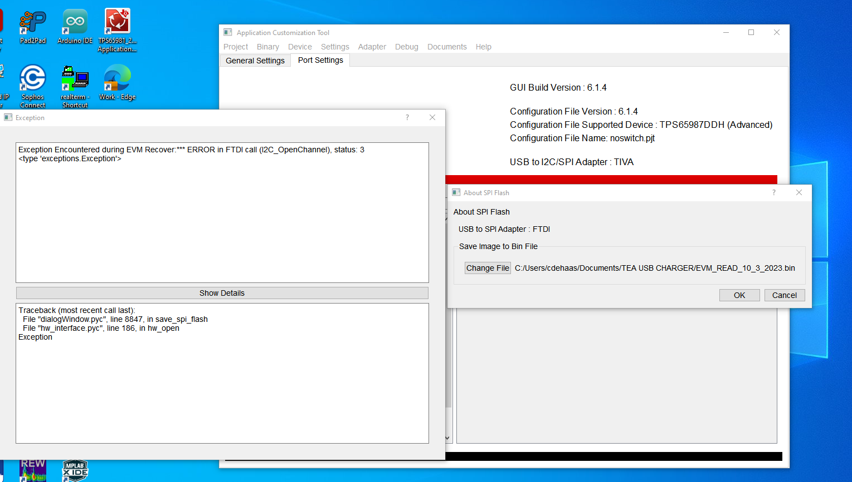

Below is example #3, first showing the results from the read which appear to be successful:

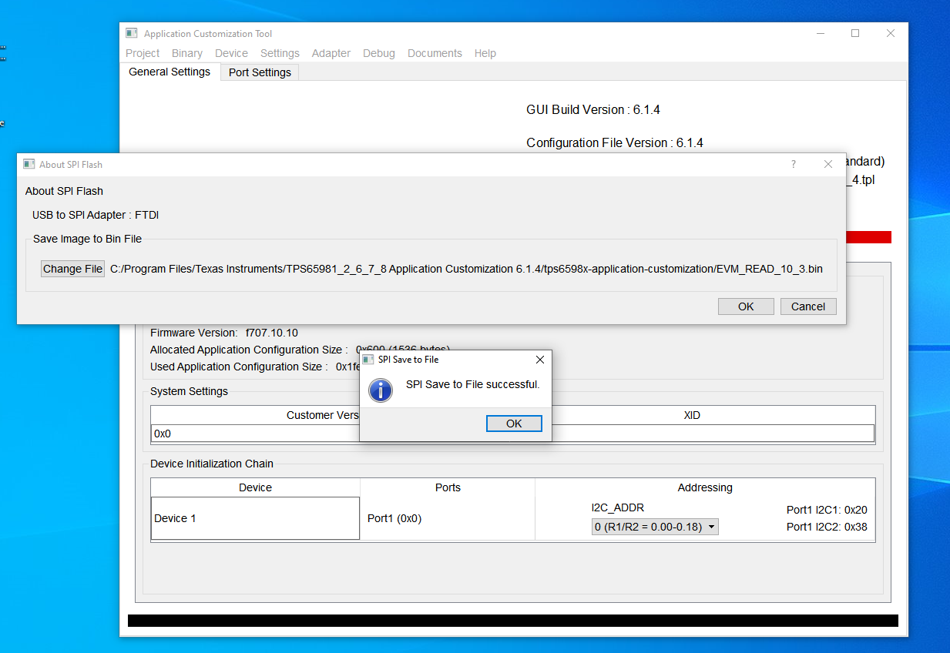

However, clicking OK yielded the following screen (and I also noted that no binary file was saved after the flash read)

