Hi Joshua,

After reflecting on the design based on your last response, I decided to reduce the switching frequency to 217kHz to prevent the chip from overheating, as my biggest concern is proper heat dissipation.

In WEBENCH, I tried to keep the switching frequency, transient response voltage change, transient response current step, and max output Vout ripple as low as possible.

The WEBENCH design is as follows:

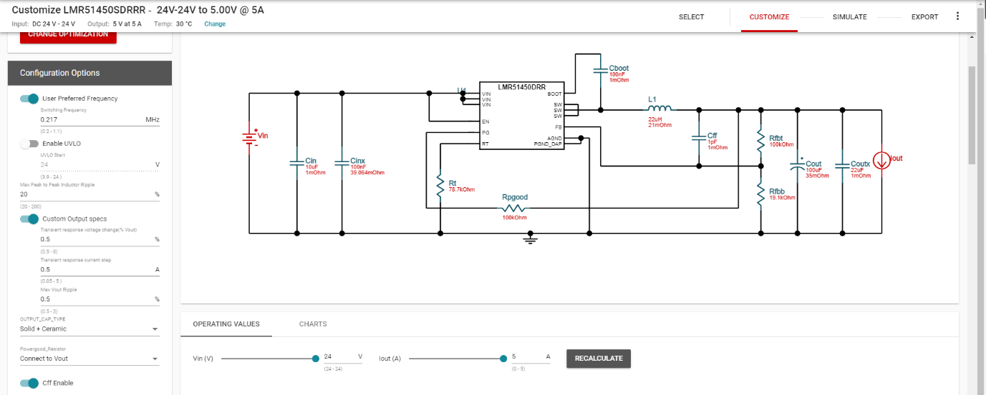

I will use these parameters in my design. In addition to this WEBENCH design, if we consider the typical parameters in section 9.1 of your recommendation: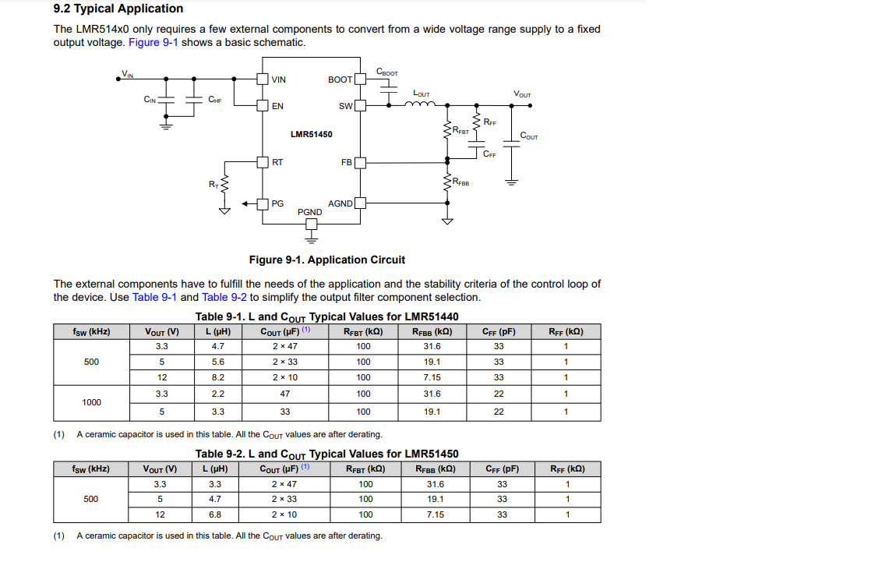

Here, I generally see that Rff is used at 1k ohm for different frequencies. I will add a 1k ohm series resistor to the Cff capacitor in the WEBENCH design.

In addition to the WEBENCH design, I will also add the capacitors specified in section 9.4 of the datasheet, specifically 100uF and 47uF.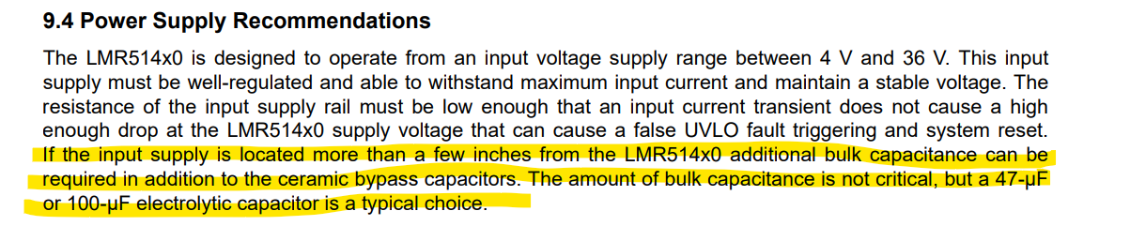

In addition to the WEBENCH design, I also want to review the reference design of the evaluation board and make some additions to the WEBENCH design. I am considering increasing the number of input and output capacitors as seen in this circuit.

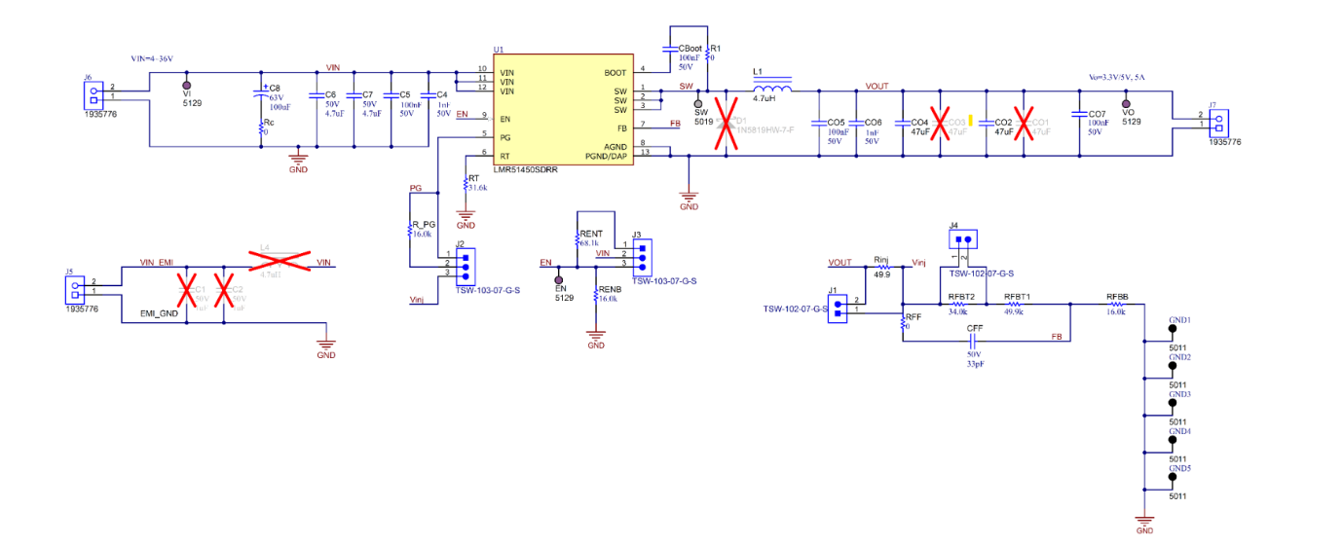

Best regards,