- Open the Fusion tool, select Addr 52d device, “Click to configure device”.
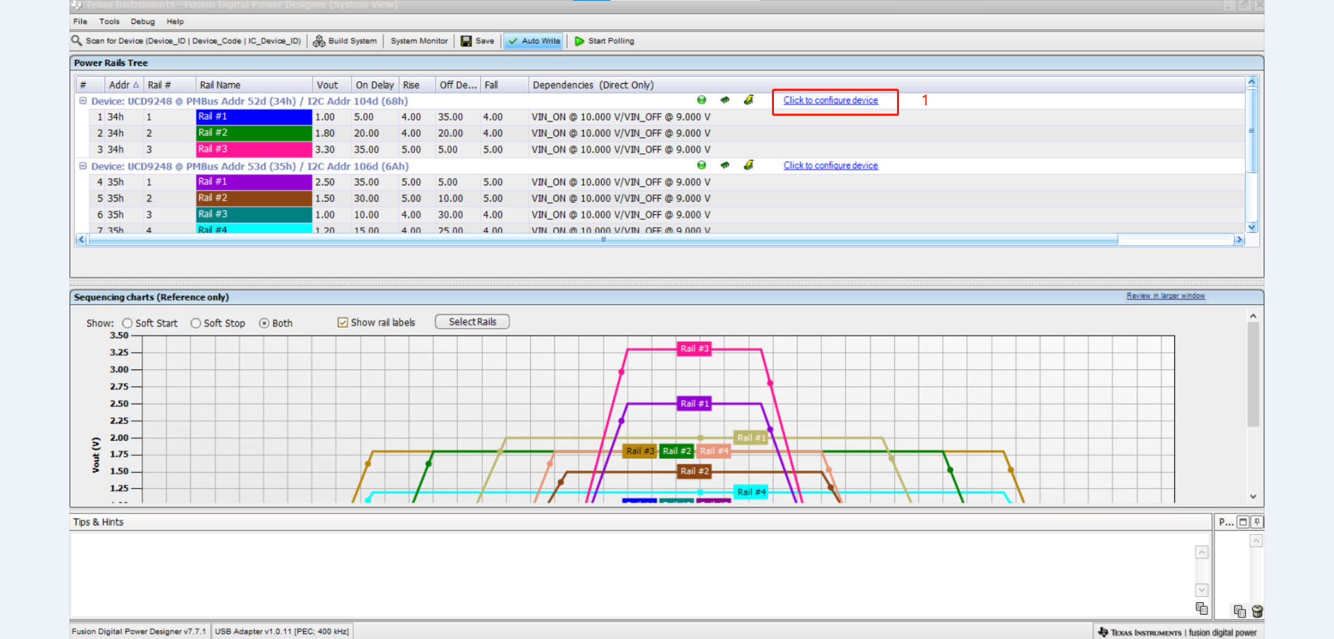
- The windows of the Configuration UCD9248 @ PMBus Addr 52d. Select File -> Import to device.
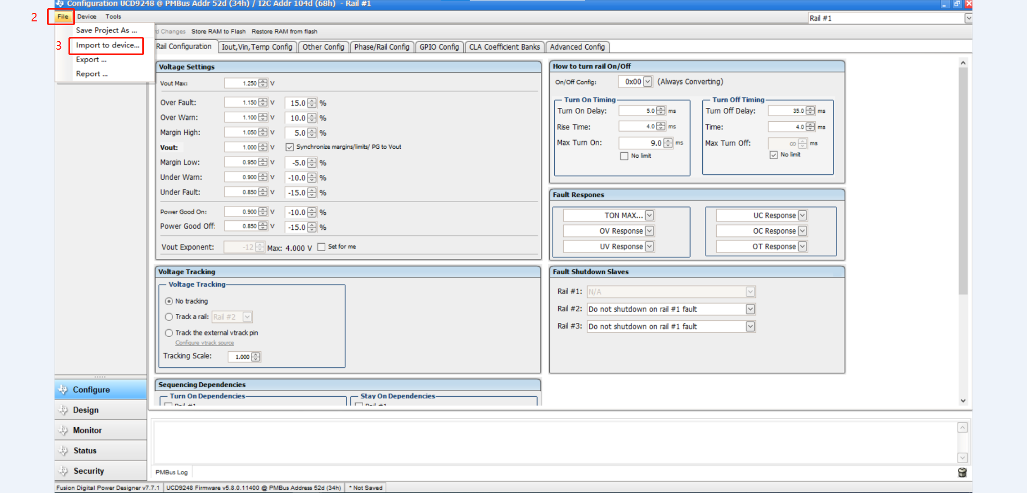
- Select Porject File(.xml) -> Next.
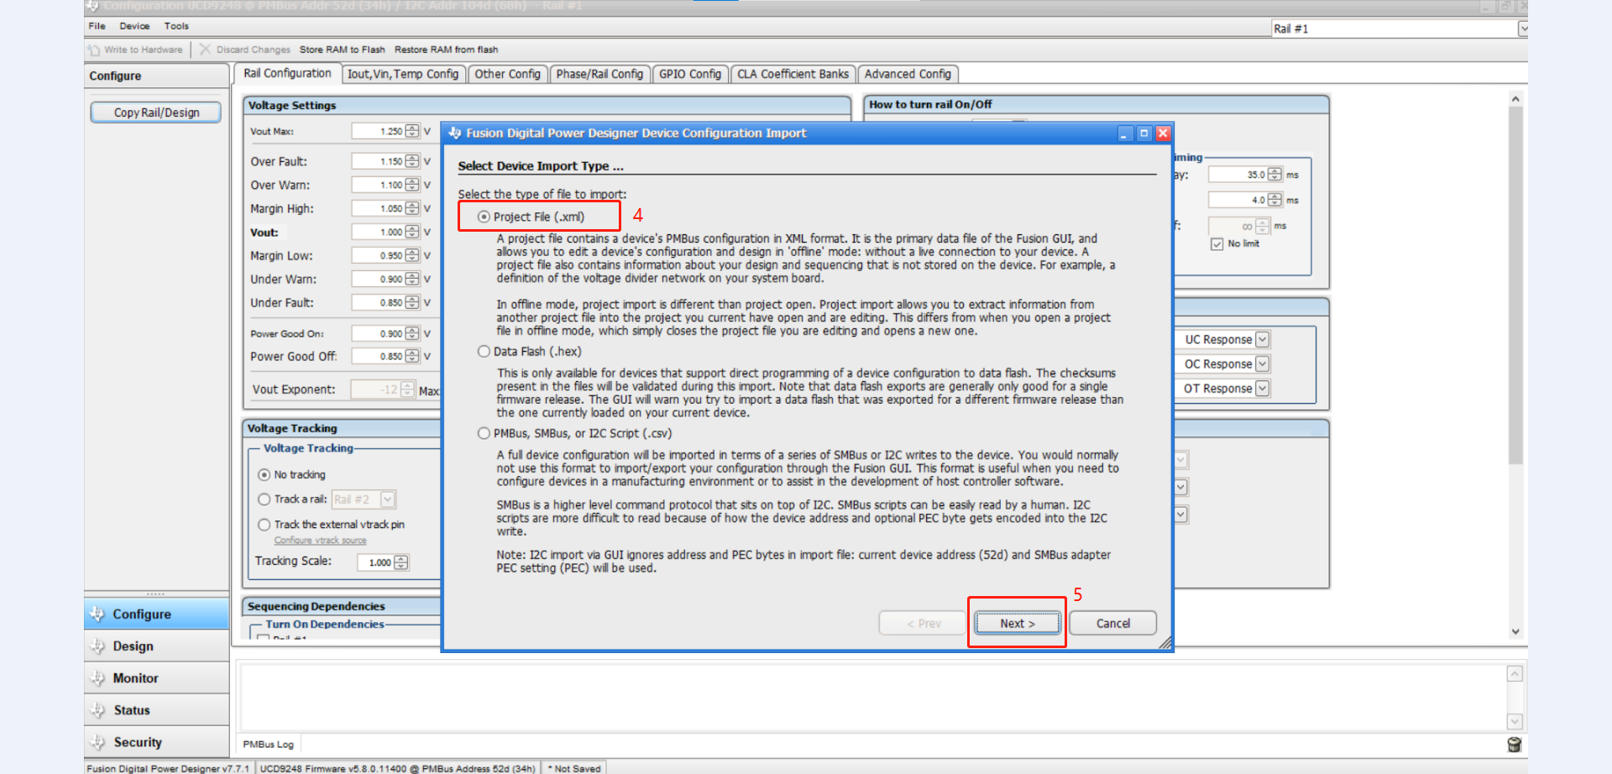

- Select File -> “select relevant file” -> Open
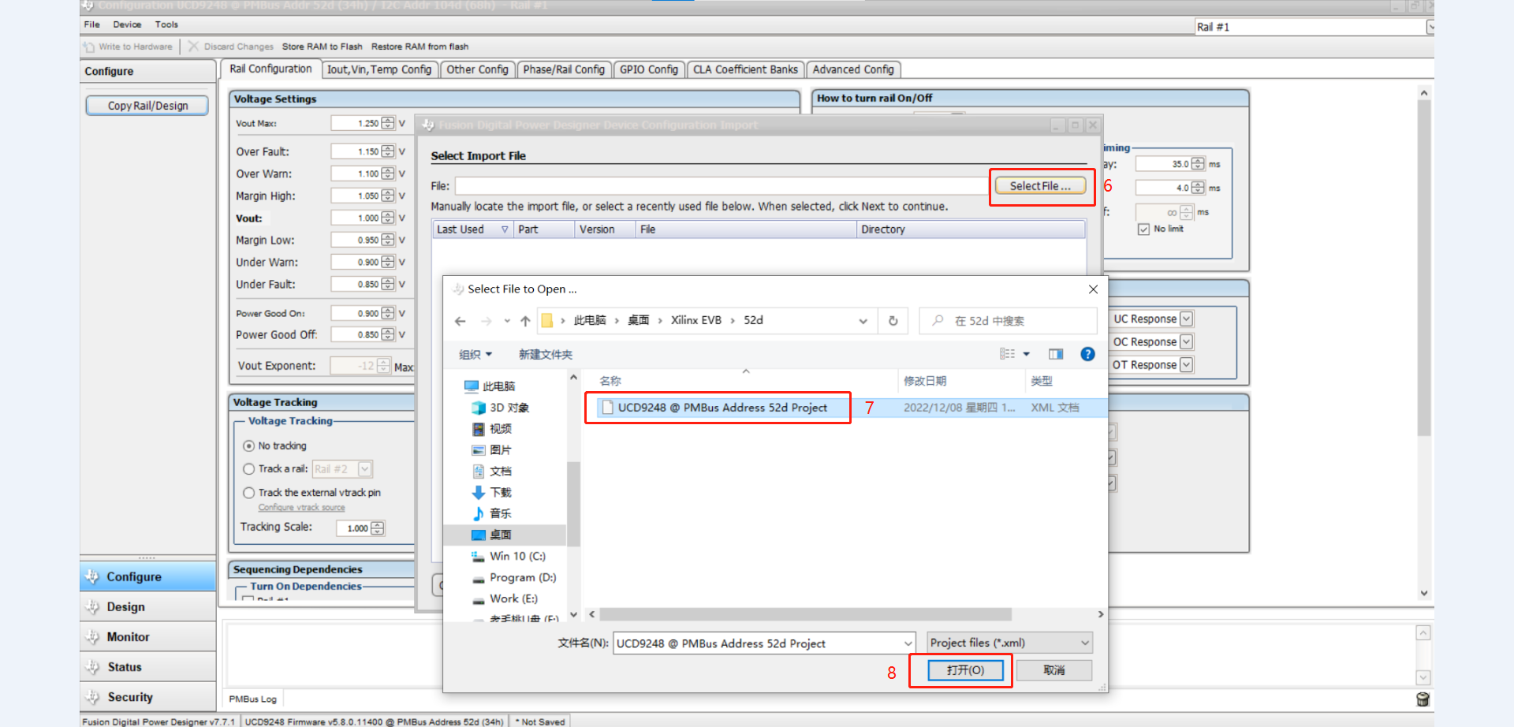
- Click “Next” button
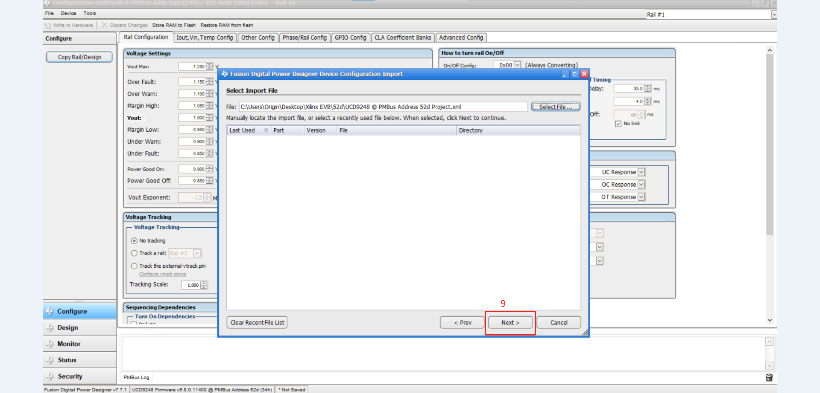
- Select “Import & Write Device Configuration” -> Next
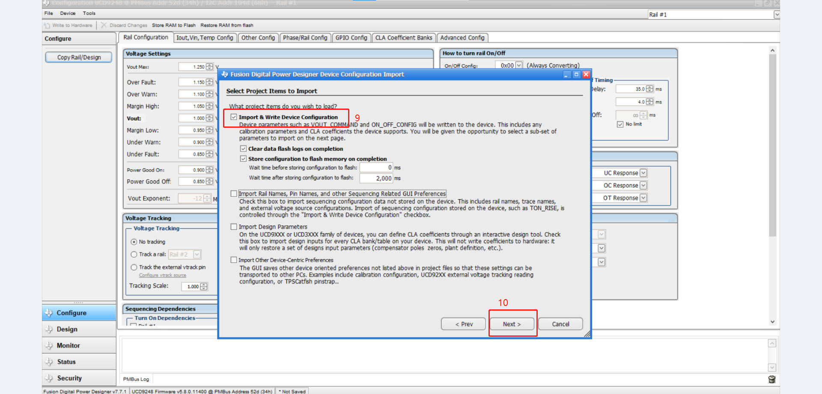

- Click “Select All” -> Next.
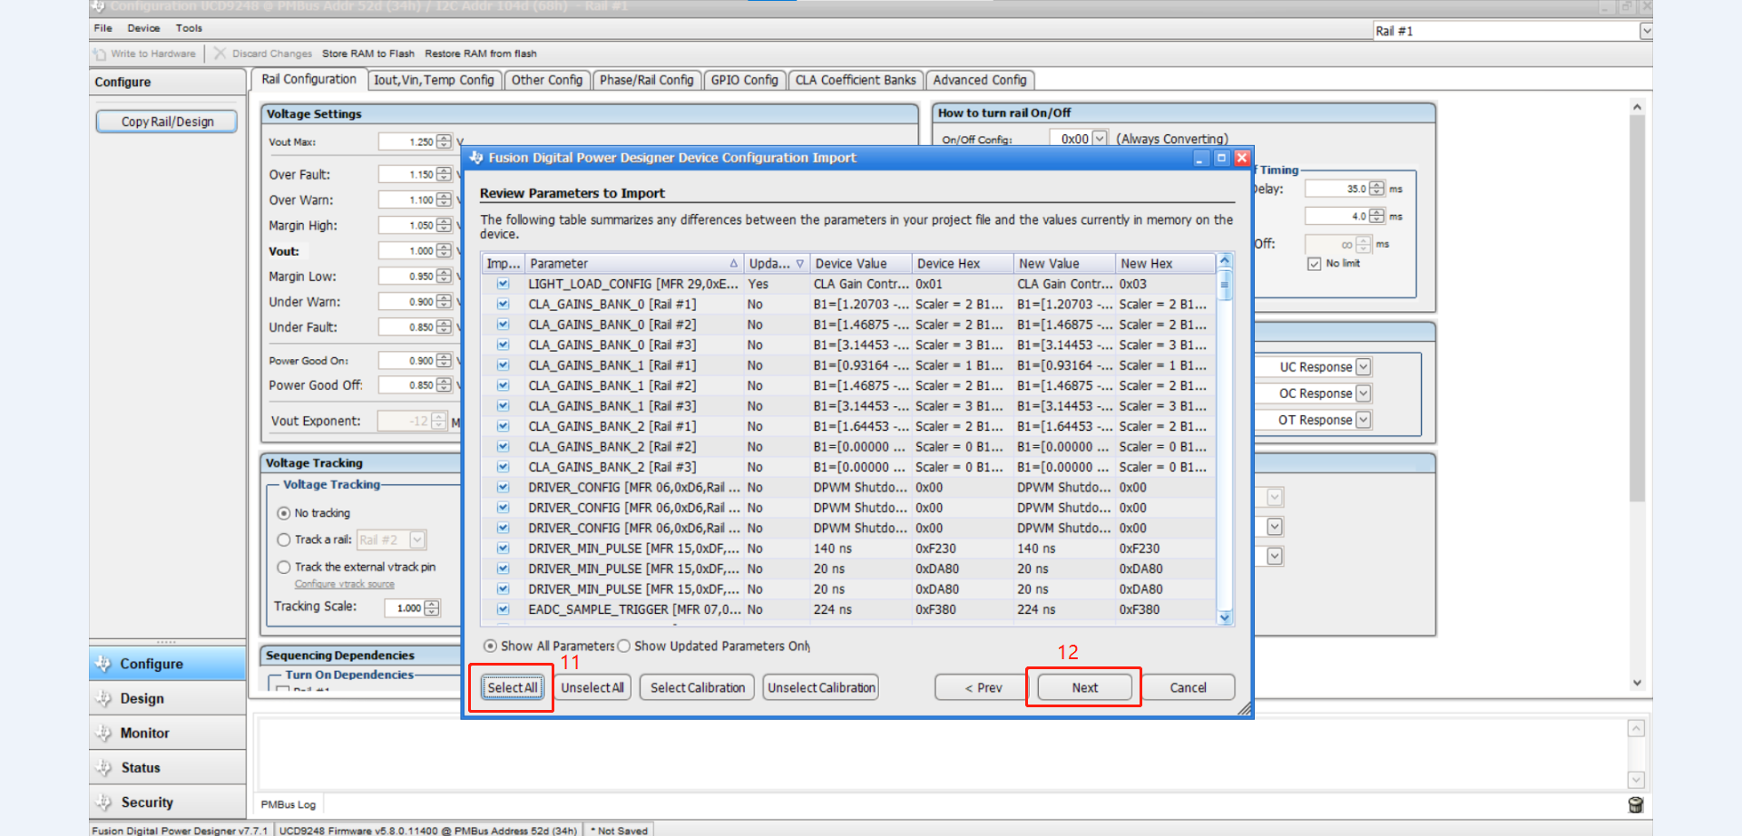
- Click “Import” button
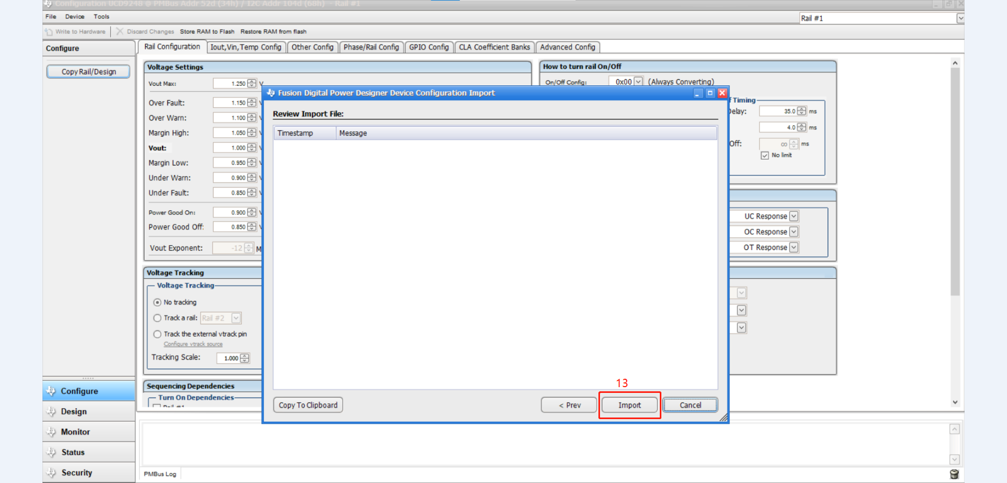
- Click “Next” button
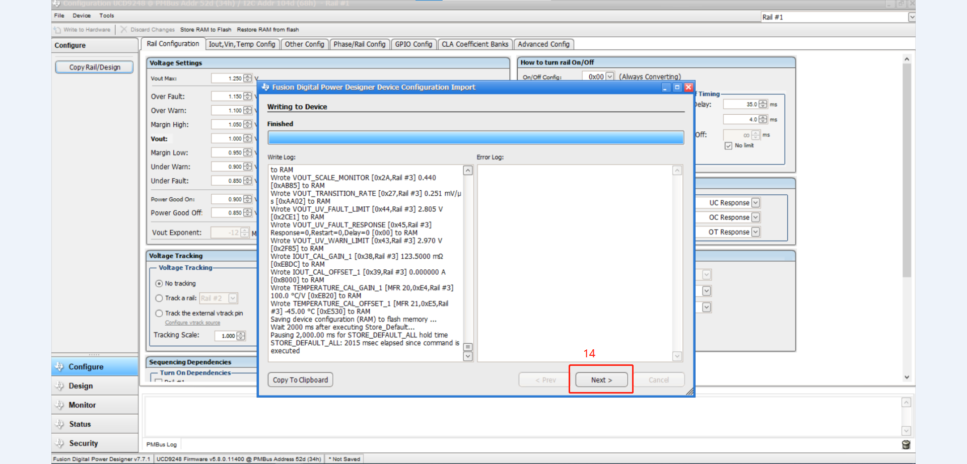

- Got a warning error in here. And then, click “ok”
