**LED DRIVER CIRCUIT WITH PWM 50% DUTY CYCLE OF 1KHZ SIGNAL:**

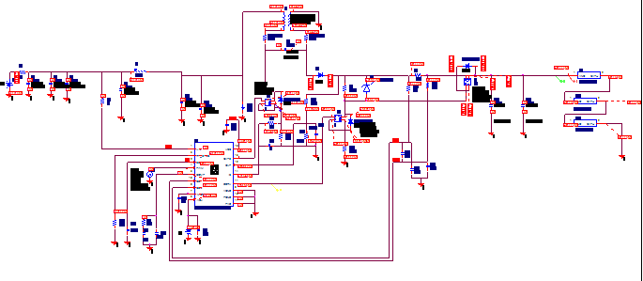

1. OUTPUT VOLTAGE AND CURRENT:

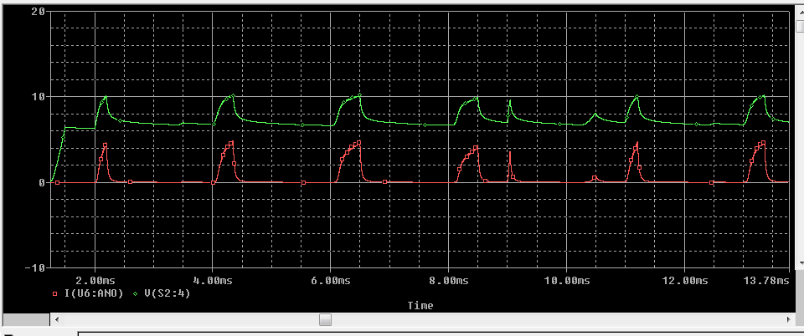

1. OUTPUT VOLTAGE, CURRENT AND GATE VOLTAGE:

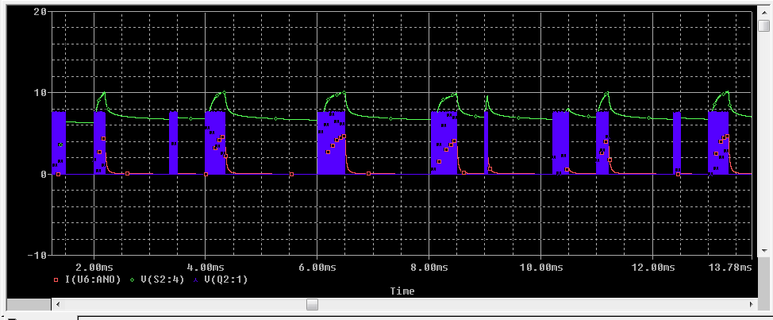

1. OUTPUT VOLTAGE, CURRENT AND DDRV VOLTAGE:

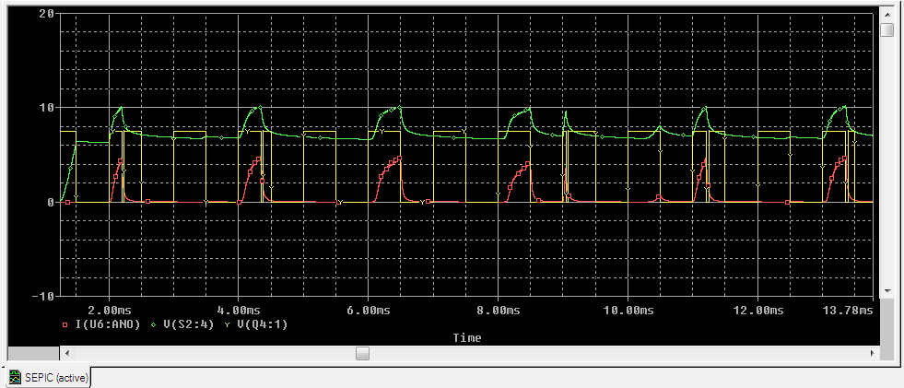

1. OUTPUT VOLTAGE, CURRENT AND IS CURRENT :

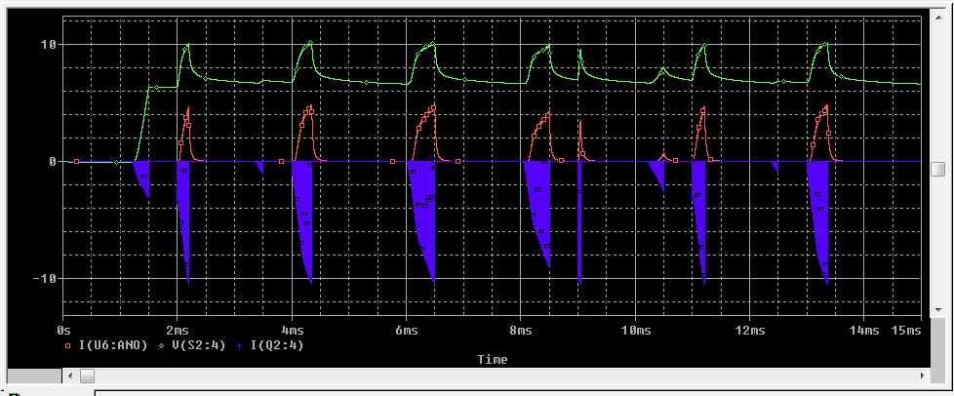

1. OUTPUT VOLTAGE, CURRENT, DDRV VOLTAGE AND IS CURRENT :

