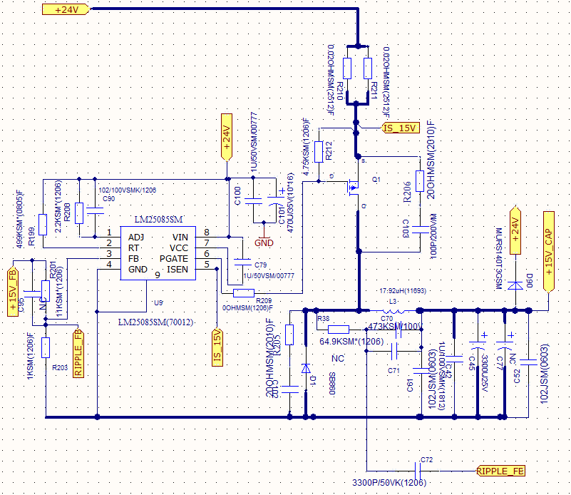

Design for:

Input voltage: 24V

Output voltage: 15V

Output load: 0-4A

Output cap 3300uF, ESR value is 28mOhm. (the output load also has 10 100uF cap)

Issue is that when have light load, the Jitter is obvious and cause current limit at every duty cycle.

The question is that

1. Will the Jitter issue be accepted ？Will the jitter issue cause output voltage be abnormal(the test value show voltage ripple is accepted)
2. If the frequent current limit is a issue to LM25085 itself(the Voltage spike of mosfet and diode has big margin)
3. If change the output cap to be 470uF 5mOhm, will it help?

If we use smaller RrCr, the jitter issue is improved while bigger output voltage ripple.

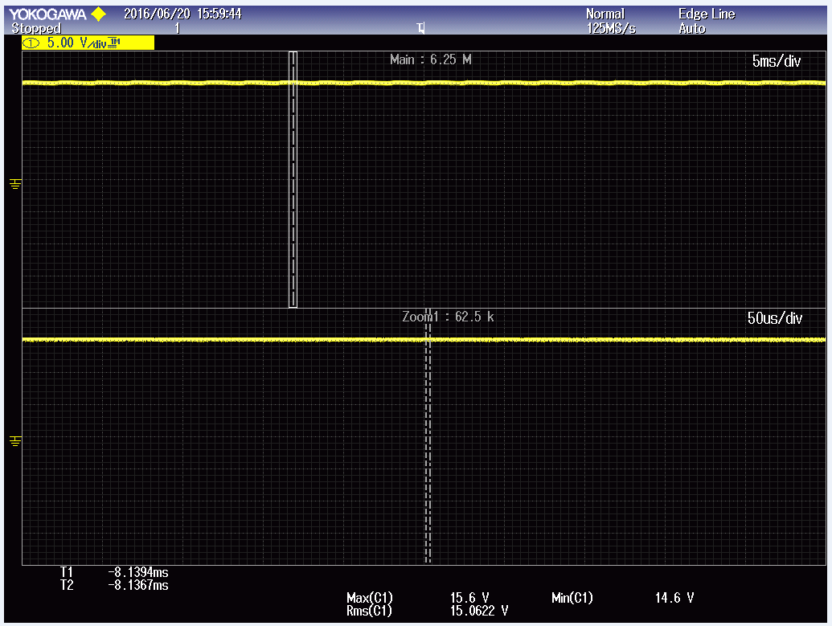

0.2A load

CH1 15V (DC)

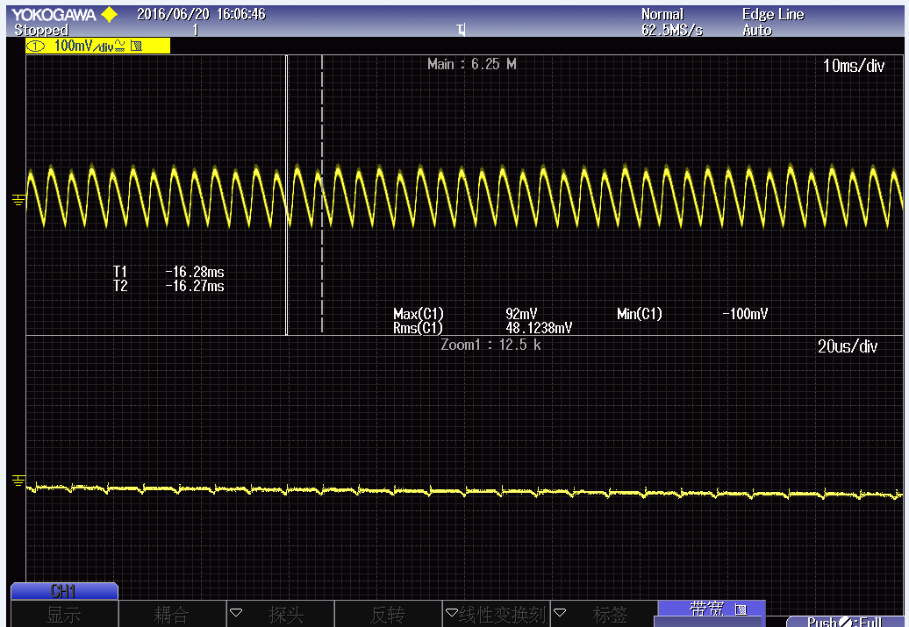

0.2A load

CH1 15V ripple voltage(AC)(2M band)

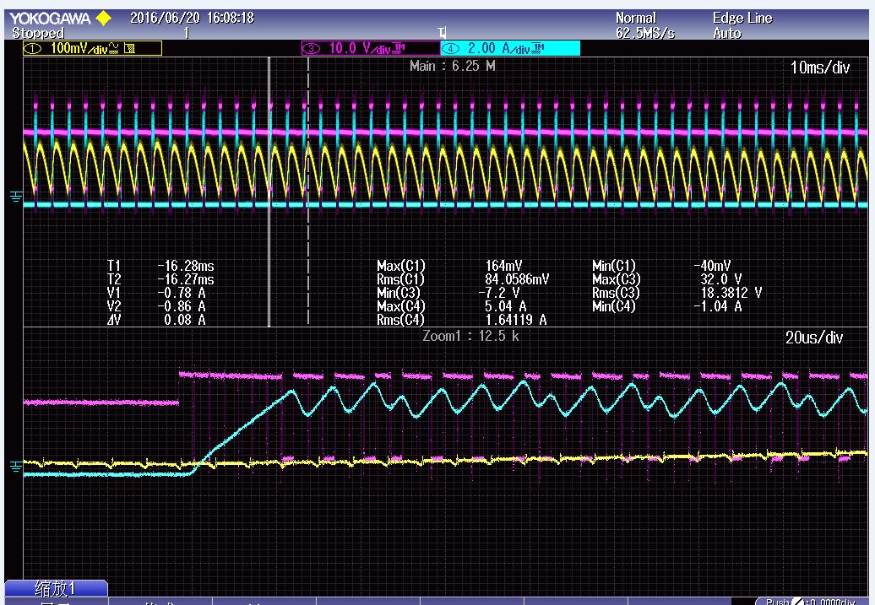

0.2A load

CH1 15v ripple(AC) (2M bandwidth)

CH2 Vr of diode

CH3 inductor current

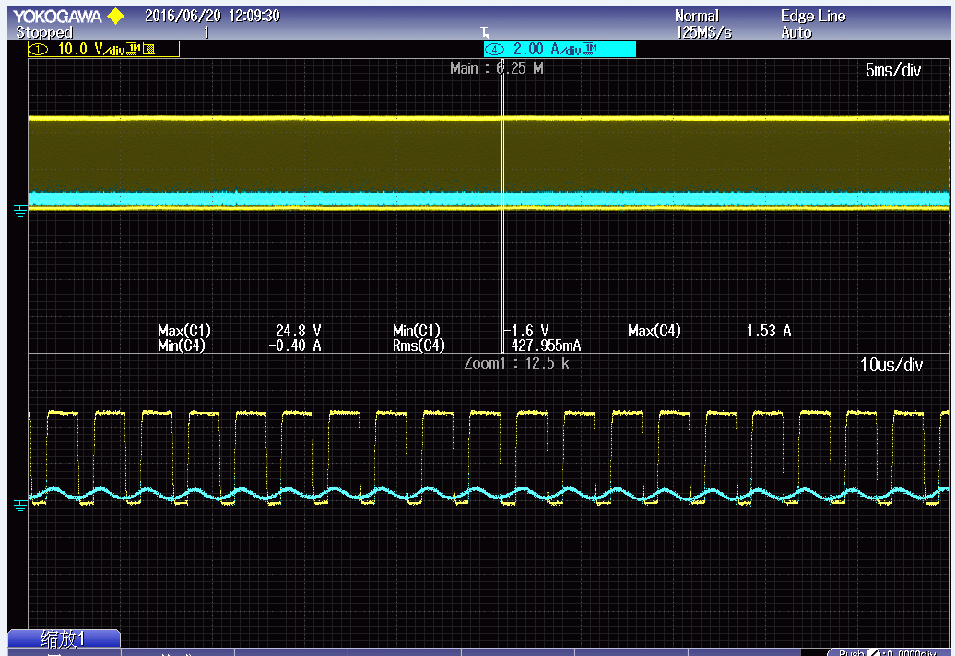

0.7A load

CH1 Vr of diode

CH2 inductor current



0.7A load

CH1 Vr of diode

CH2 inductor current

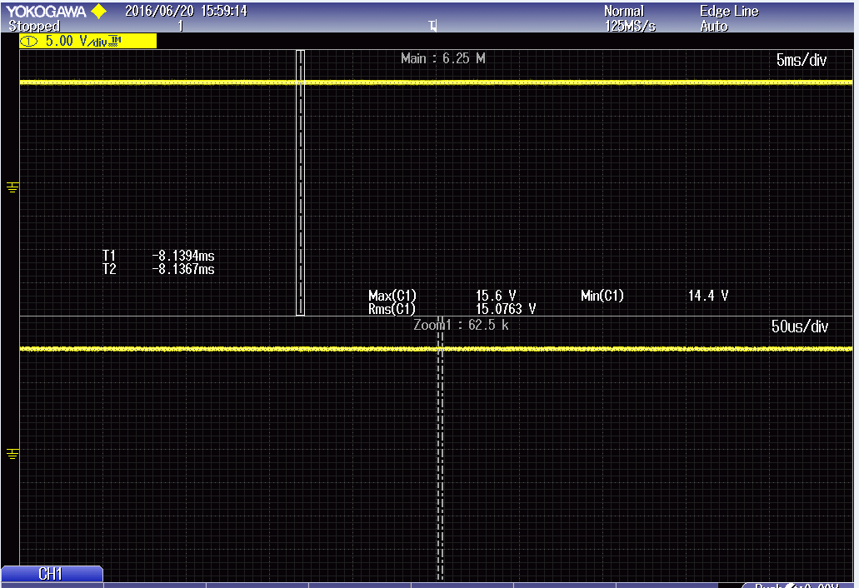

2A load

CH1 15V



2A load

CH1 15V

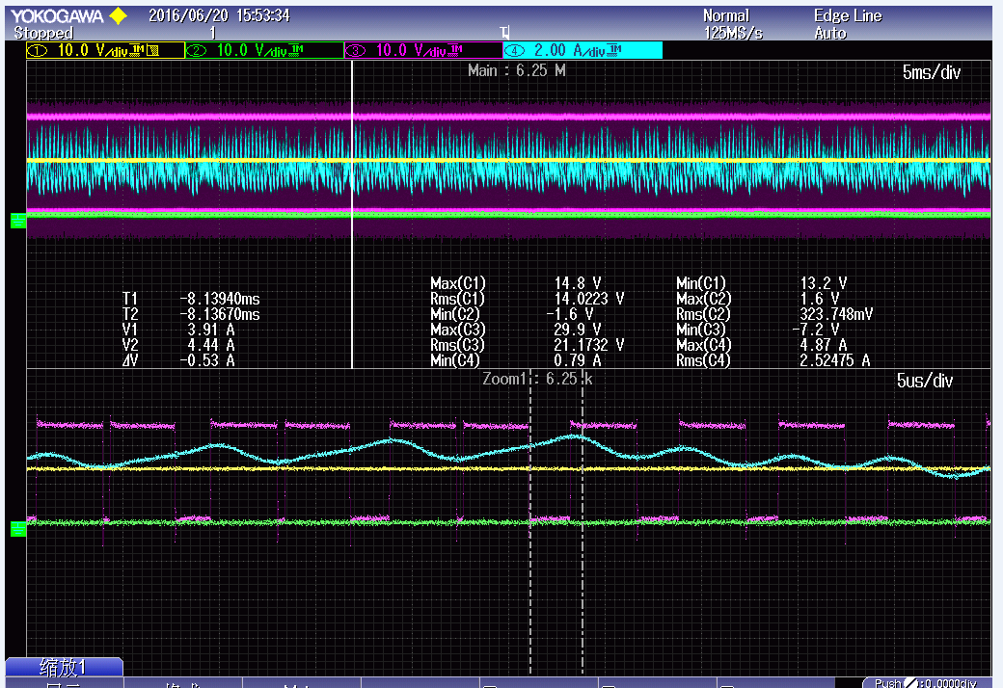

3A load

CH1 the Vr of diode in sps 2

CH3 the Vr of diode in sps 1

CH4 the inductor current