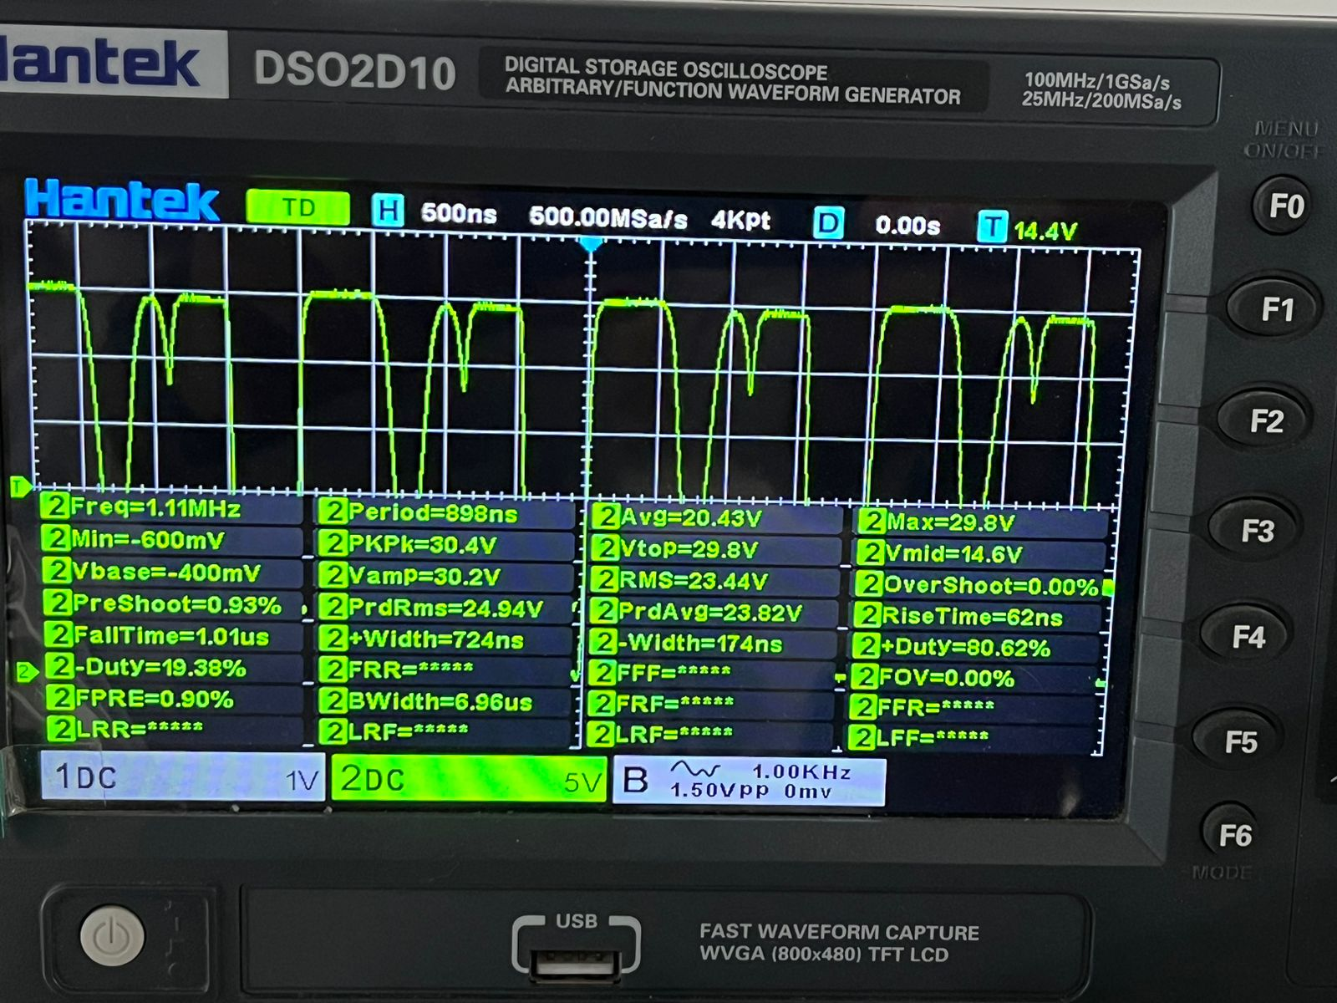
1.Vin: 29.1V
Vout: 20.3V
This case the regulation is good but check the frequency, it is not what I have set using RT resistor. It should be 517kHz.
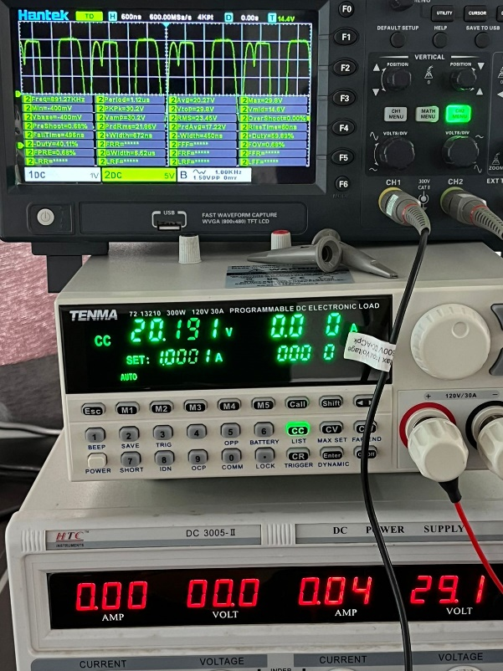
2.In another case I got a good regulation and a good switching frequency as shown below at 29.4V input:
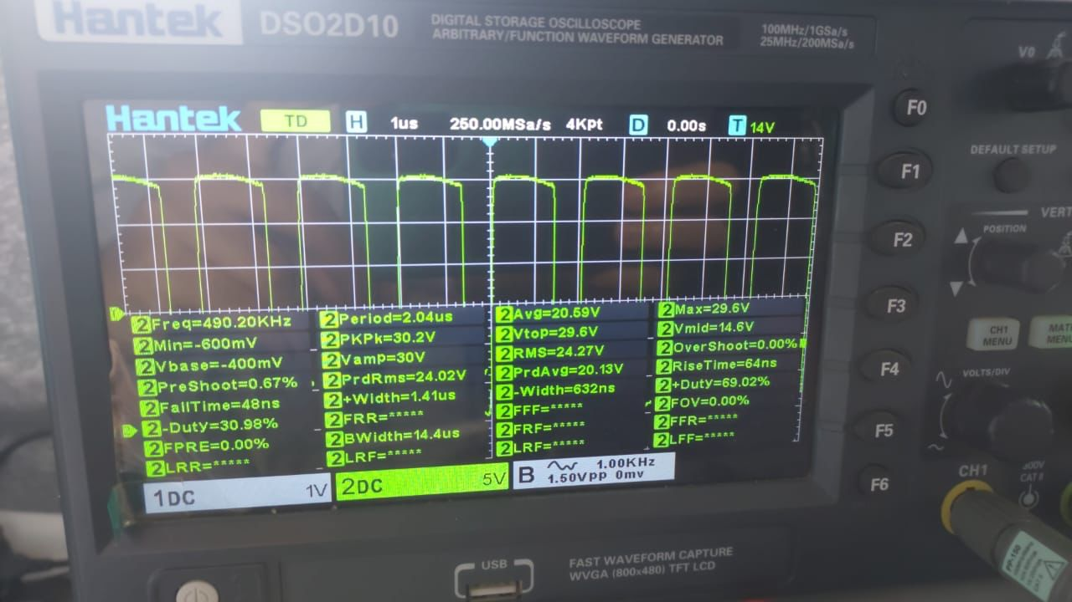

3.Now check this out:
On a load of 2A and a Vin=25.2V, the output falls to 17.9V as seen in the picture below
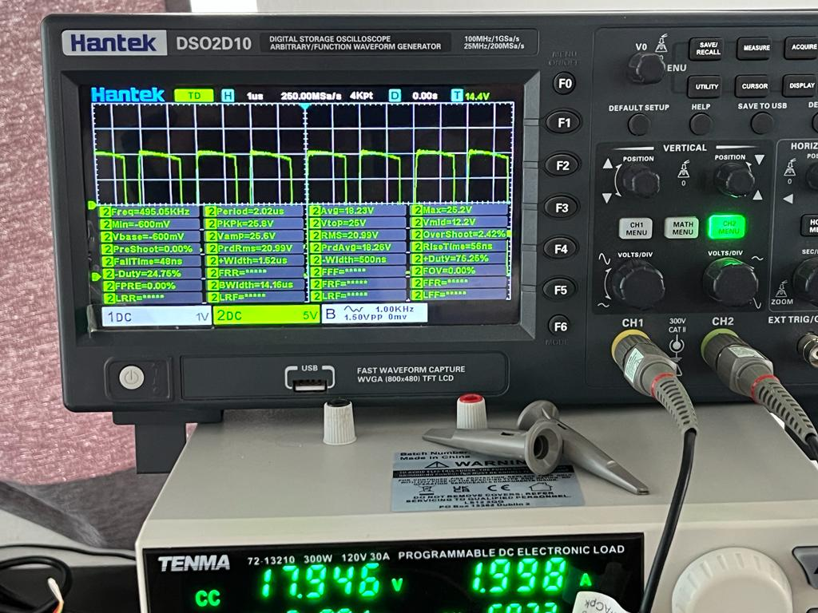
4.In this case, the load of 2A got the IC to go into a fault condition and dropped the output voltage to 2.1V as shown at an input of 24.7V which should not happen since I’ve set the current limit to around 9A (C_ramp=220pF, R_ramp=273.4k Ohm and R_sense= 5mOhm)
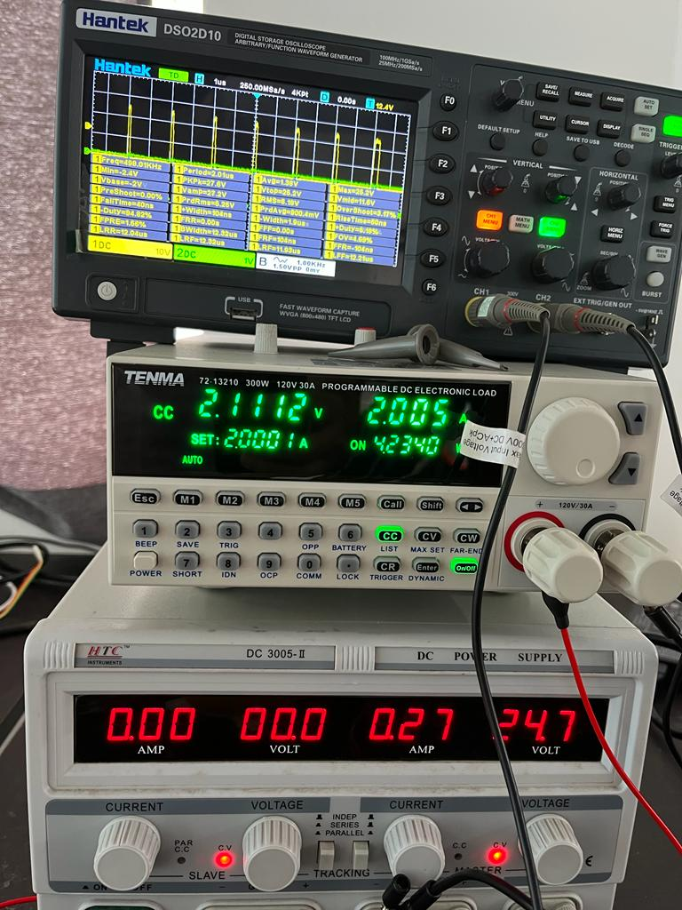

5. Last case is on NO_LOAD where the duty cycle is not increasing and the voltage at the output drops with dropping input. (No image provided)

