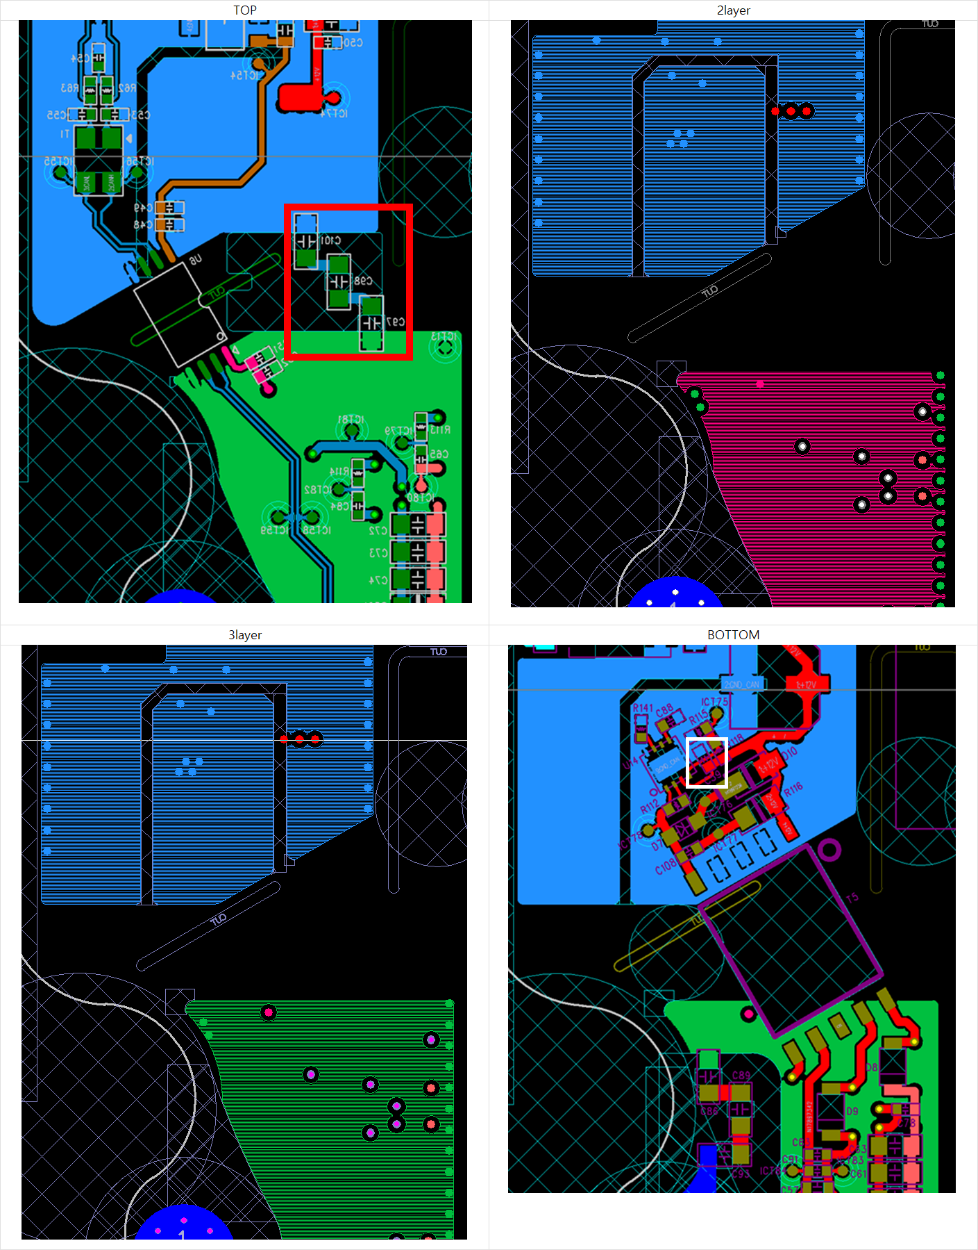
C59: ceramic cap
White square
C97, C98, C101

