LM2576HVT-5.0:

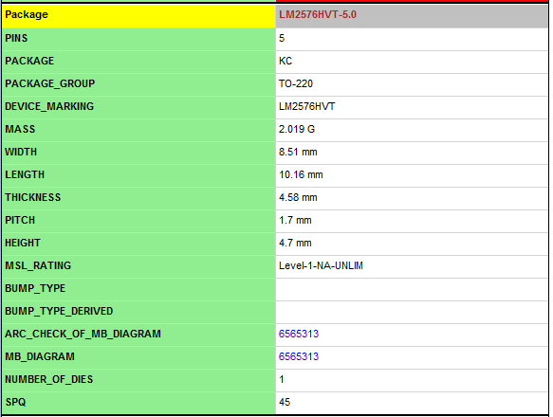

LM2576HVT-5.0/LB03:

