PCB layout:

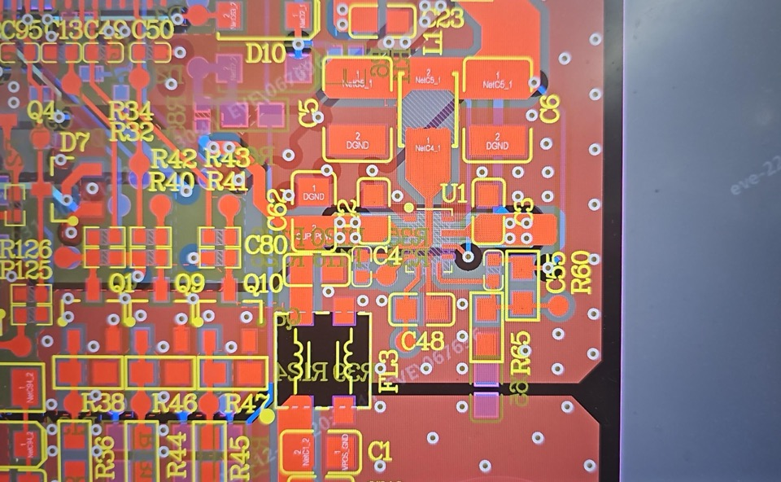

EMC tuning step for LMR36006AQRNXRQ1

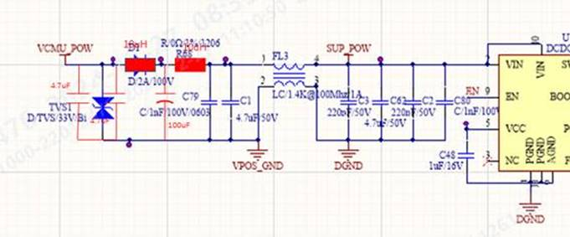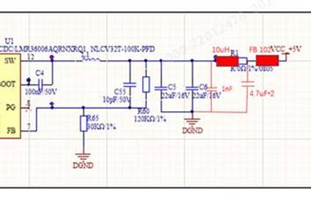

1. Add 2\*10uH inductor, 2\*4.7uF +100uf cap on input
2. 1000Ω FB (impedance is 100M) ,10uH inductor, 1nF + 4.7uF cap on output

Result:

CE margin on FM frequency is only 1dB；RE on MW frequency is 2dB above standard)

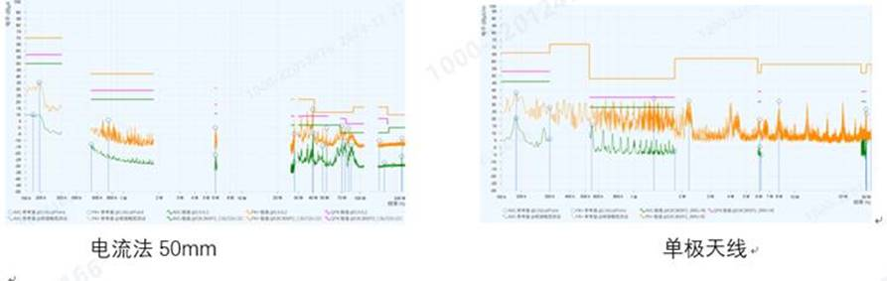

EMC tuning for LMR36006FSCQRNXRQ1:

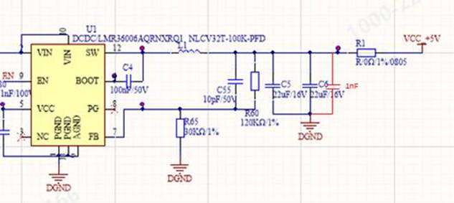

Result: pass

