LM36510

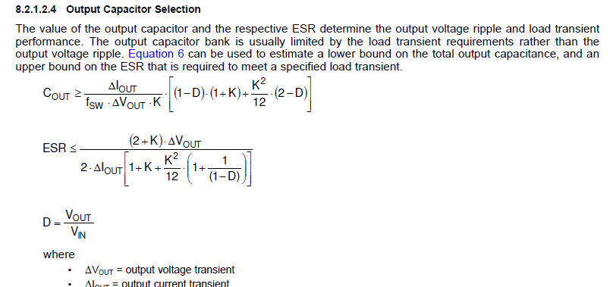

Here

Page no 19.

What is ΔVOUT = output voltage transient

• ΔIOUT = output current transient

In this data there is no value provided?

How to do Conduction and switching losses of Buck Regulator?