Project Description: Full bridge hard switching power conversion, LM5036 main PWM control chip, with two isolated drive cores to drive a pair of bridge arms.Input voltage 18-36VDC, output 28VDC.Target power is 600W.
The circuit diagram is as follows:
Problem description:
The power supply does not work properly, triggering the LM5036 internal protection mechanism (overcurrent protection).
Some related abnormal waveforms captured at the input voltage of 19VDC are shown in the table below:
Output synchronous rectifier, CSSSR capacitance value is small.1 channel SSSR voltage;2 channels SS voltage;3 channel output voltage VO
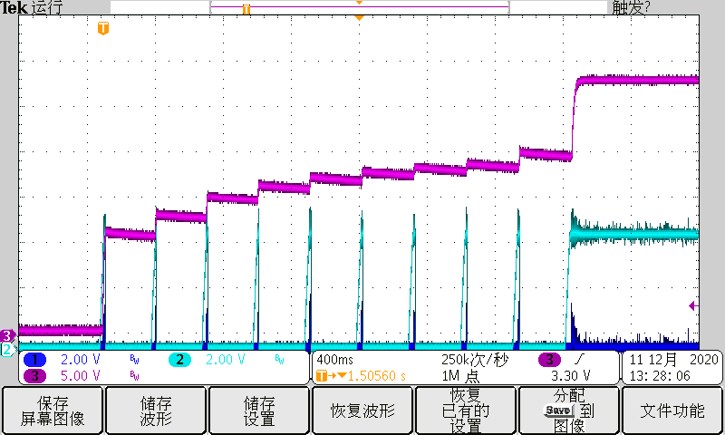  Io=0A | 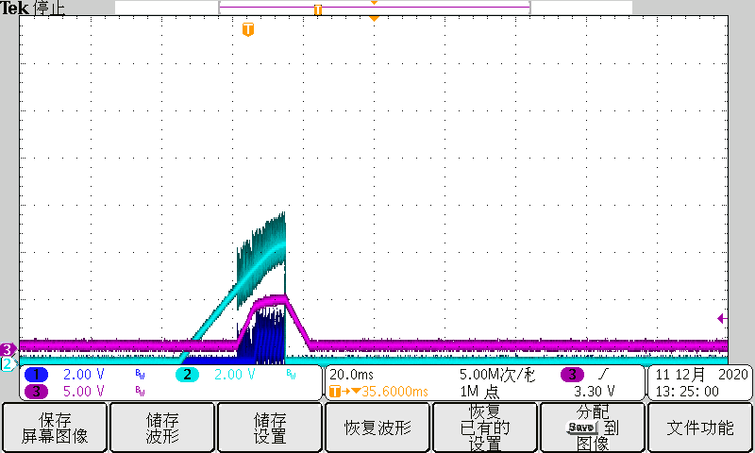  Io=1A
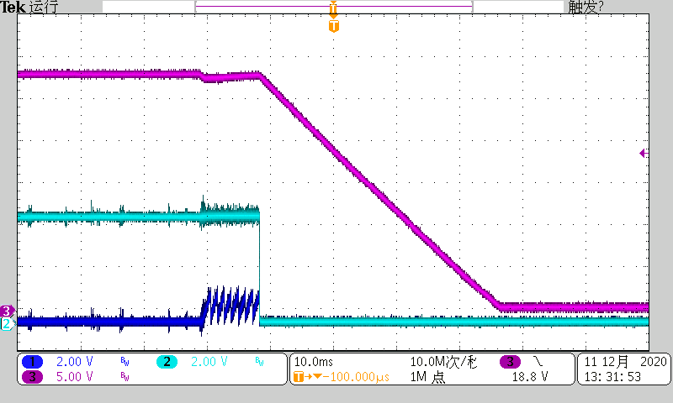  IO switches from 0A to 1A | 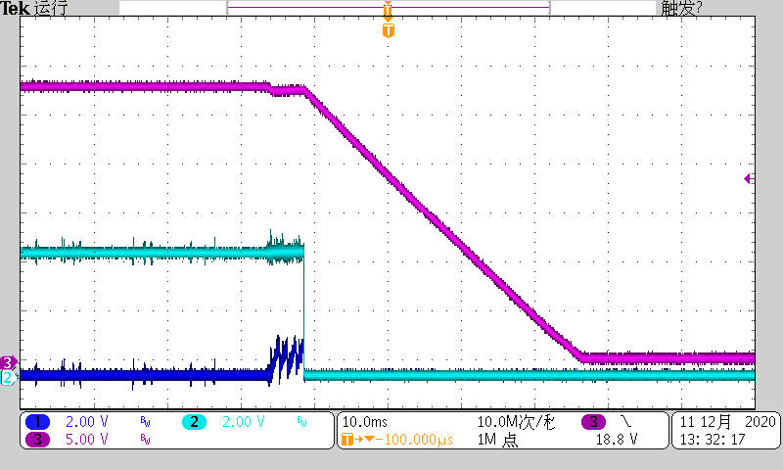  IO switches from 0A to 1A
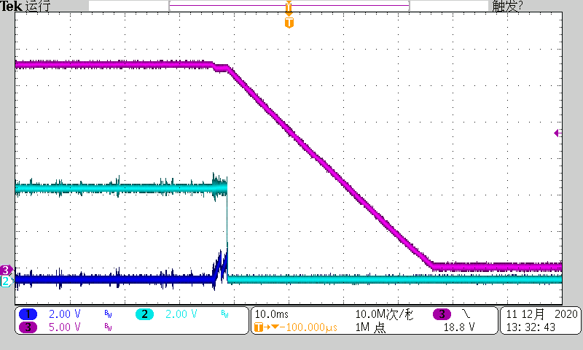
IO switches from 0A to 1A

Output synchronous rectifier, CSSSR capacitor in parallel on the basis of the previous 104.1 channel SSSR voltage;2 channels SS voltage;3 channel output voltage VO
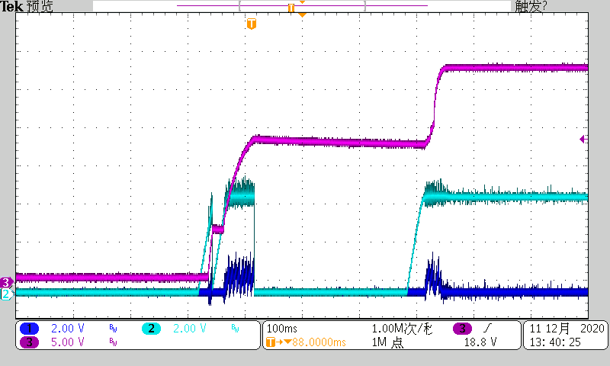  Io=0A | 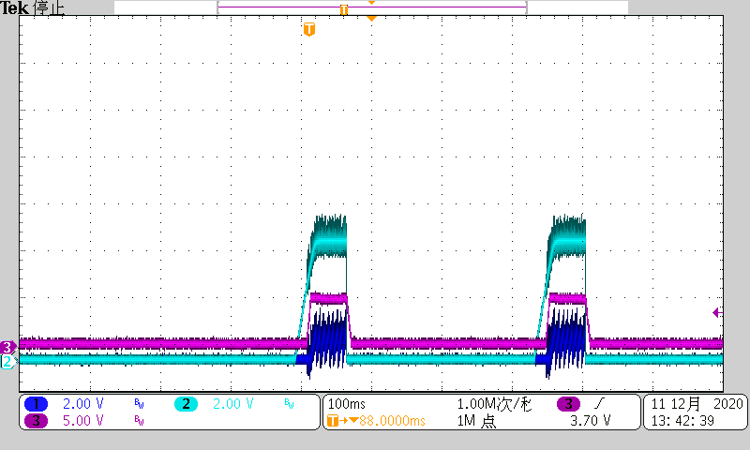  Io=1A
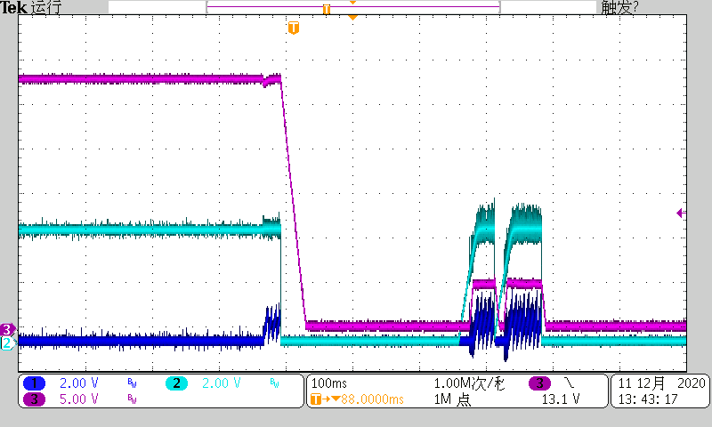  IO switches from 0A to 1A | 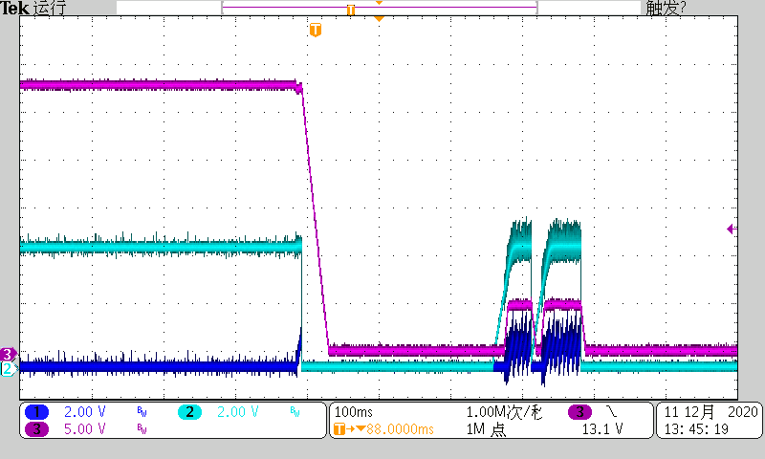  IO switches from 0A to 1A
Turn off the synchronous rectifier and use the MOS bulk diode to rectify
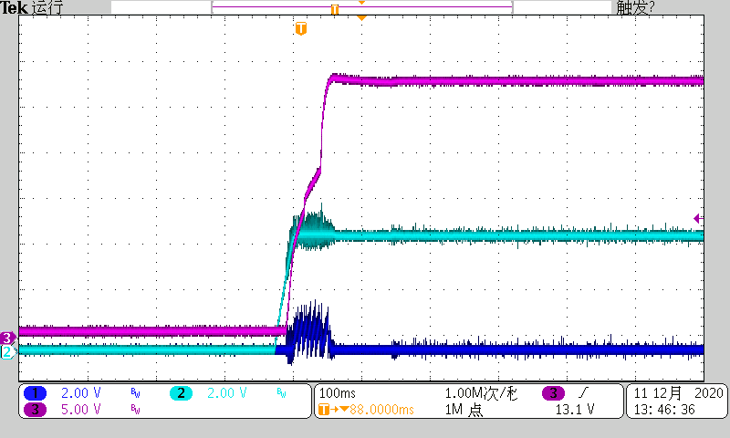  Io=0A | 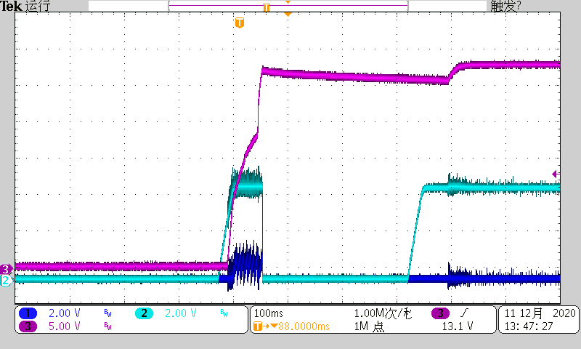  Io=0A
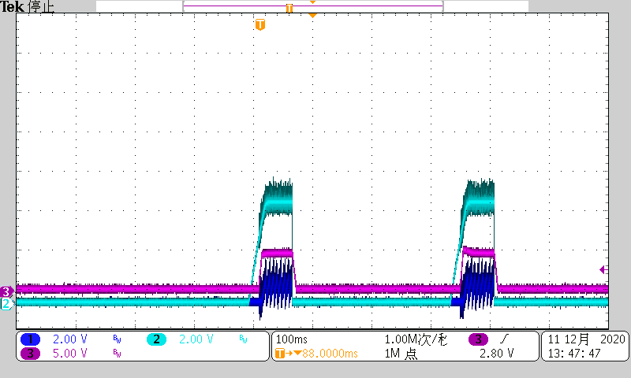
Io=1A
Using ST super fast recovery diode
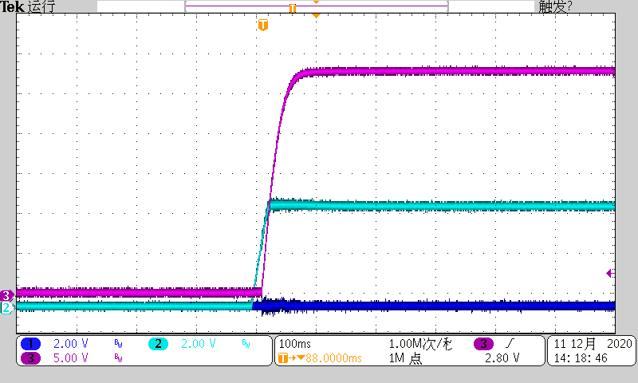  Io=0A | 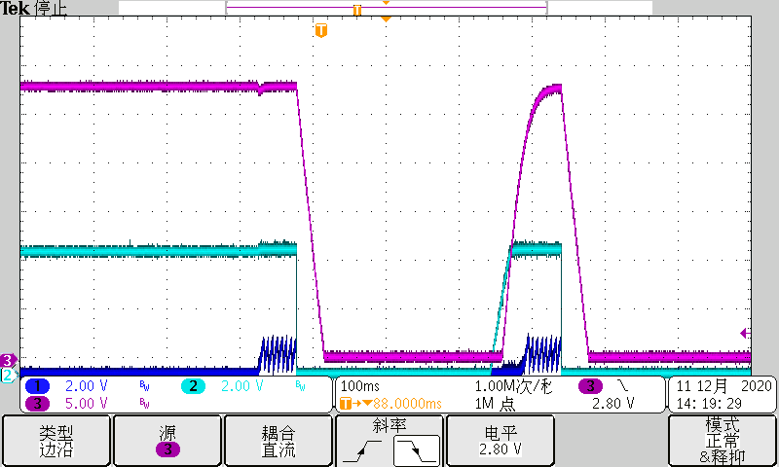  IO switches from 0A to 1A
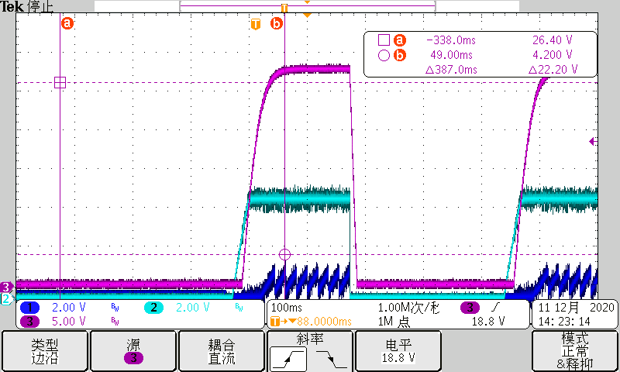  Io=3A | 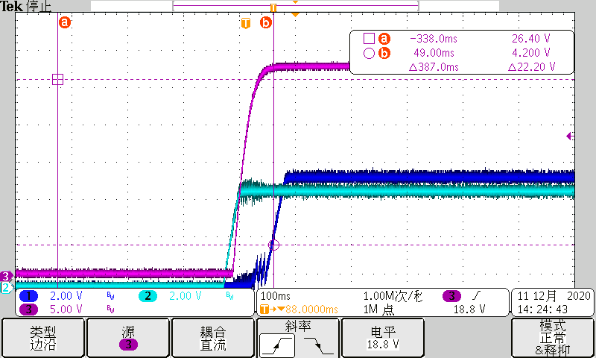  Io=3A
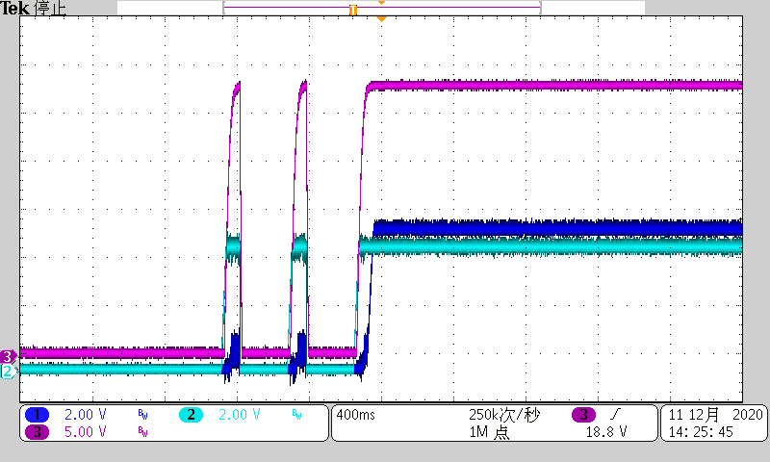
Io=3A
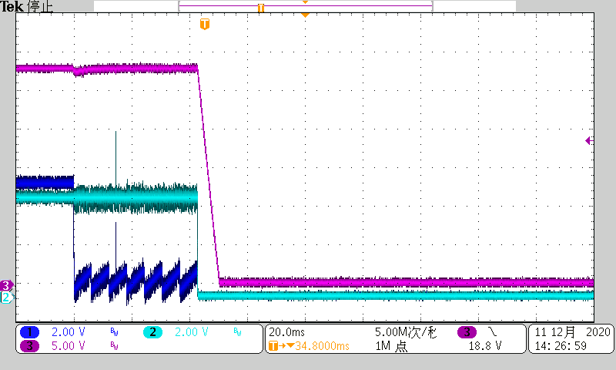  IO switches from 3A to 4A | IO switches from 3A to 4A

