Hi Eric,

Here are the measurements of the step-down regulator. At higher current, the voltage is stable; I'm only bothered by the jitter on the falling edge, even though pin 10 dithering is connected to GND. When operating without a load and at lower current up to approximately 100 mA, the voltage drops below 24 V and exhibits low-frequency ripple. Is there any alternative solution besides using an additional dummy load? I’d rather avoid increasing thermal dissipation in the circuit by using a dummy load

Schematic 48V/24V/5.5A



NO LOAD CONDITION – Pin 10 Dithering connected to GND

Green - Switch node probe (short ground spring) beetwen cathode and gnd of sense resistor

Purple - short ground spring Pin 7 COMP

Light Blue - Outout voltage 18V

Blue - Input voltage 47V

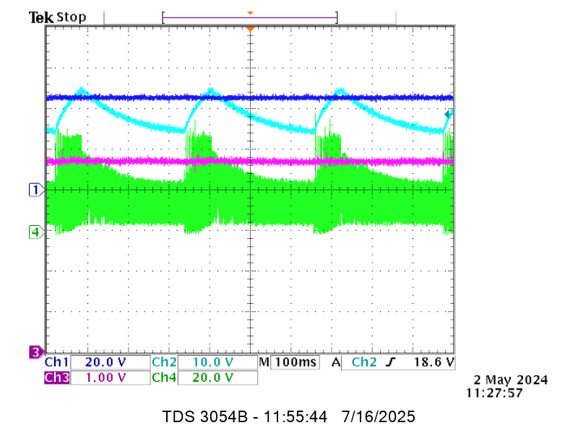

Load 235 ohm / 100mA

Green - Switch node probe (short ground spring) beetwen cathode and gnd of sense resistor

Purple - short ground spring Pin 7 COMP

Light Blue - Outout voltage 24V

Blue - Input voltage 47V

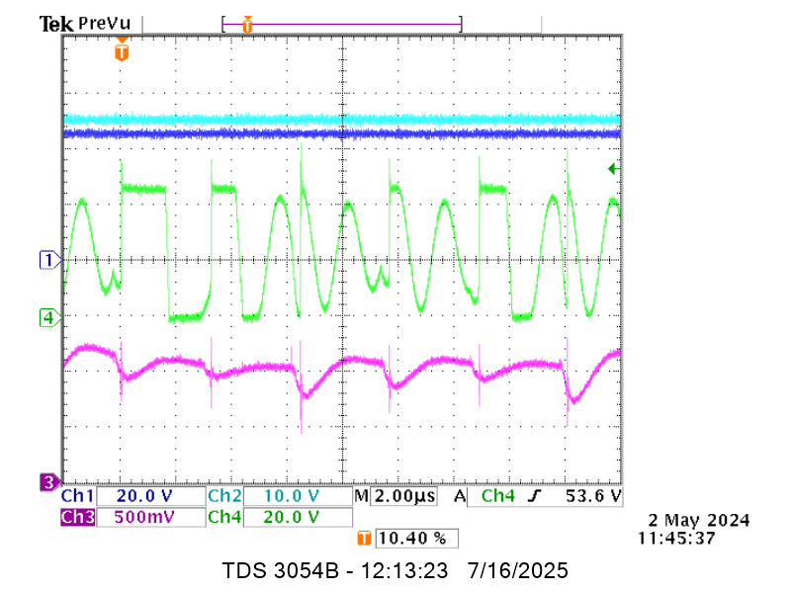

Load 10 ohm / 2.4A

Green - Switch node probe (short ground spring) beetwen cathode and gnd of sense resistor

Purple - short ground spring Pin 7 COMP

Light Blue - Outout voltage 24V

Blue - Input voltage 47V

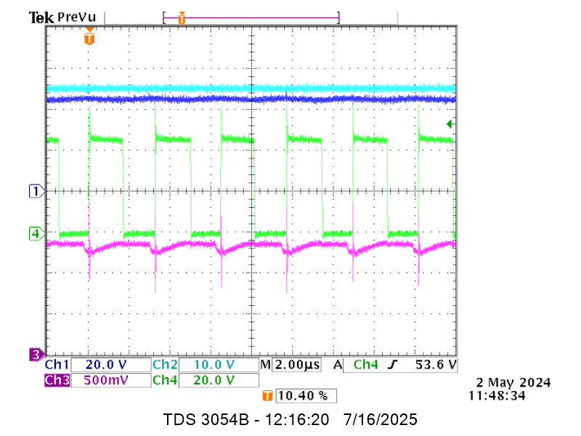

Load 4.6 ohm / 5.2A

Green - Switch node probe (short ground spring) beetwen cathode and gnd of sense resistor

Purple - short ground spring Pin 7 COMP

Light Blue - Outout voltage 24V

Blue - Input voltage 47V

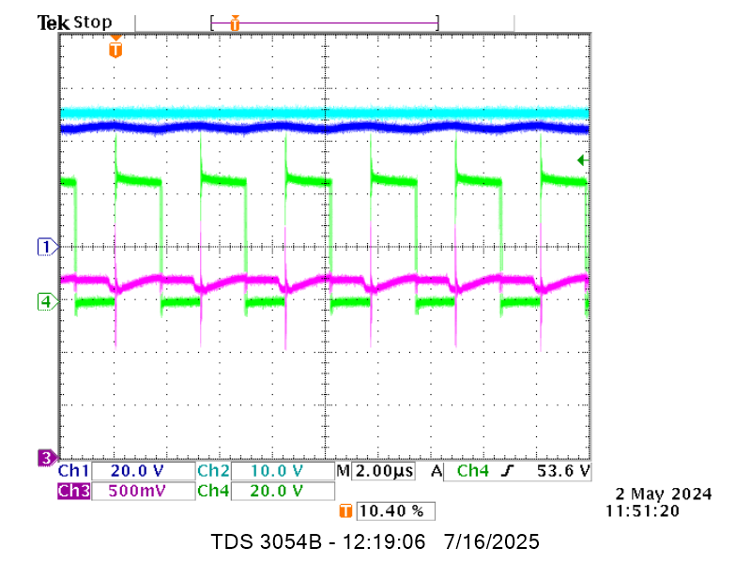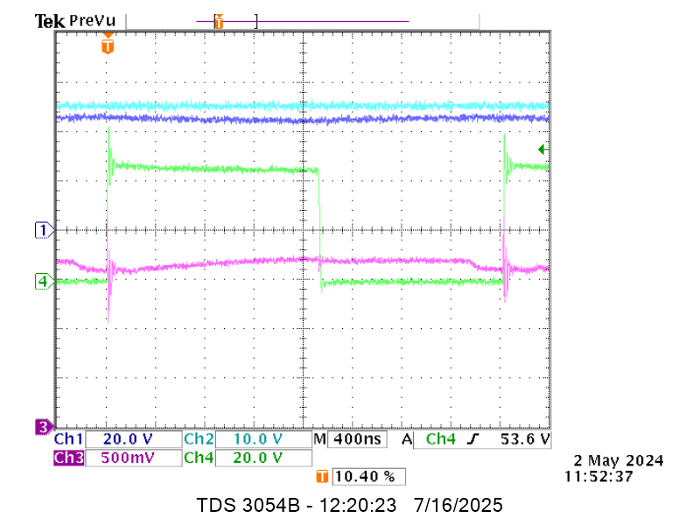

Jitter on falling edge - Pin 10 Dithering connected to GND

