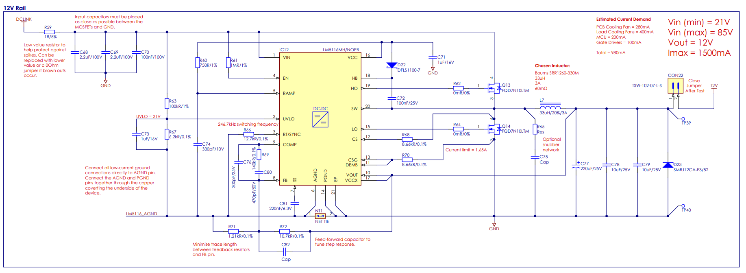

**\*750k**

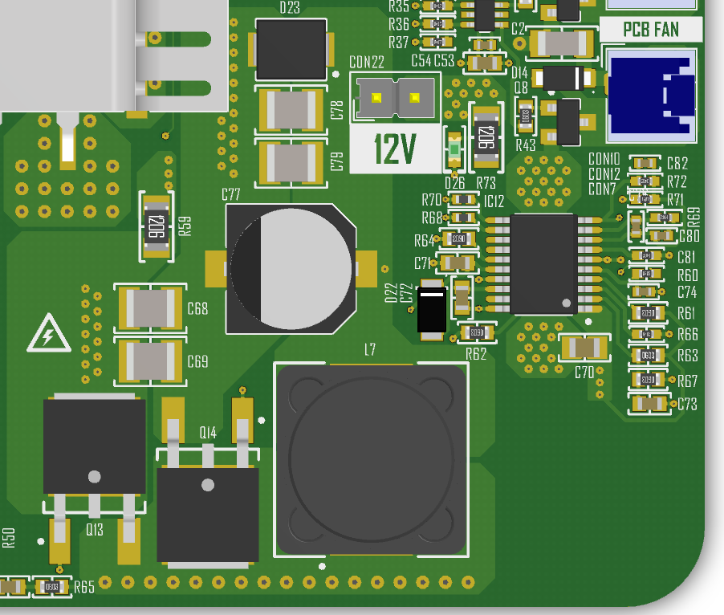

**LM5116 CONTROLLER**

**VOUT**

**COUT**

**CIN**

**INDUCTOR**

**HIGH SIDE MOSFET**

**HIGH SIDE MOSFET**

**INPUT VOLTAGE**

**TOP LAYER – POWER/SIGNAL**

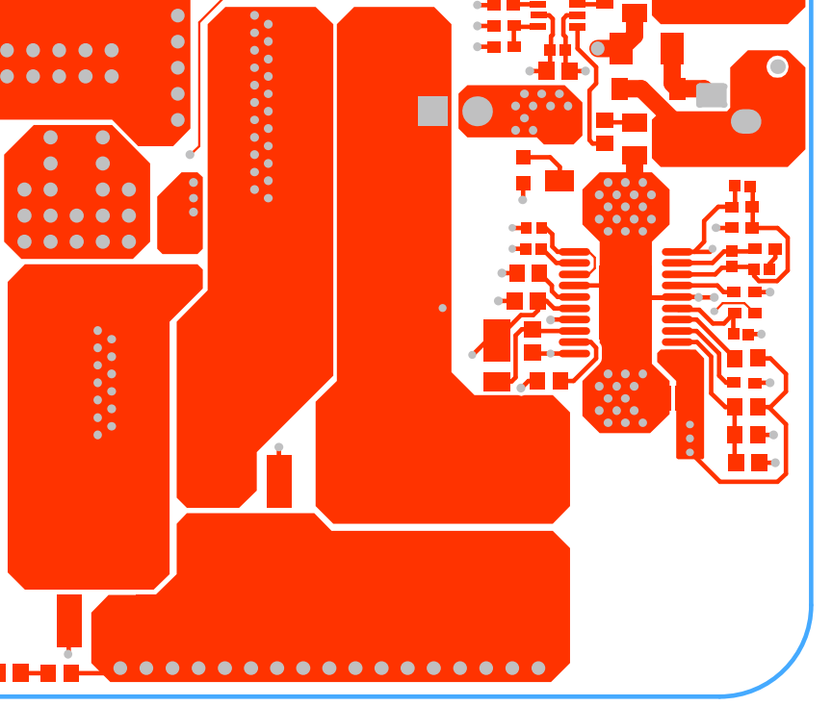

**GROUND**

**OUTPUT VOLTAGE**

**SWITCH NODE**

**INPUT VOLTAGE**

**INNER LAYER 1 - GROUND**

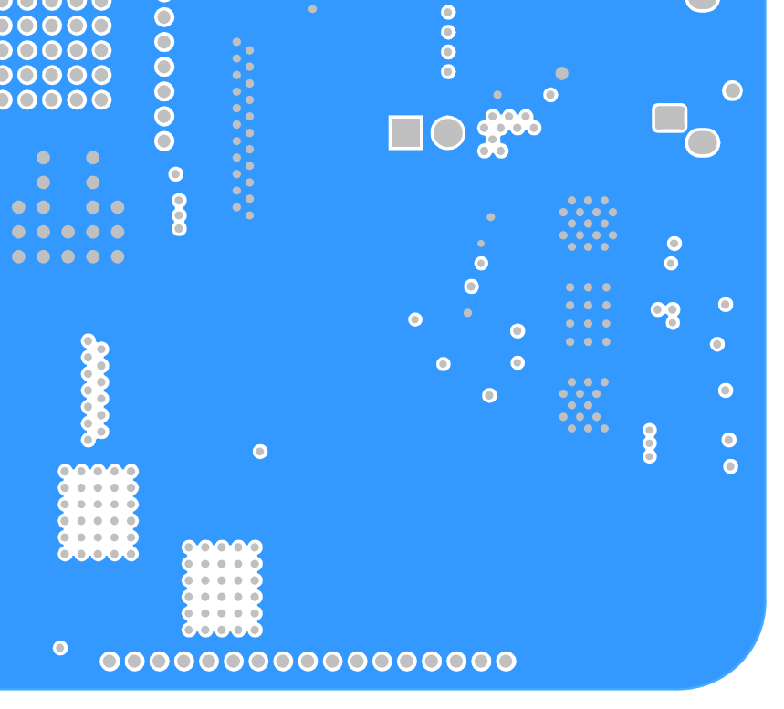

**GROUND**

**INNER LAYER 2 – SIGNAL**

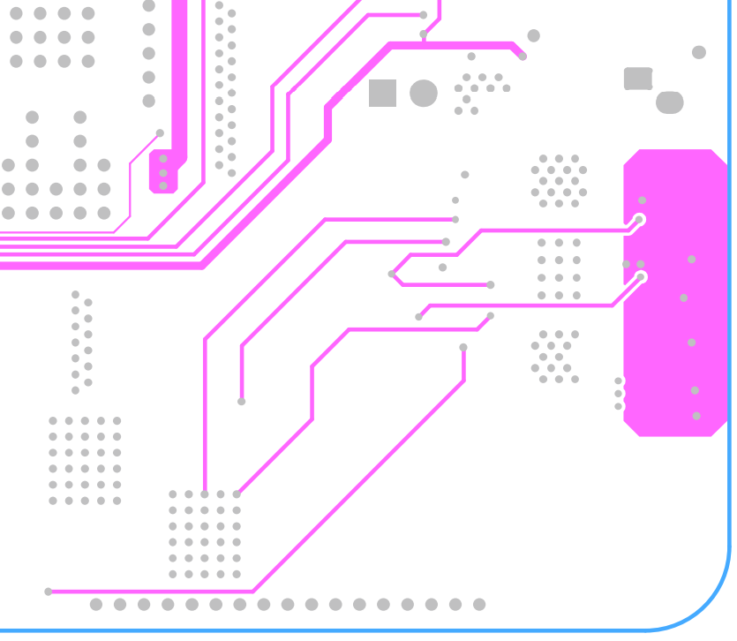

**SW PIN**

**LO PIN**

**HO PIN**

**BOTTOM LAYER – POWER/GROUND**

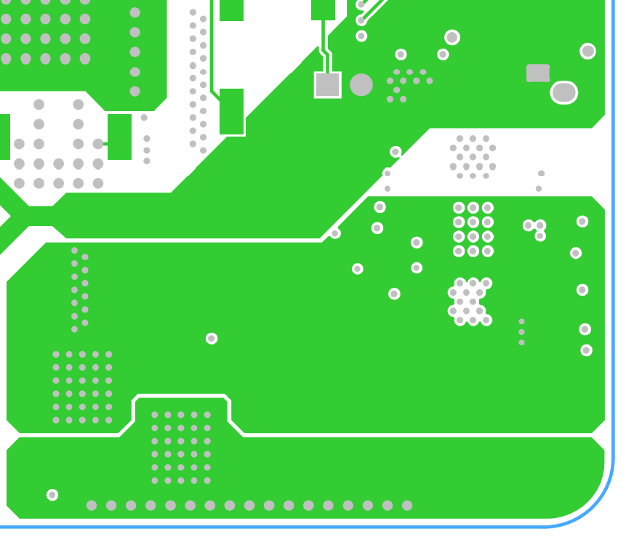

**OUTPUT VOLTAGE**

**INPUT VOLTAGE**

**SWITCH NODE**