Hi Team,

I encountered a problem using LM5118MH.

My design should work at the next parameters:

Vin= 10.2V ÷ 28.8V

Vout = 12V

Iout limit = ~0.9A

The problem I encountered was, that when using an initial constant load of about 600mA (resistive load connected to the output), and input voltage lower than 14.7v – when turning on the input voltage, the output voltage got to about 8.2v, and not 12v as it should.

When looking at the transistors gate, it can be seen that the D.C is about 80% (off time = 400nSec):

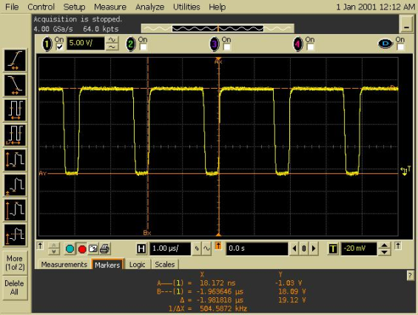

I was expecting that at this state, the working mode will change gradually to buck-boost mode, but it didn't.

It stayed at this situation, until the current was decreased (by increasing the resistor value).

It seems like the converter is in over current mode.

After the current was decreased, the converter started working as it should and reached  the expected maximum current.

When turning on the converter without load, and then increasing the load to 600mA, it works the way it should!

I attached my design.

1. Am I right? Is the converter in over current mode?
2. If it is, why?
3. Why is it happening only at startup?
4. How can I fix it?

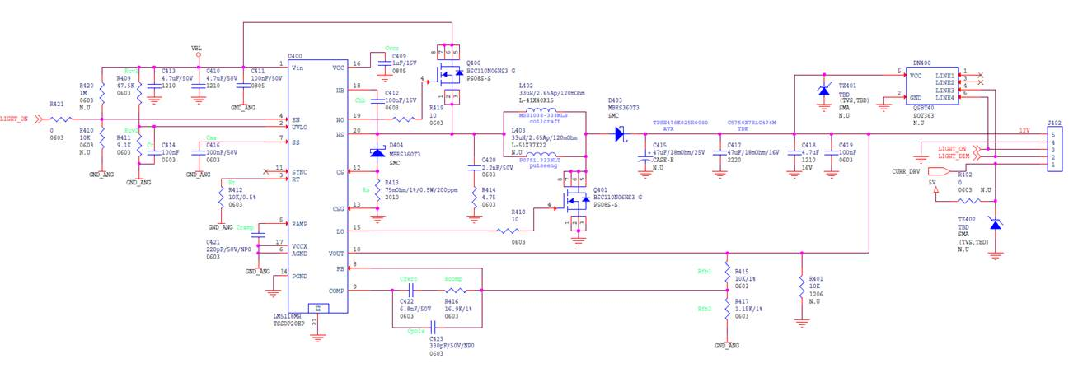

Thanks,

Shlomi