Hi Team,

I have few questions regarding TI P.N LM5118MHX (<http://www.ti.com/lit/ds/snvs566j/snvs566j.pdf>):

1. Can you please advise what the height of the chip device body from the pcb surface including the tolerance?

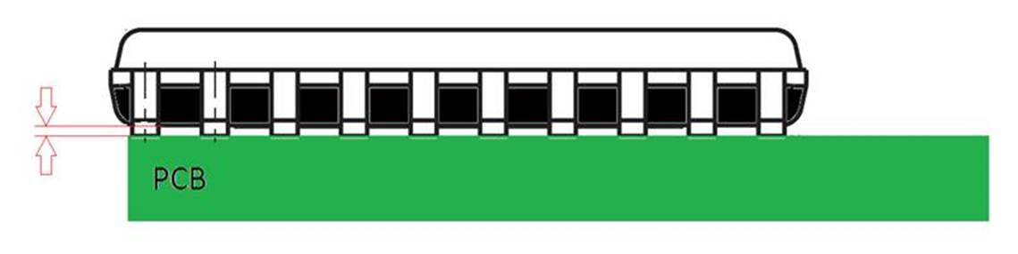

2. In the spec drawing we have found 2 different dimensions that marked in red circle in the screen shoot below,

   Can you please update what the difference between them?

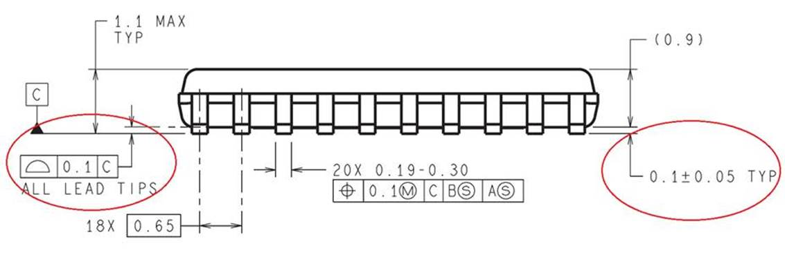

3. Can you please share information about TI recommendation for the thickness of the solder paste?

4. In the spec drawing, found the TI land pattern recommendation,

    Can you please share information about TI recommendation for the solder mask?

Best Regards,

Shlomi