LM5148 pin 19 EN is burned out, the resistance between pin 14 SW and pin 10 GND is 14.4 ohms, the resistance between pin 14 SW and pin 15 CBOOT is 11.8 ohms, and the resistance between pin 15 CBOOT and pin 10 GND is 5 ohms
LM5148 SW与GND 14.4R,CBOOT与SW 11.8R,CBOOT与GND 5R The waveform-related tests are as follows ：

There are two unclear points; please confirm with the product line. Thank you.
1. During normal operation, when the lower transistor Q13 is turned on, the voltage at the lower transistor's DS is around 8V. Is there a risk of direct conduction?
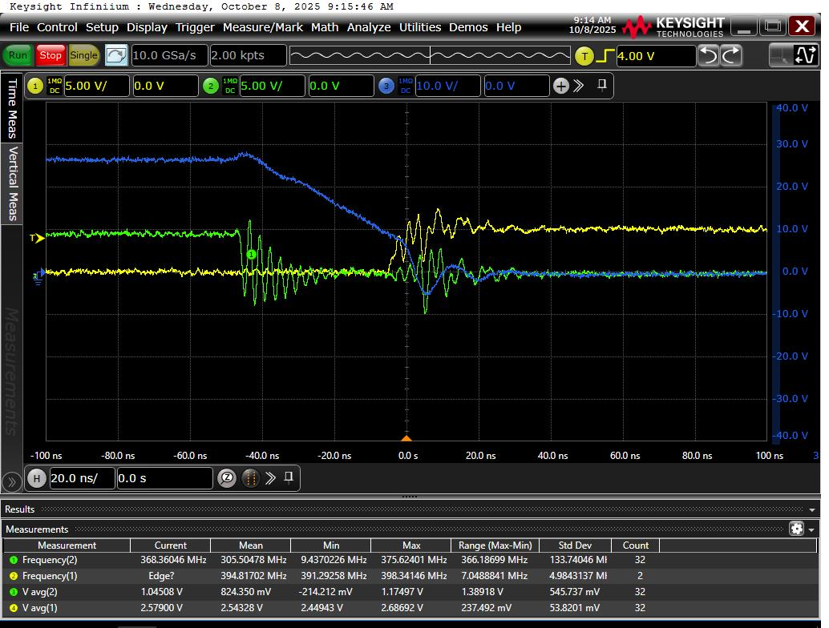
Figure 1: Channel 1 Q13_GS, Channel 2 Q12_GS, Channel 3 Q13_DS (SW), with a load of 0.3A
2. Because EN is connected to VIN, when the VIN voltage reaches about 16V, as shown in Figure 2, there is a 20ns dead time between the upper MOSFET turning off and the lower MOSFET turning on, as shown in Figure 3. After the upper MOSFET turns off in Figure 4, due to the inductor current being negative, the upper MOSFET’s diode conducts, and the lower MOSFET’s DS voltage does not drop. After 20ns, the lower MOSFET’s GS turns on, pulling the lower MOSFET’s DS to 0V, causing DS voltage oscillation, and negative voltage appears on pin 14. Please help analyze whether this operating condition could cause a short circuit between LM5148’s SW and GND.
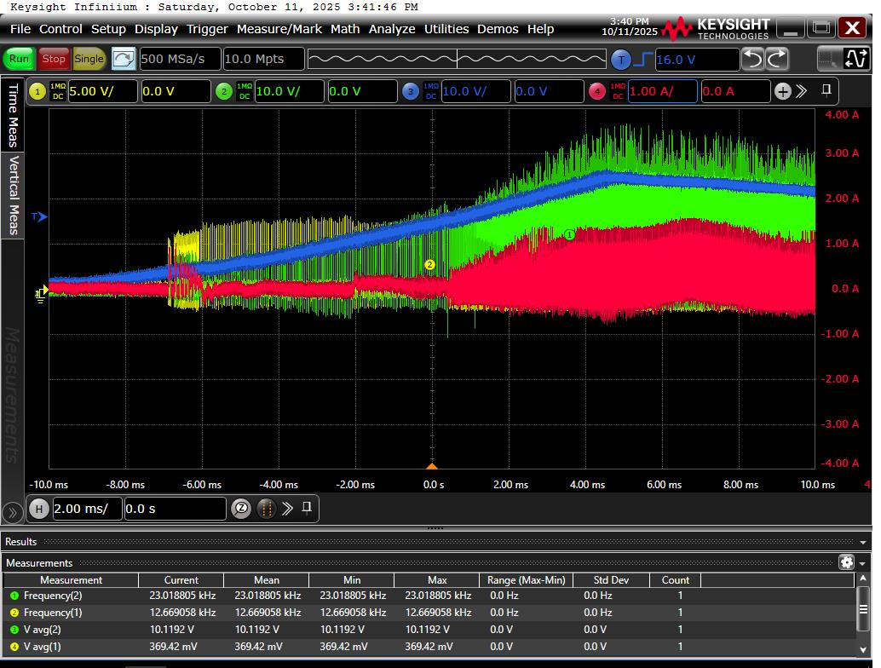
Figure 2: Channel 1 Q13_GS, Channel 2 Q13_DS, Channel 3 C82 voltage, Channel 4 L9 current. Load current 0.3A
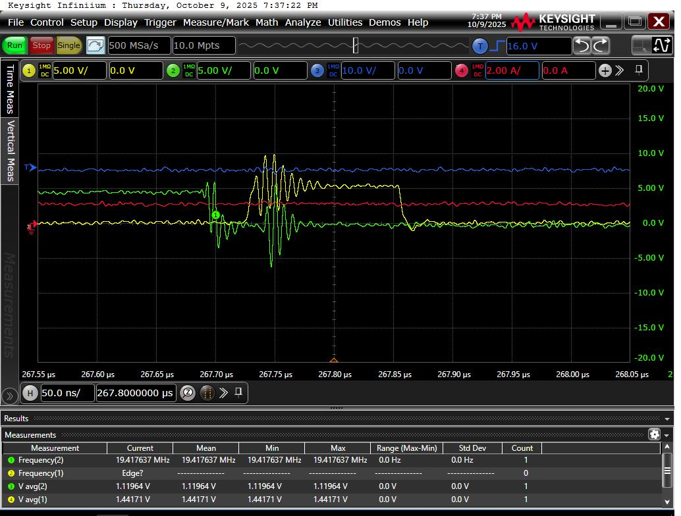
Figure 3: Channel 1 Q13_GS, Channel 2 Q12_GS, Channel 3 C82 voltage, Channel 4 110V input current. Load current 0.3A
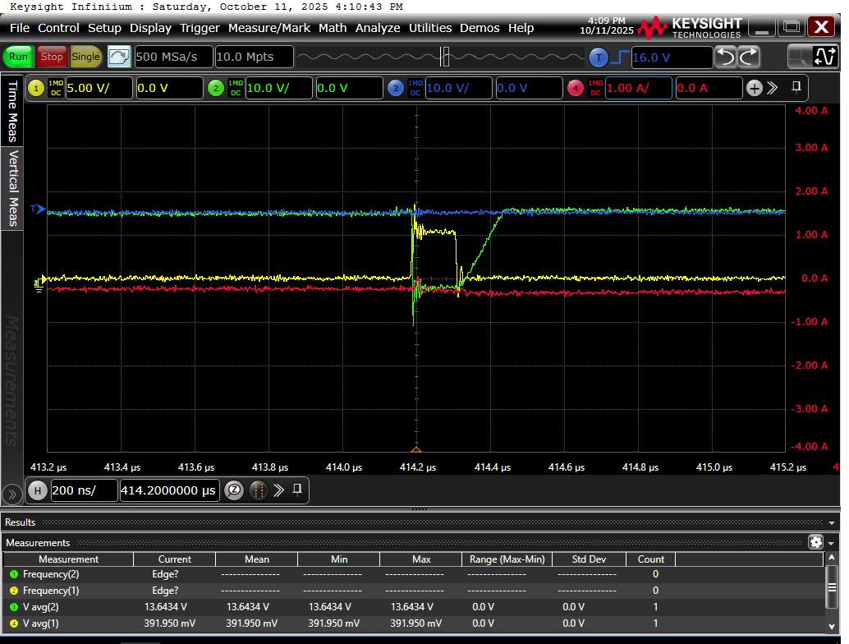
Figure 4: Channel 1 Q13_GS, Channel 2 Q13_DS, Channel 3 C82 voltage, Channel 4 L9 current. Load current 0.3A

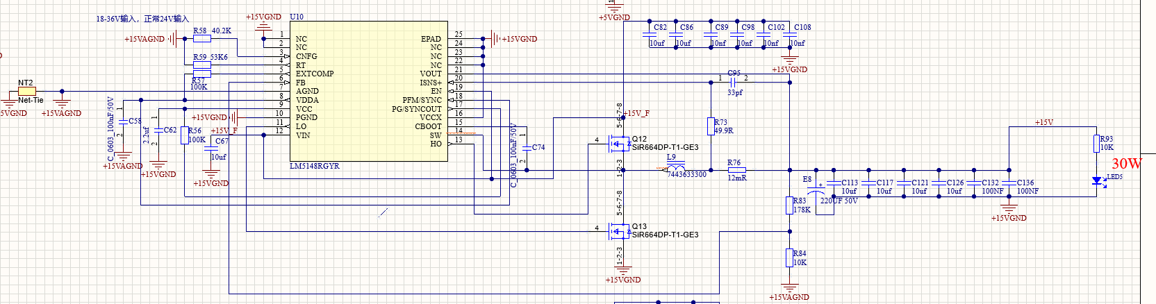

Channel 1 Q13_GS, Channel 2 Q13_DS, Channel 3 C82 voltage, Channel 4 L9 current. Load current 0.3A
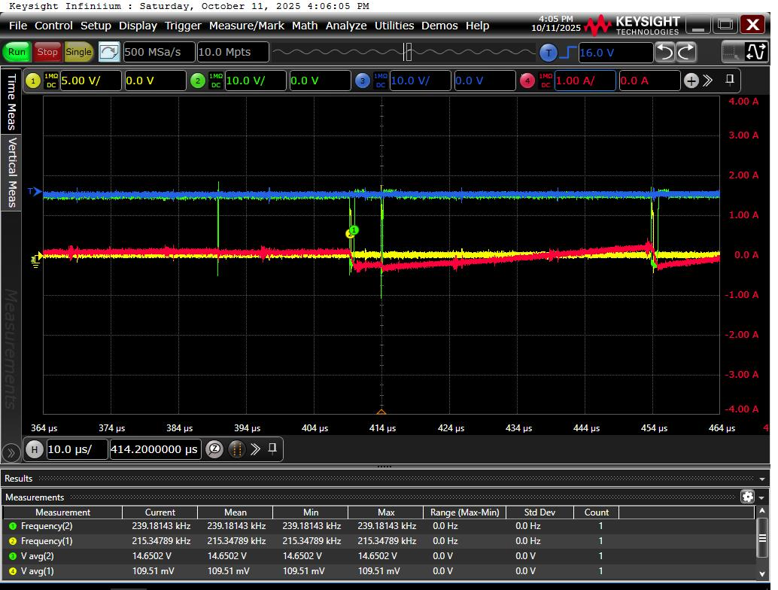
Channel 1 Q13_GS, Channel 2 Q13_DS, Channel 3 C82 voltage, Channel 4 L9 current. Load current 0.3A
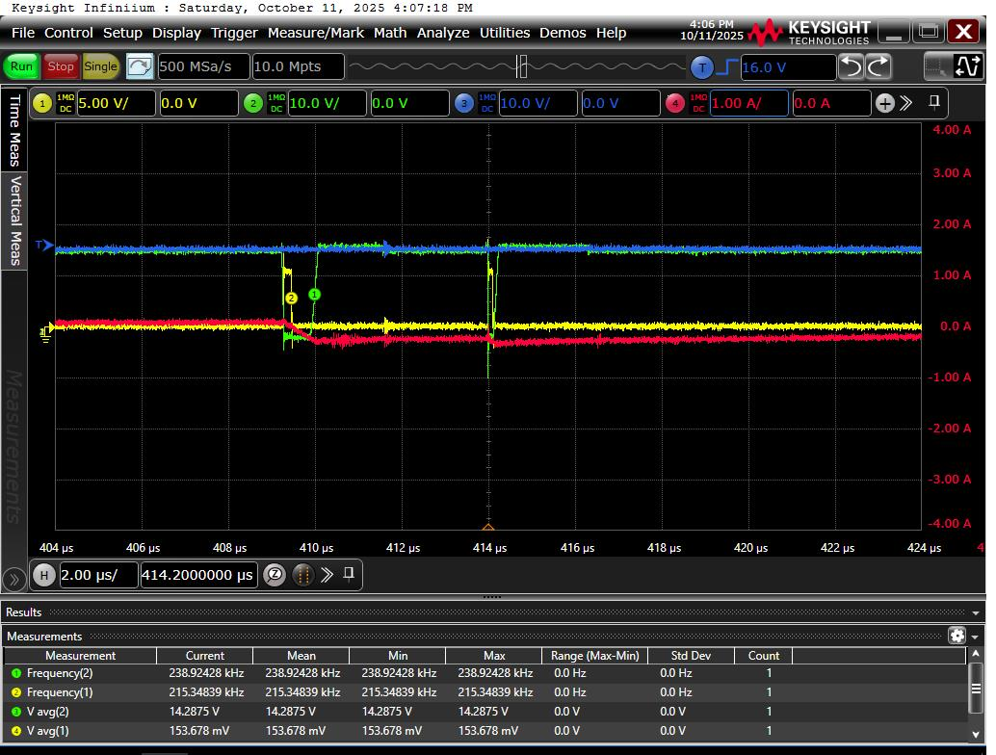
Channel 1 Q13_GS, Channel 2 Q13_DS, Channel 3 C82 voltage, Channel 4 L9 current. Load current 0.3A
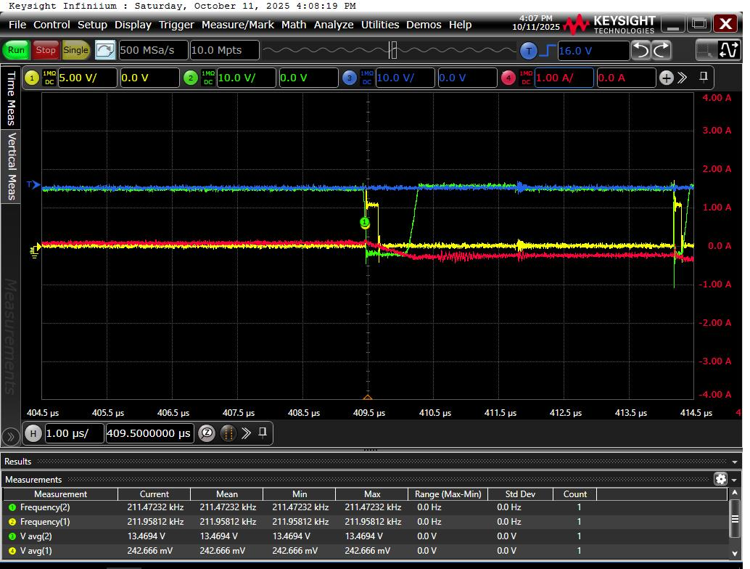
Channel 1 Q13_GS, Channel 2 Q13_DS, Channel 3 C82 voltage, Channel 4 L9 current. Load current 0.3A
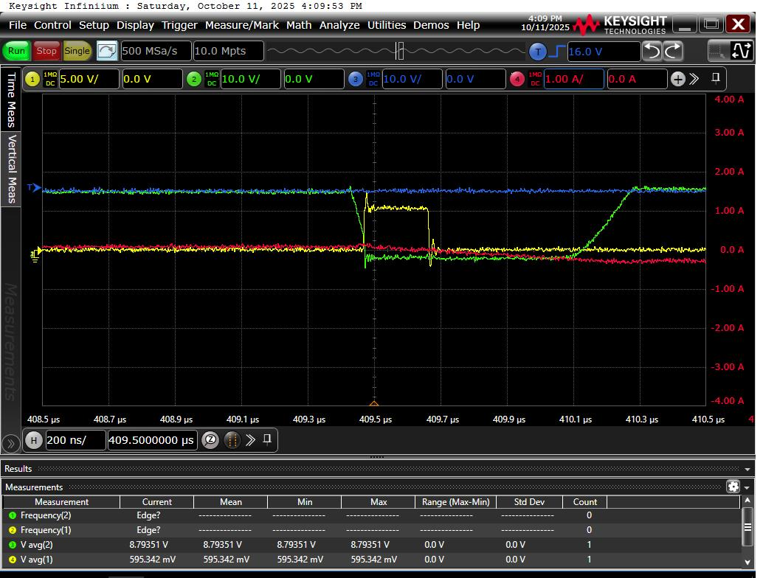
Channel 1 Q13_GS, Channel 2 Q13_DS, Channel 3 C82 voltage, Channel 4 L9 current. Load current 0.3A
Channel 1 Q13_GS, Channel 2 Q13_DS, Channel 3 C82 voltage, Channel 4 L9 current. Load current 0.3A

