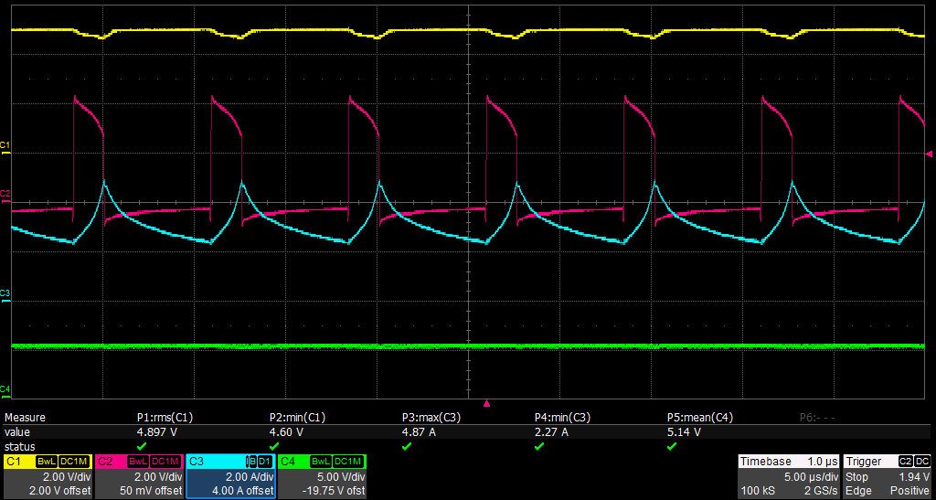

CH1 : LM5160 Pin 3 (VIN = 5V)

CH2 : LM5160 Pin 12 (SW voltage)

CH3 : LM5160 Pin 12 (Transformer Current)

CH4: LM5160 Pin 10 (VCC)