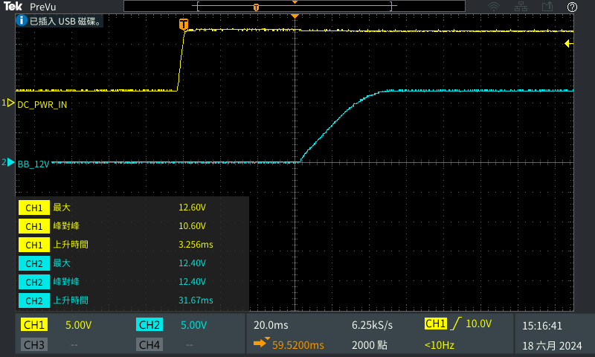 | 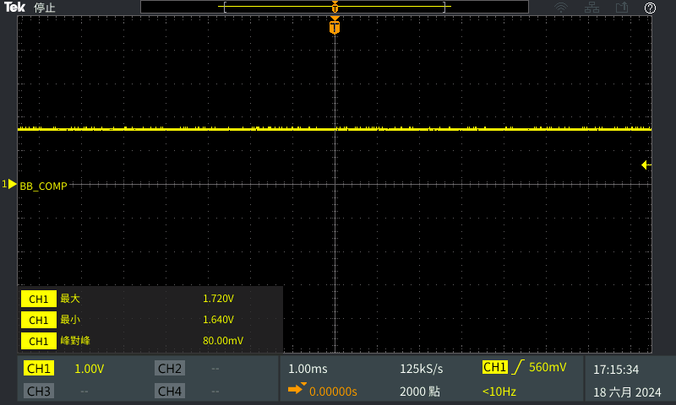
Vin :12V & Vout :12V | COMP
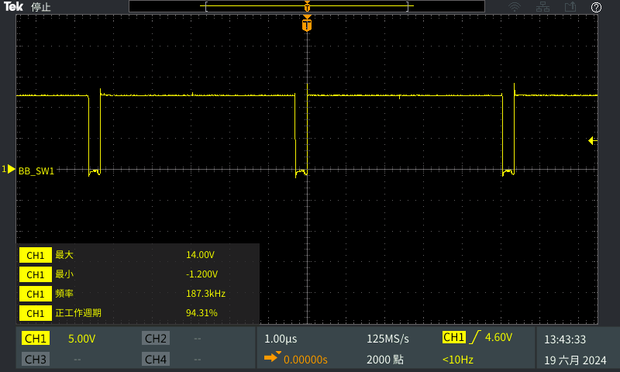 | 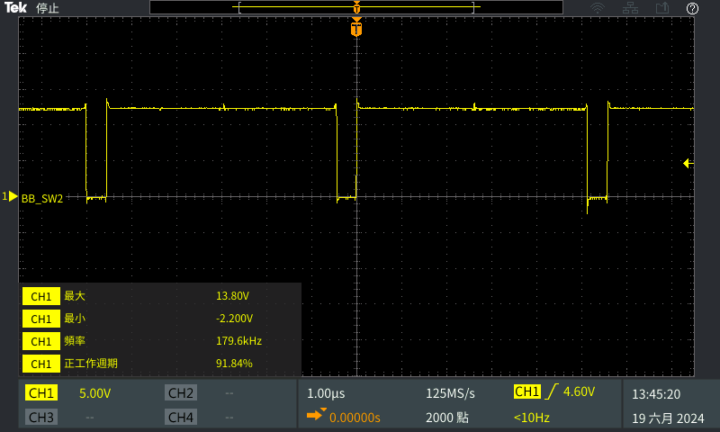
BB_SW1 | BB_SW2
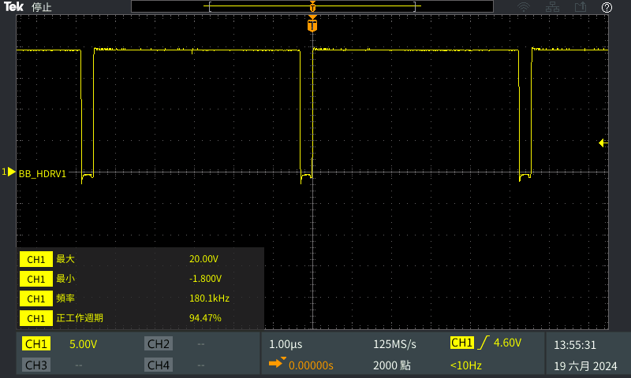 | 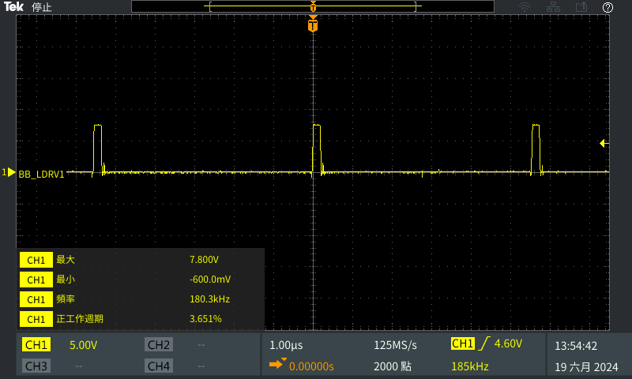
Q10 Vg (HDRV1)-Duty Cycle :94.47% | Q11 Vg (LDRV1)-Duty Cycle :3.651%

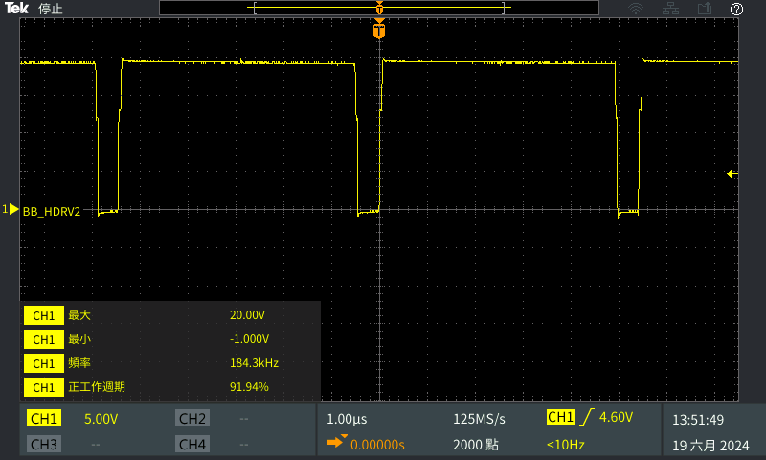 | 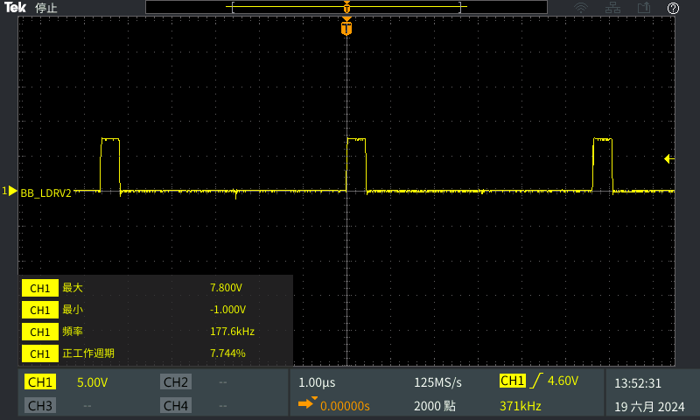
Q12 Vg (HDRV2)-Duty Cycle :91.94% | Q13 Vg (LDRV2)-Duty Cycle :7.744%
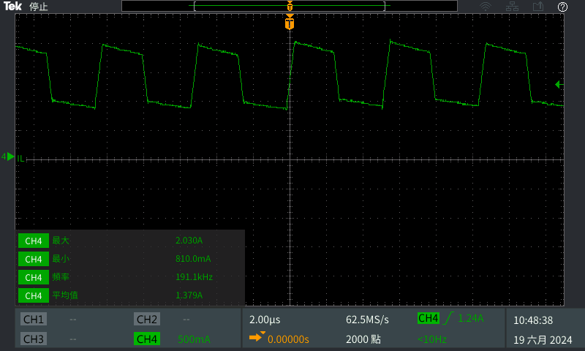 | N/A
Inductor Current (IL)
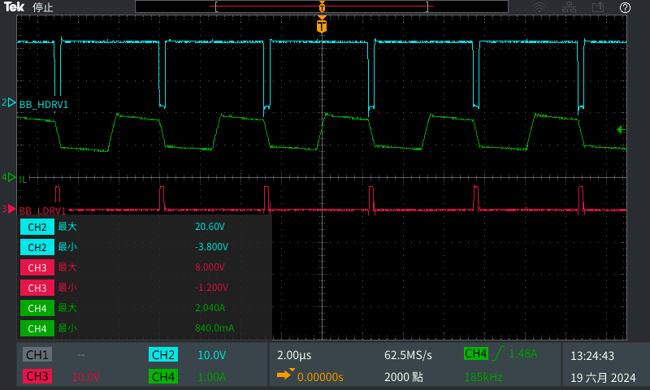 | 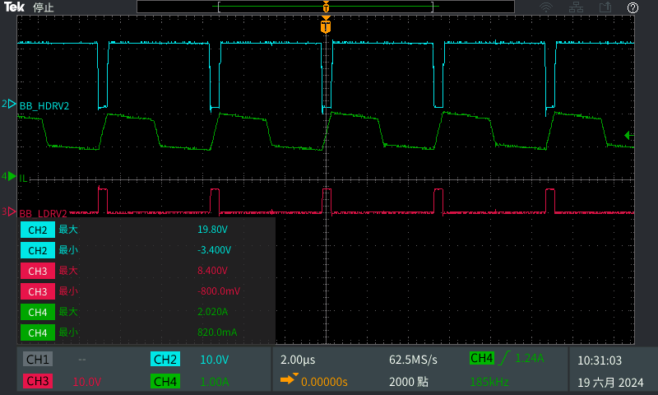
IL_HDRV1_LDRV1 | IL_HDRV2_LDRV2

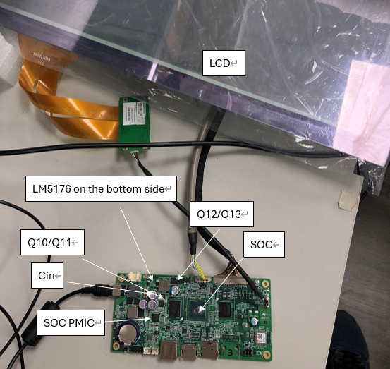

Begging | 1hr later
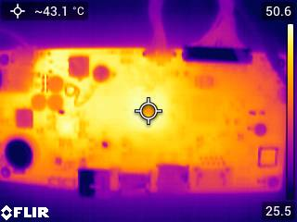 | 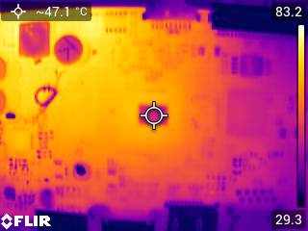
SOC:43.1°C | SOC:47.1°C
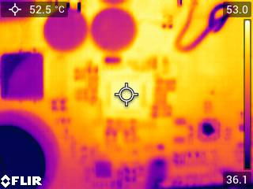 | 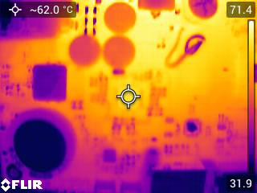
SOC PMIC:52.5°C | SOC PMIC:62°C
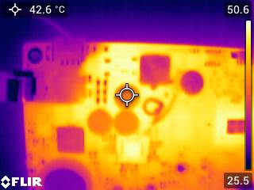 | 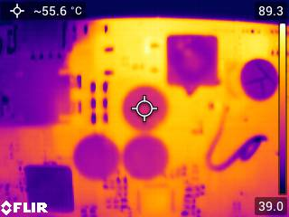
Input CAP C6:42.6°C | Input CAP C6:42.6°C
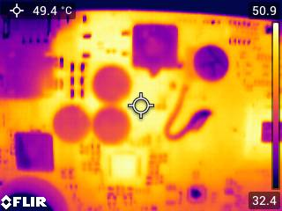 | 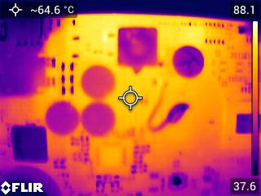
Q10/Q11:49.4°C | Q10/Q11:64.6°C
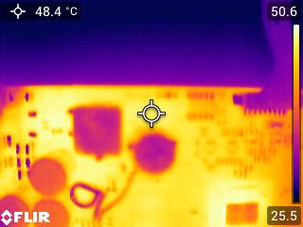 | 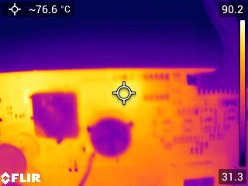
Q12/Q13:48.4°C | Q12/Q13:76.6°C
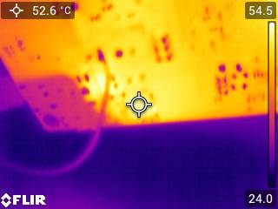 | 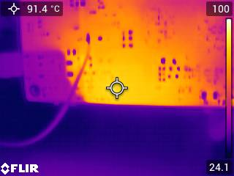
LM5176:52.6°C | LM5176:91.4°C

