Board Level Reliability (BLR) of LM65645-Q1 “Cobra” device in 20-pin RZT QFN package has been assessed by using the BLR Temperature Cycle (TC) test data of a 20-pin RZT QFN daisy chain package with the same bill of material (BOM) and similar silicon die size.

LM65645-Q1 “Cobra” device in 20-pin RZT QFN Package:
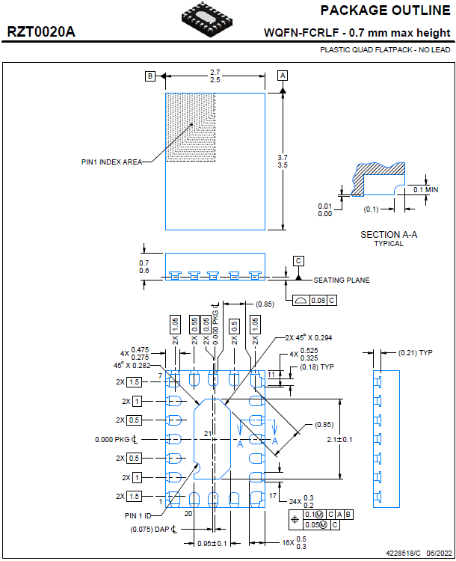

BLR TC Test Data of 20-pin RZT QFN Daisy Chain Package:
Parameter | Value
Test Method | Per IPC-9701 standard
Board Material | High Tg FR4
Board Thickness (mm) | 1.6
Number of Copper Layers | 8
Solder Paste | SAC305, Lead-free, No Clean
Min. Temperature (ºC) | -40
Max. Temperature (ºC) | 125
Number of Cycles per Hour | 1
Dwell Time (minutes) | 15
Cycle Time (minutes) | 60
Sample Size (units) | 32
Definition of Failure | Daisy chain resistance being higher than 1000 ohm
Number of Failed Samples | 19
Number of Non-Failed Samples | 13
Number of Cycles Completed | 6533
Cycles to First Failure | 4814
Characteristic Life (at 63.2% failure rate, Cycles) | 6519
Shape Parameter (Slope) | 11.6

Weibull Plot | 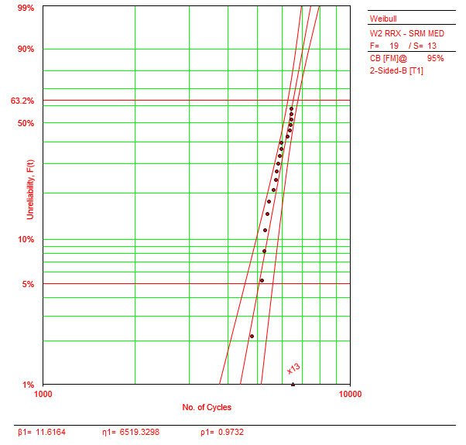

IMPORTANT NOTICE AND DISCLAIMER

TI PROVIDES TECHNICAL AND RELIABILITY DATA (INCLUDING DATASHEETS), DESIGN RESOURCES (INCLUDING REFERENCE DESIGNS), APPLICATION OR OTHER DESIGN ADVICE, WEB TOOLS, SAFETY INFORMATION, AND OTHER RESOURCES “AS IS” AND WITH ALL FAULTS, AND DISCLAIMS ALL WARRANTIES, EXPRESS AND IMPLIED, INCLUDING WITHOUT LIMITATION ANY IMPLIED WARRANTIES OF MERCHANTABILITY, FITNESS FOR A PARTICULAR PURPOSE OR NON-INFRINGEMENT OF THIRD PARTY INTELLECTUAL PROPERTY RIGHTS.

These resources are intended for skilled developers designing with TI products. You are solely responsible for (1) selecting the appropriate TI products for your application, (2) designing, validating and testing your application, and (3) ensuring your application meets applicable standards, and any other safety, security, or other requirements. These resources are subject to change without notice. TI grants you permission to use these resources only for development of an application that uses the TI products described in the resource. Other reproduction and display of these resources is prohibited. No license is granted to any other TI intellectual property right or to any third party intellectual property right. TI disclaims responsibility for, and you will fully indemnify TI and its representatives against, any claims, damages, costs, losses, and liabilities arising out of your use of these resources.

TI’s products are provided subject to TI’s Terms of Sale (www.ti.com/legal/termsofsale.html) or other applicable terms available either on ti.com or provided in conjunction with such TI products. TI’s provision of these resources does not expand or otherwise alter TI’s applicable warranties or warranty disclaimers for TI products.

