Hi Team,

When looking at the data-sheet, it recommends using a series resistor on the CE pin:

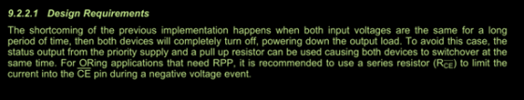

When looking at the evaluation board, TI use a 1k resistor on the GND pin:

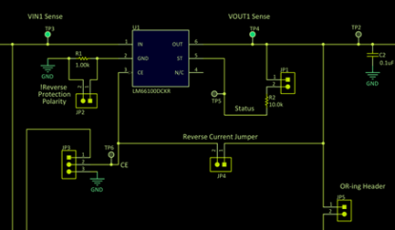

I will appreciate your help with a clarifying this issue, and the correct way to operate this device.

Thanks,

Shlomi