Circuit diagram:



BOM for circuit:

|  |  |  |  |  |  |  |
| --- | --- | --- | --- | --- | --- | --- |
| C11 | 100nF | 100nF, 16V, Y5V, 0603 | CAPC1608N | Cap | Kemet | C0603C104Z4VACTU |
| C12 | 100nF 0805 | 100nF, 50V, X7R, 10%, 0805 | CAPC2012N | Cap | Murata | GRM21BR71H104KA01 |
| C13 | 10uF | 10uF, 25V, X5R, 10%, 3225 | CAPC3225N | Cap | TDK | C3225X5R1E106K |
| C38 | 22uF | 22uF, 16V, X5R, 20%, 3225 | CAP 1210 (C3225) N 3D | Cap | TDK | C3225X5R1C226M |
| C39 | 22uF | 22uF, 16V, X5R, 20%, 3225 | CAP 1210 (C3225) N 3D | Cap | TDK | C3225X5R1C226M |
| C40 | 22uF | 22uF, 16V, X5R, 20%, 3225 | CAP 1210 (C3225) N 3D | Cap | TDK | C3225X5R1C226M |
| C41 | 22uF | 22uF, 16V, X5R, 20%, 3225 | CAP 1210 (C3225) N 3D | Cap | TDK | C3225X5R1C226M |
| C42 | 22uF | 22uF, 16V, X5R, 20%, 3225 | CAP 1210 (C3225) N 3D | Cap | TDK | C3225X5R1C226M |
| C43 | 22uF | 22uF, 16V, X5R, 20%, 3225 | CAP 1210 (C3225) N 3D | Cap | TDK | C3225X5R1C226M |
| C55 | 10uF | 10uF, 25V, X5R, 10%, 3225 | CAPC3225N | Cap | TDK | C3225X5R1E106K |
| C56 | 1uF | 1uF, 16V, X7R, 10%, 0805 | CAPC2012N | Cap | Murata | GRM21BR71A105KA01L |
| D2 | NSR0620P2T5G | Ultra Fast Schottky, 0.5A, 20V, SOD-923 | SOD-923 | D Schottky | ON Semi | NSR0620P2T5G |
| L3 | 3.3uH | 3.3uH, 20%, 3.3A, 48mR, SMD Shielded | Inductor Bourns SRP4020 | Inductor XAL4030 | Bourns | SRP4020-3R3M |
| R26 | 750R | 750R, 1%, >250mW, 1206, 100ppm/C | RESC3216N | Res | PANASONIC | ERJ8ENF7500V |
| R27 | 6K65 | 6K65, 1%, >60mW, 0603, 100ppm/C | RESC1608N | Res | Any |  |
| R31 | 1K | 1K, 1%, >60mW, 0603, 100ppm/C | RESC1608N | Res | Any |  |
| R41 | 4K7 | 4K7, 1%, >60mW, 0603, 100ppm/C | RESC1608N | Res | Any |  |
| TP4 | Test Point |  | Test Pad | Test Point | * | * |
| U6 | LMR12015 | 2Mhz 2A DC-DC switch reg | PWSON-10 | LMR12015 | Texas | LMR12015XSD/NOPB |

All components layout on bottom layer of PCB. The vias of U6 connect to an internal ground plane.

12V input

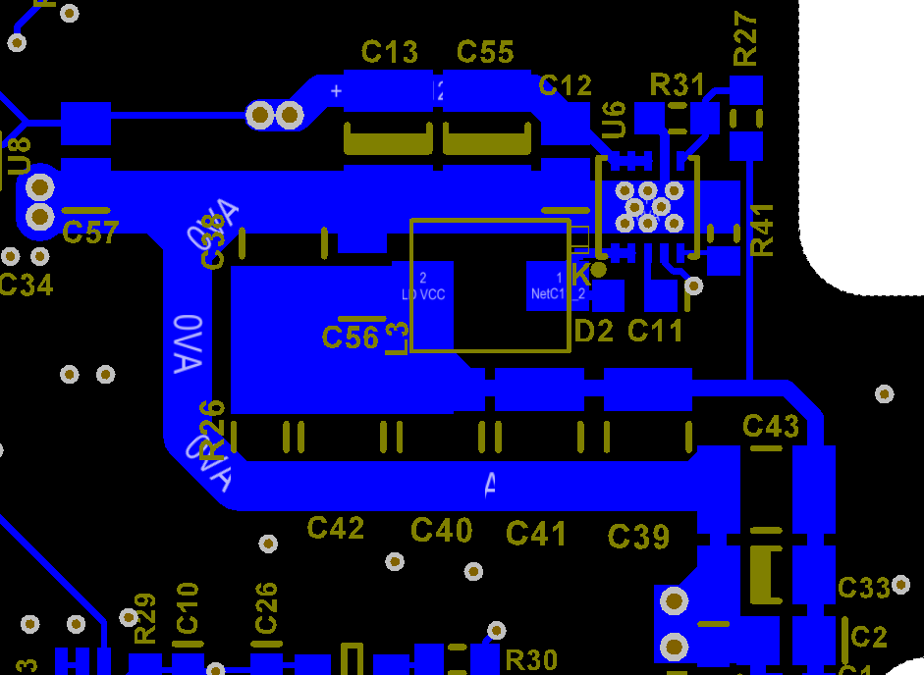

Output. Extra decoupling caps at load.

Load ground return.

