Top trace is Vboost node and lower trace is Switch Node. The difference is 3.63V

\\Officeserver\Quality\Incident Reports\Open\IR728\Data\Scope captures for U6 testing\PRINT_47.TIF

Below is just the switch node voltage on a unit that was drawing 100mA from the supply and then after a 6 power up and down cycles (switched the 12V ON and OFF) it increased to 135mA.

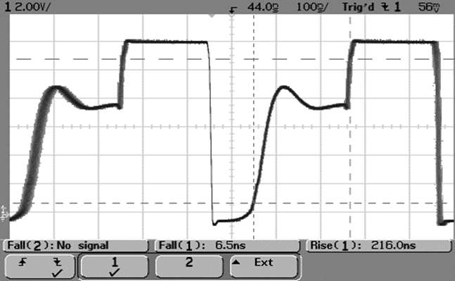

Below is the Vswitch node waveform for a 3.6V supply. These have never failed.

\\Officeserver\Quality\Incident Reports\Open\IR728\Data\Scope captures for U6 testing\PRINT_44.TIF