24V power supply; Yellow – VCC_5V; Violet - LMR33630-Pin2 (Vin)
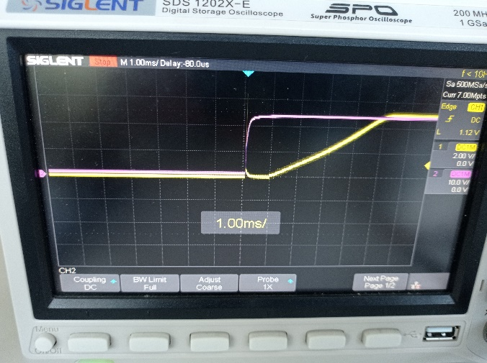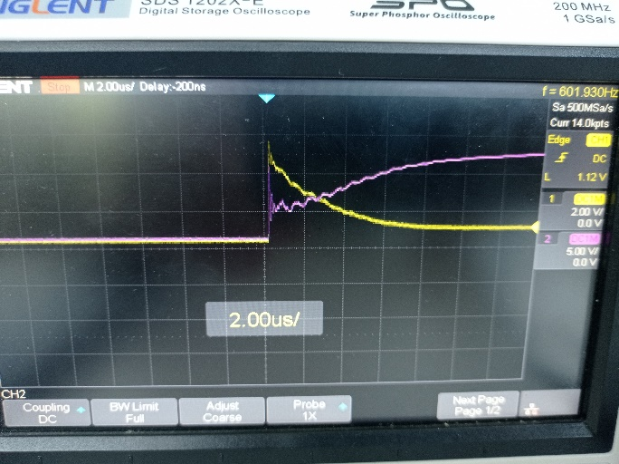
12V power supply; Yellow – VCC_5V; Violet - LMR33630-Pin2 (Vin)
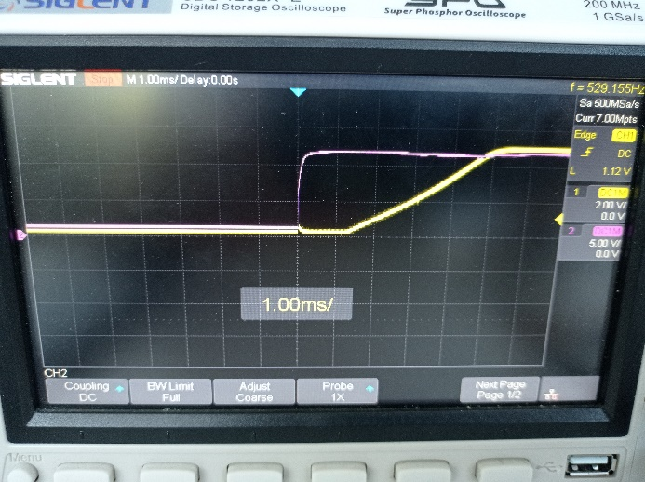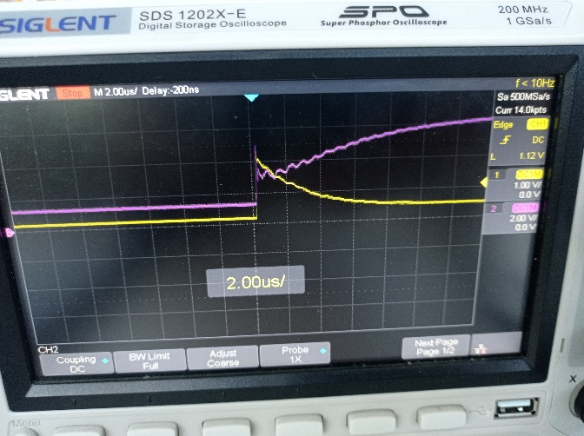
24V LiPo battery; Yellow – VCC_5V; Violet - LMR33630-Pin2 (Vin)
