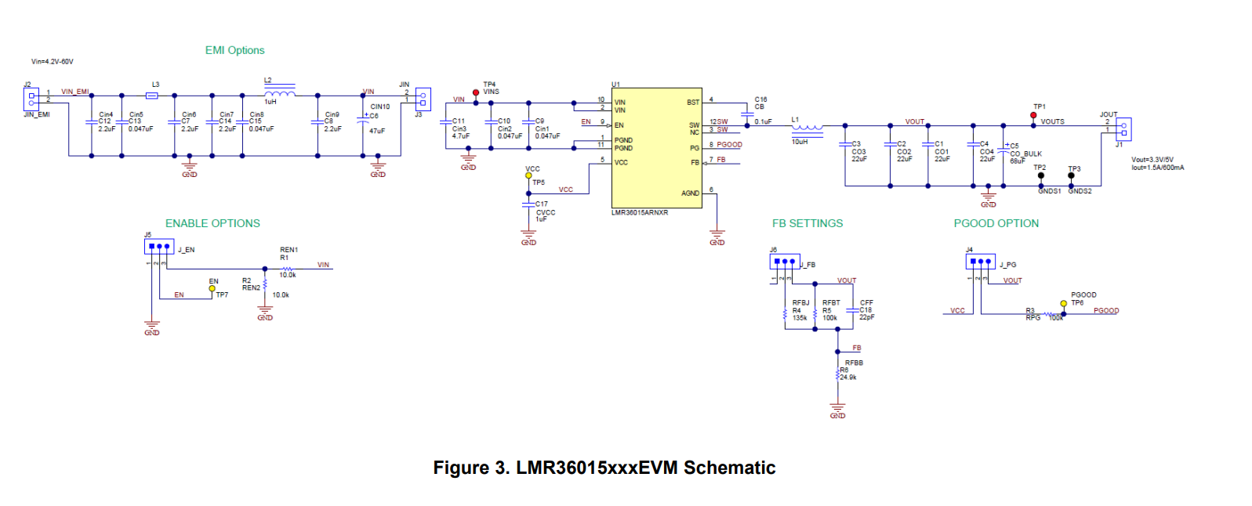

Changes

* U1 change to LMR36006AQRNTXQ1
* L1 to 33uH (TDK )
* L1 to 39uH (WE 7447789139)
* L1 to 47uh (TDK
* Remove Cout3,4
* Change RFBB to 6.8k (16Vout)
* Change RFBB to ~7.1k (15Vout)

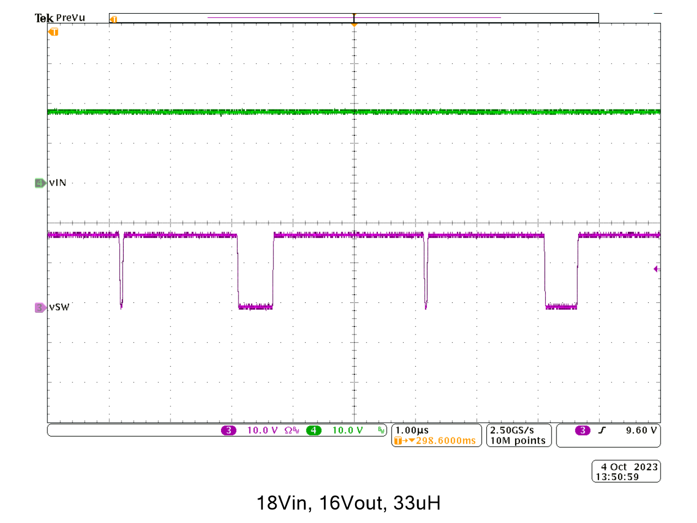

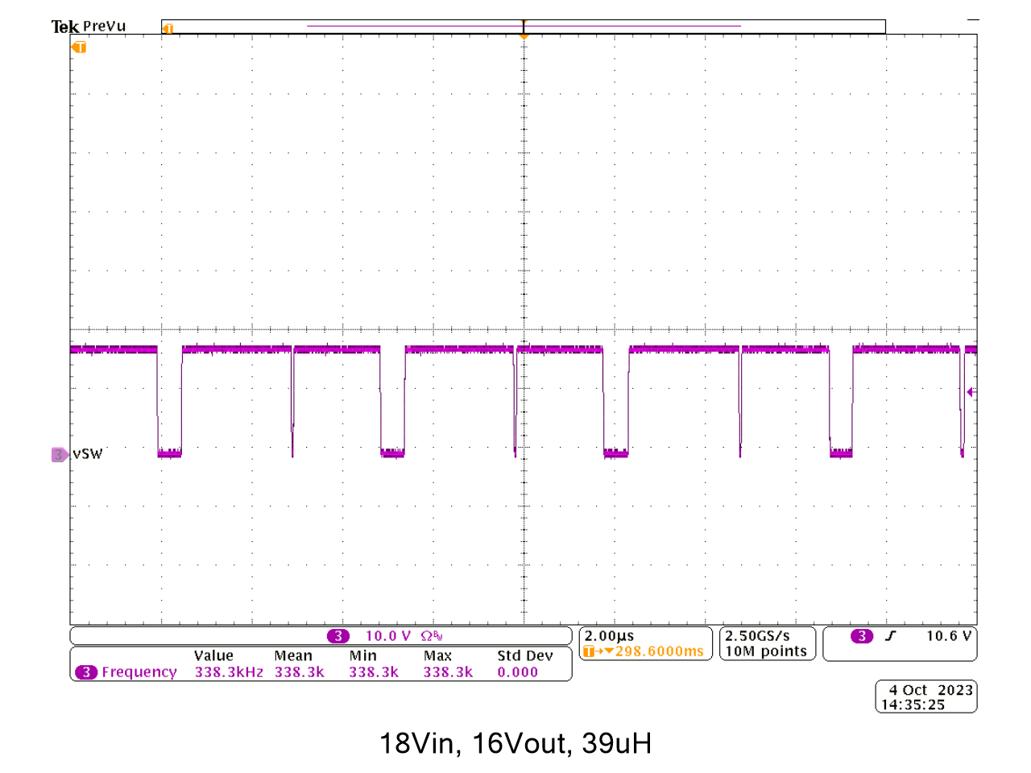

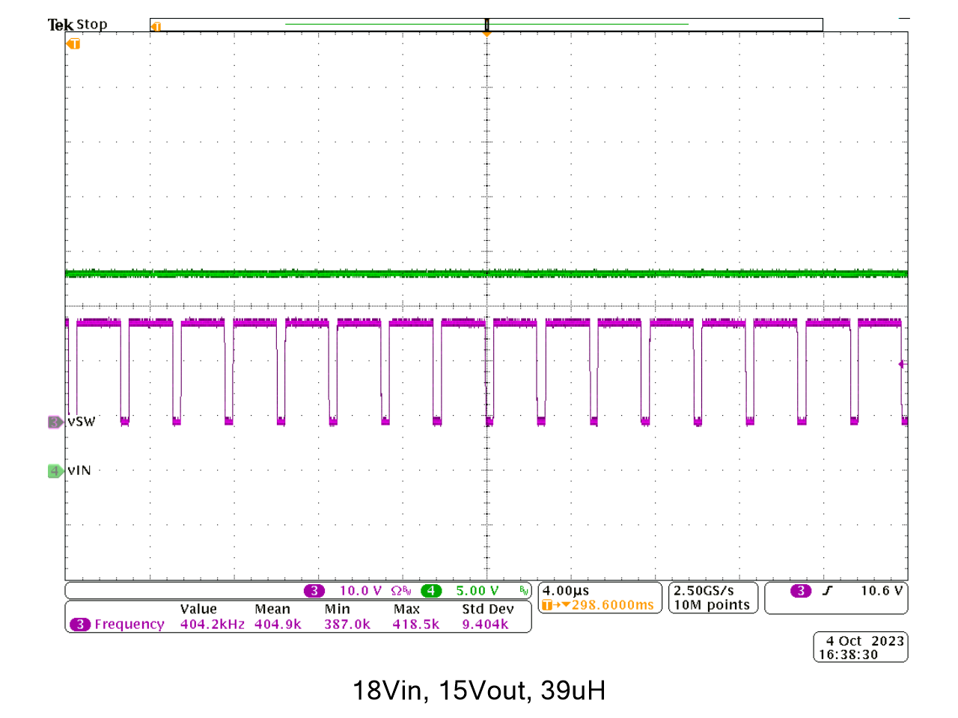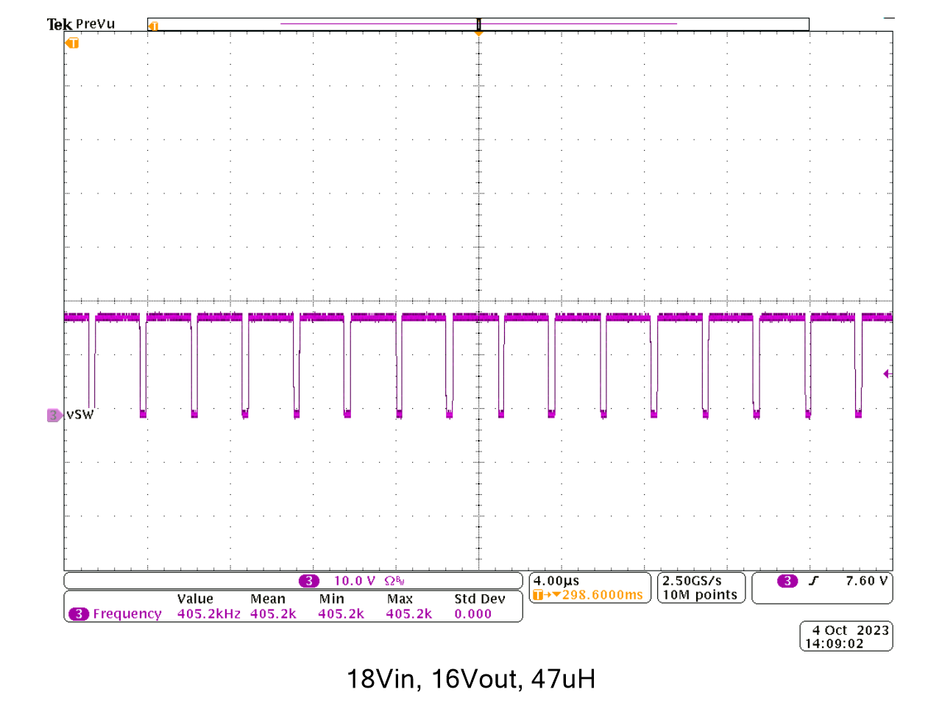

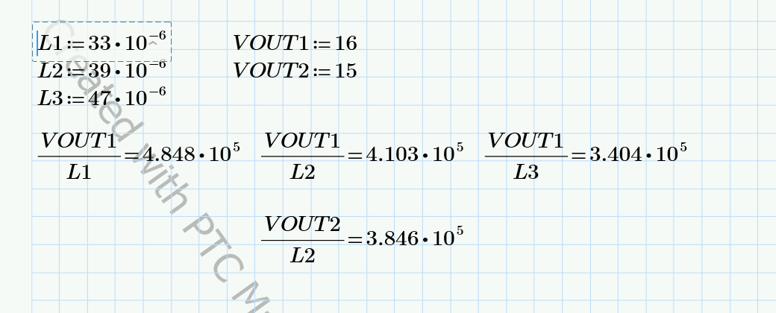

* With internal slope comp, inductor ripple current downslope dictates stability
* The datasheet equation for Lmin is based on internal slope comp
  + It needs to be improved based on this report
* 33uH instability was confirmed
* 39uH also appeared unstable at worst-case (right before dropout)
* 47uH appeared stable
  + To confirm margin, vout was decreased to 15Vout, to have the inductor downslope be between 39uH and 47uH (calculation above)
  + Margin was confirmed with 39uH with 15Vout showing stability