- Before add waiting instruction between ‘set_pwm 0 ’ and ‘set_pwm 255’
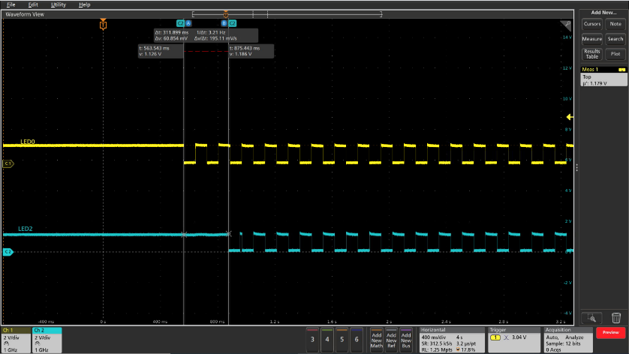
Engine 1 begin

Engine 2 begin

t=0.08s T_delay= 311.899ms

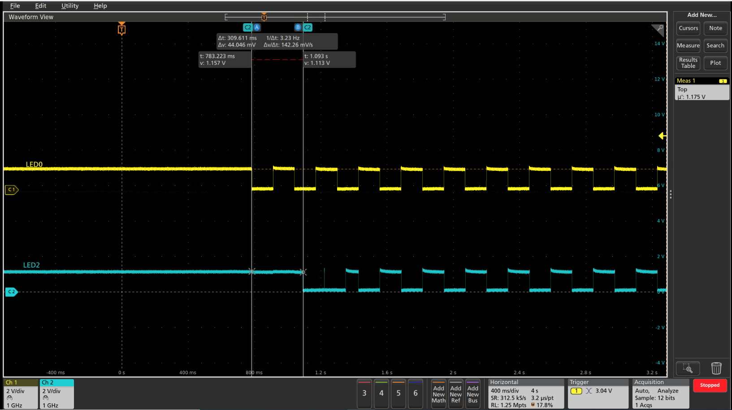
t=0.12s T_delay=309.611ms

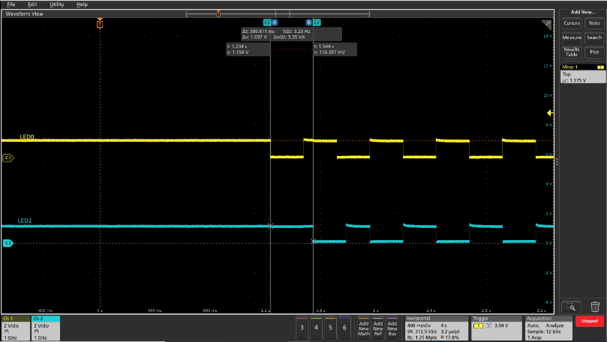

t=0.24s T_delay=309.611ms

- After add waiting instruction（wait 360ms） between ‘set_pwm 0 ’ and ‘set_pwm 255’
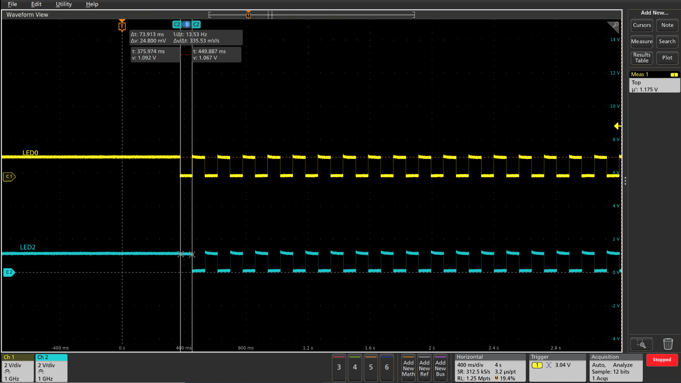
t=0.08s normal
- Reference program code
