1 SCH

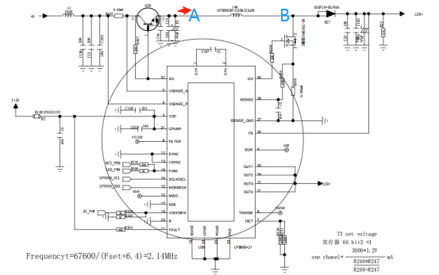

2 ）Abnormal situation

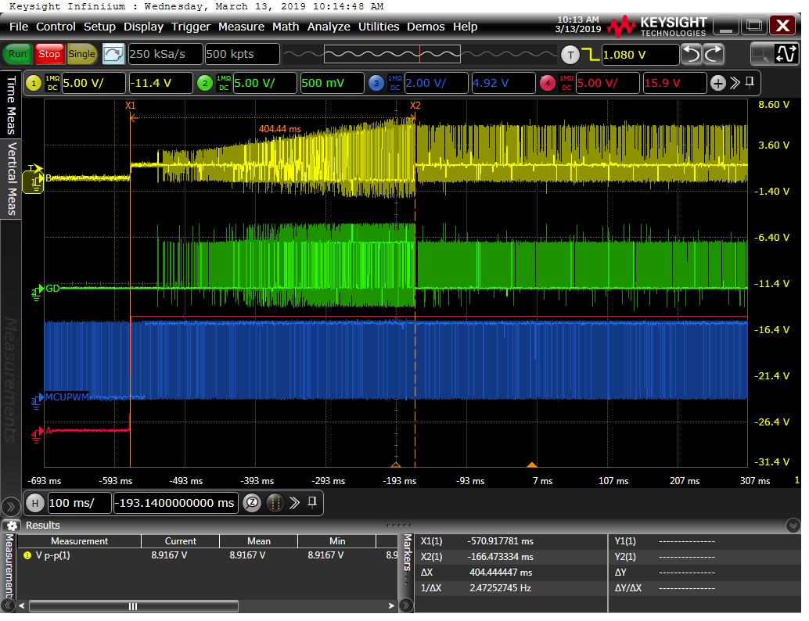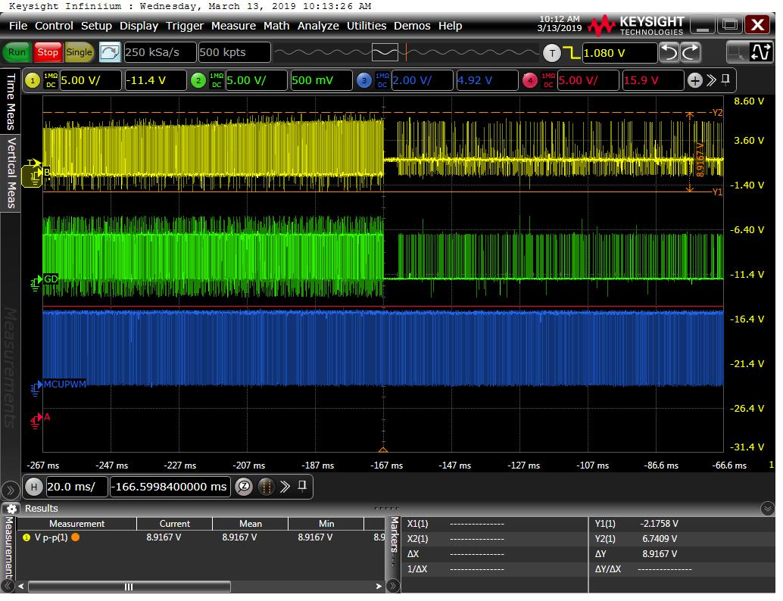

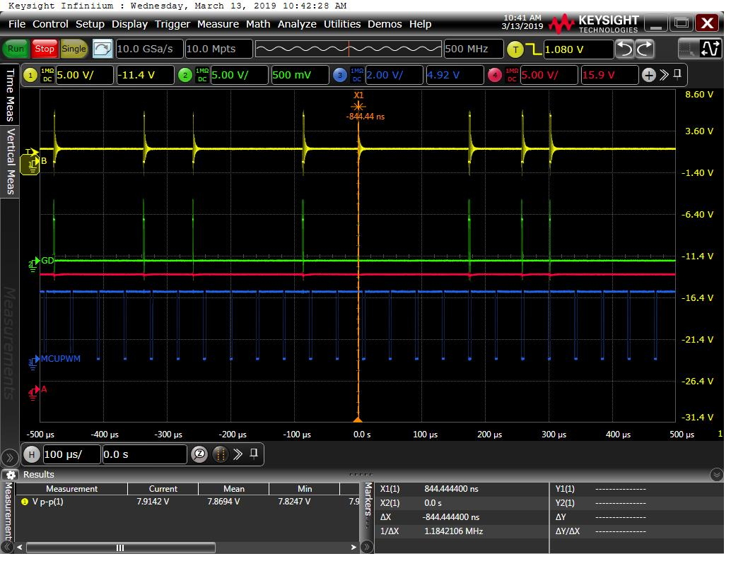

1 Yellow B点波形

2 Green 8860 PIN30 GD波形

3 Blue MCU_PWM波形

4 Red A点波形

From the first figure, it can be seen that after 400ms of electrification, the waveform of GD foot began to change, leading to the change of waveform at point B.As a result, the backlight brightness is reduced or not bright.In this case, both 19PIN hi-power and 18PIN MCU_PWM are normal.

1. Normal

